**Lecture 1 – Statistical Modelling**





When F(·; θ) is known then we have a parametric problem, when F(·) is unknown the problem is non-parametric.

**Covariates** are the p independent(?) columns on the **design matrix X**

The **set of outcomes** will be written as Ω. An **event** is a subset F ⊂ Ω of Ω.



An **event F** is **“realised”** whenever the outcome of the experiment is an element of F.

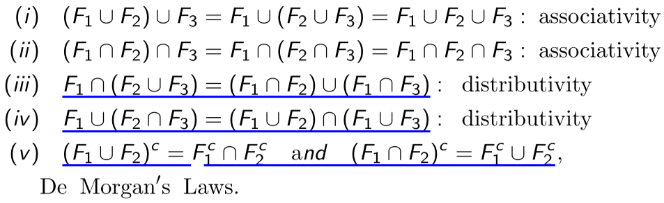

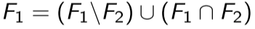 , axiom of probability (?)



**Applied to probability:**

 🡨 **IMPORTANT**

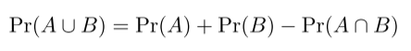



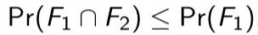

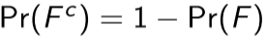

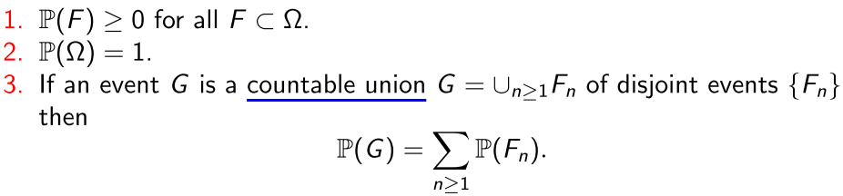

**Lecture 1 – Conditional Probability and Dependence**

**Conditional Probability:**

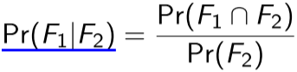

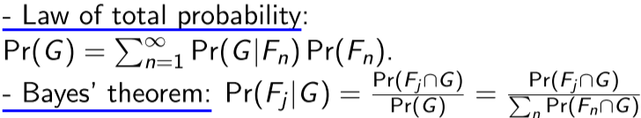

A and B and **independent** if Pr(A ∩ B) = Pr(A) × Pr(B)

A **random variable** is a real function X : Ω → R

We write {a ≤ X ≤ b} to denote the event {ω ∈ Ω : a ≤ X(ω) ≤ b}.

if A ⊂ R, we write {X ∈ A} to denote the event {ω ∈ Ω : X(ω) ∈ A}

**distribution function** (or cumulative distribution function) F of a random variable X (or the law of X): 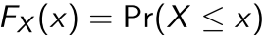 where 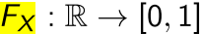

Properties:

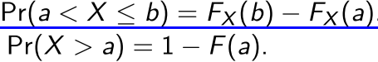

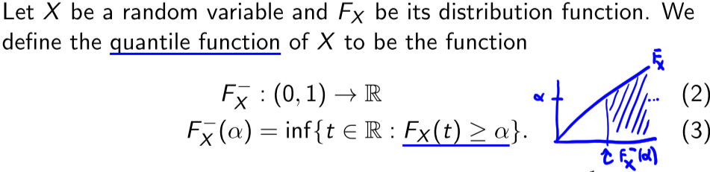

Given an α(0, 1) the **α-quantile** of X is the real number: 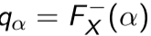

Note: the infimum (**inf**) of a subset S of a partially ordered set T is the greatest element in T that is less than or equal to all elements of S.

A **continuous random variable** X has **probability density function (PDF)** f_X if :

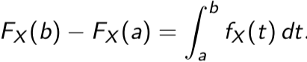

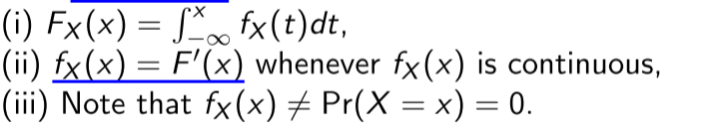

For a **discrete** random variable X we may define its **probability mass function (PMF)**

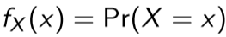 (this does not hold for PDF)!

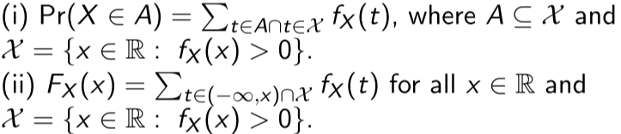

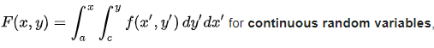

**Transformed Mass Functions.** We use the output of a func of random vars, instead of random vars

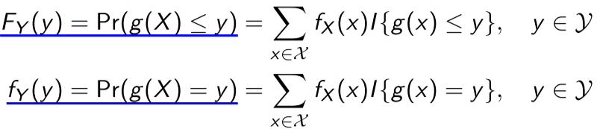

**Random vectors:** a finite collection of random variables: 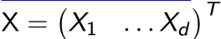

* **Joint distribution:** 
* **Joint mass function:** 
* **Joint density function:** 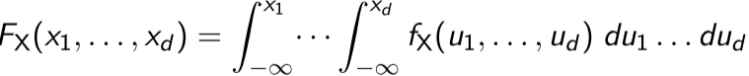
  + If f_X is continuous: 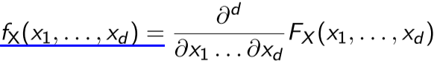
* **Marginal mass function:**

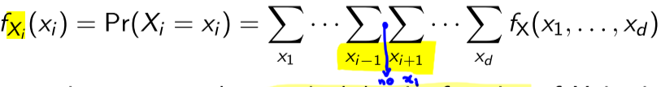

* **Marginal density function:**



* Ie to marginalize we integrate/sum over the remaining variables from the overall joint density/mass function

**Lecture 2 – Random Vectors**

**Joint frequency/density function of the subset of first k, discrete case:** 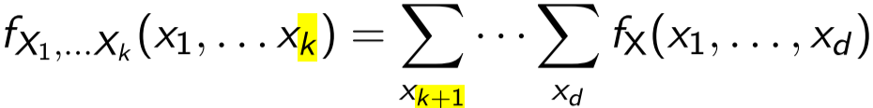

**Joint frequency/density function of the subset of first k, continuous case:** 

**Conditional PDF / PMF**

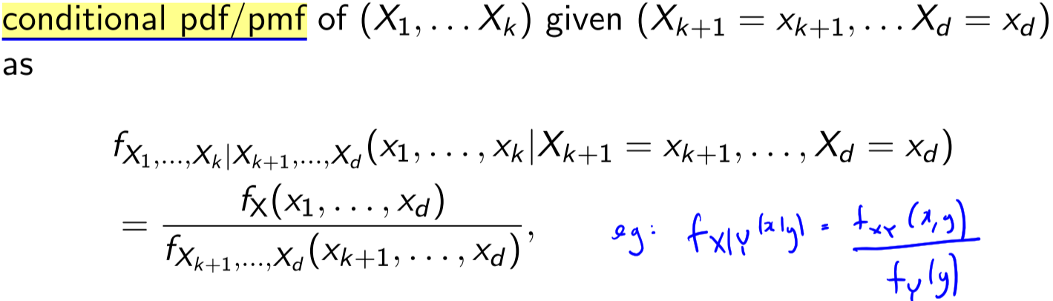

**Indepentent** ie if

* 
* 

When vars are independent, conditionals reduce to marginals:



X is **Conditionally independent** of Y given Z () if:

*  🡨 distribution
*  🡨 density (equivalent)
* 
  + Thus 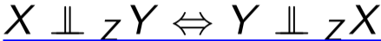

**Sum of Random variables** of independent X and Y (density of X+Y is the convolution of f_X and f_Y):

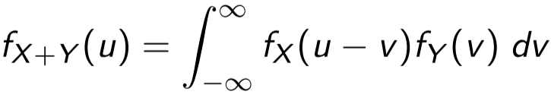 or SUM for discrete!

**Lecture 2 – Multivariate transformations**

**Expectation** or  **Expected value:**

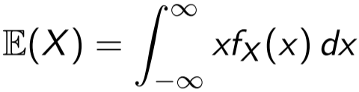or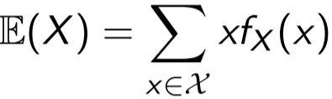

Properties:

* E [ E [ X ] ] = E[X]
* Linearity: E(X1 + αX2) = E(X1) + αE(X2)
  + Thus: sum of 2 random vars: E[X+Y] = E[X] + E[Y]
* 
* For random vector: 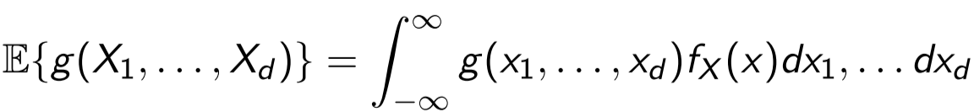

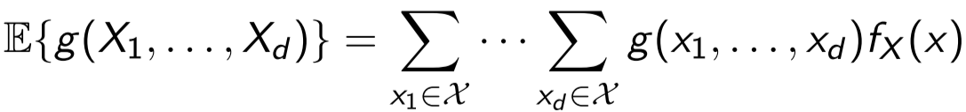

* Mean vector is the expectation of individual components:
  + 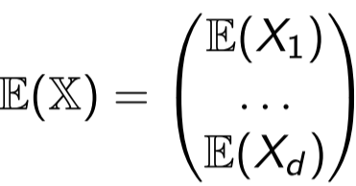

**Variance** defines how sparse data is around its expectation:

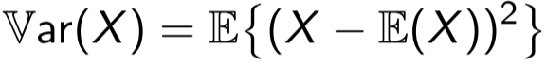

**Dispersion** = Var(X)/E[X)

**Covariance** expresses the linear dependence between the two random vars:



* + if they’re independent, covariance equals 0, and so does the correlation
    - **But not the other way around (they’re are just uncorrelated ie corr=0)**

**Correlation** conveys equivalent dependence information to the covariance. Advantages: invariant to scale changes, can be understood in absolute terms(ranges in [−1, 1])

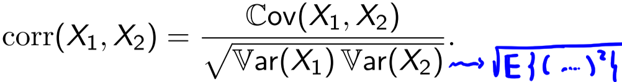

Properties:

* var(aX + bY) = a^2 var(X) + b^2 var(Y), where we compute var from formula below

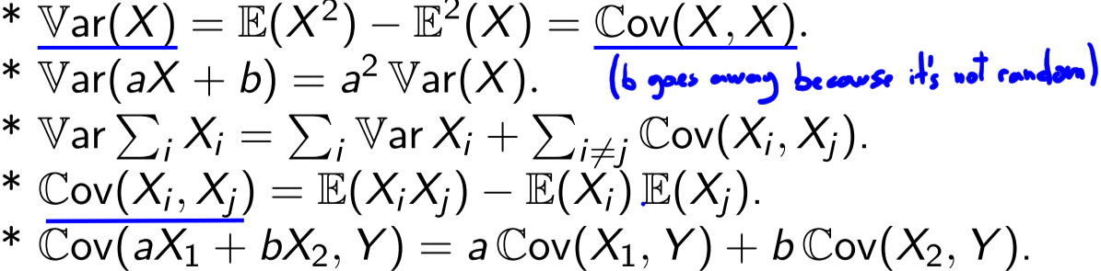

* + variance of sum of **independent** random vars:
    - var [X +Y] = var[X] + var[Y] − 2cov(X, Y) = var[X] + var[Y]
    - var [X -Y] = ?? = var[X] + var[Y]

- for 2 independent variables

- cov(X,Y) = E [ (X− E[X])(Y − E[Y]) ] = E[XY] − E[X]E[Y]

- in vector form

- cov (X,Y) = E [ (X− E[X])(Y − E[Y])^T ] = E[XY^T] − E[X]E[Y]^T

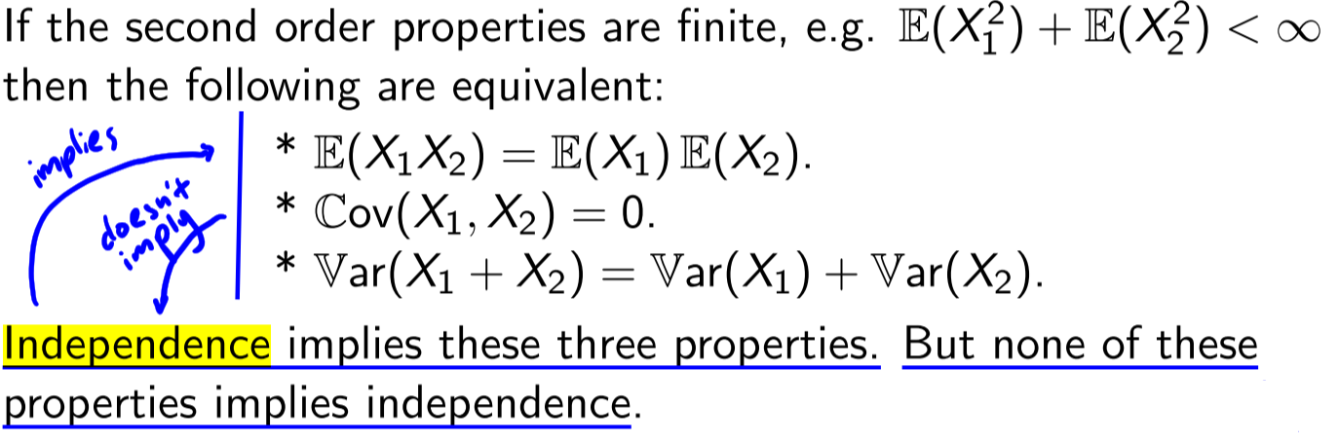

Note: never say that Cov=0 implies independency (tricky exam question). Cov=0 means we have to factorize the distribution. Gaussian vars are different, but we'll cover that later!

**Conditional Expectation** (calculation of expectation of the conditional distribution):



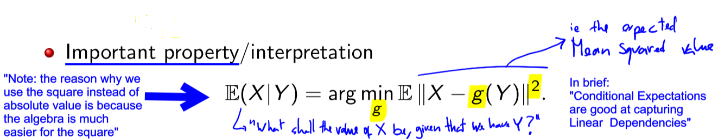

Thus among all measurable functions of Y, E(X|Y) best approximates X in the mean square sense.

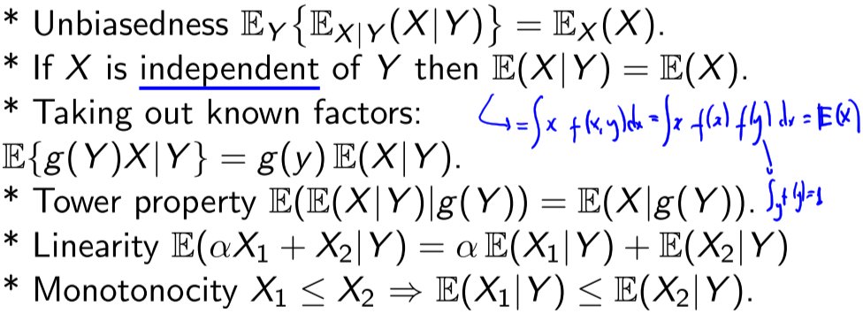

**Conditional Variance**



Law of total variance:

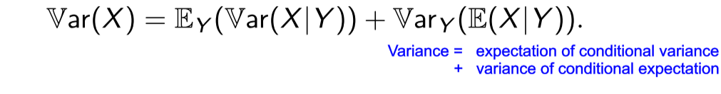

**Covariance Matrix** of a random vector Y, is a dxd symmetric matrix:



Mean vector (or expectation of Y):





Let Y be a random d × 1 vector with mean vector µ and covariance matrix Ω:



Given X is assumed to be a non-negative random variable. Then, given any epsilon>0 we have (**Markov’s inequality**): 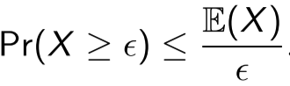

**Chebychev’s inequality**: 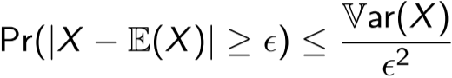

**Jensen’s inequality**: 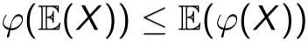

**Lecture 2 – Moment Generating Functions (MGF)**

An alternative specification of probability distribution:

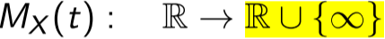 and 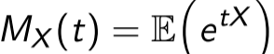 = \int e^tx * f(x)] **dx**

Properties

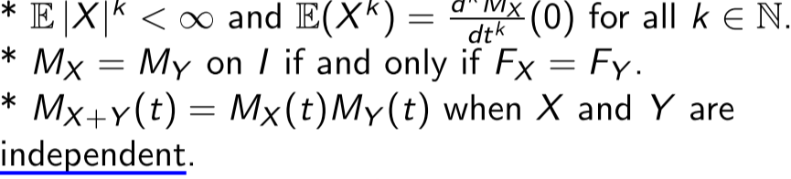

For a random vector

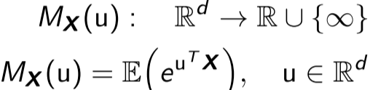

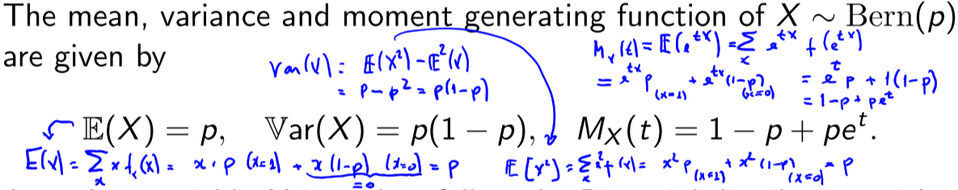

**Lecture 3 – Important Distributions**

**Binomial**  is a generalization of the Bernoulli for several trials

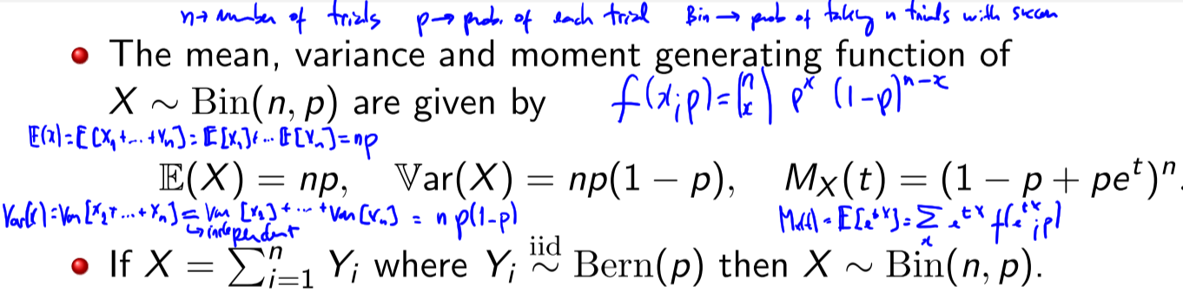

**Geometric** is the number of trials until a first Bernoulli success

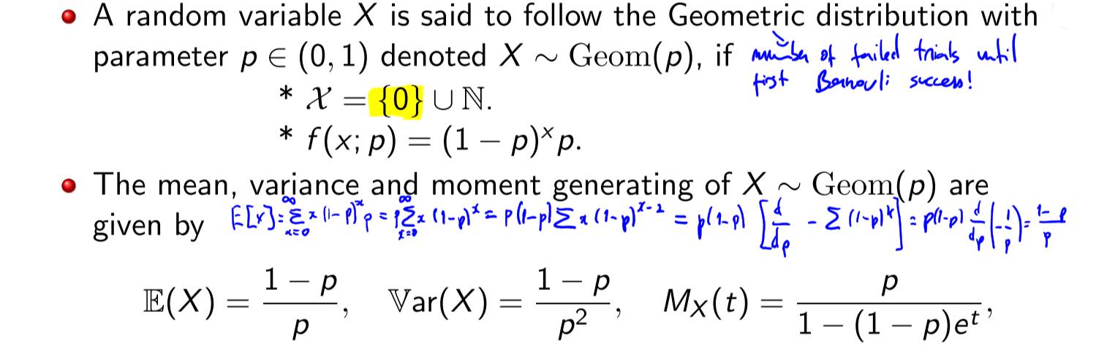

**Negative binominal** describes the prob of x trials before r successes are obtained. Thus, the geometrical can be thought of a negative binomial distribution with parameter r=1

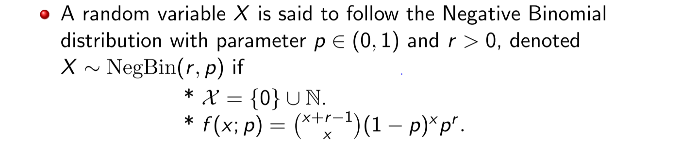



Sum of geometric distributions give a negative binomial. Also a sum of Bernoullis give a binomial.



**Poisson** is a discrete prob distribution that expresses the probability of a given number of events occurring in a fixed interval of time or space (when events occur with constant mean rate and independent of time since last event)

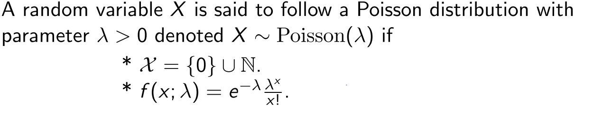



To go between Bernoulli and Poisson:

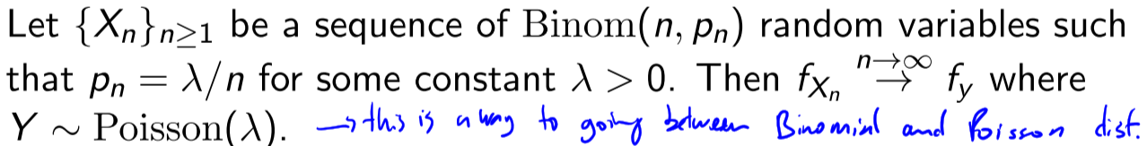

Poisson generalizes the Binomial

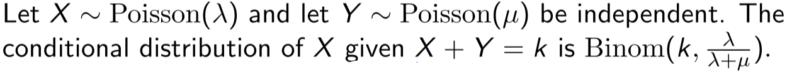

**Multinomial** is similar to Binomial , but includes more than 2 classes. It’s a generalization of Binomial for n independent trials, with k possible outcomes

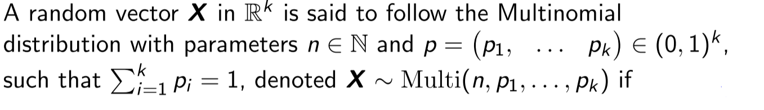

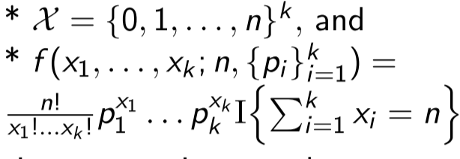

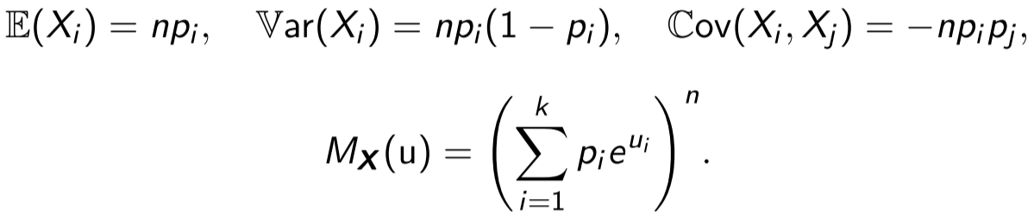

Lemma: Poisson and Multinomial

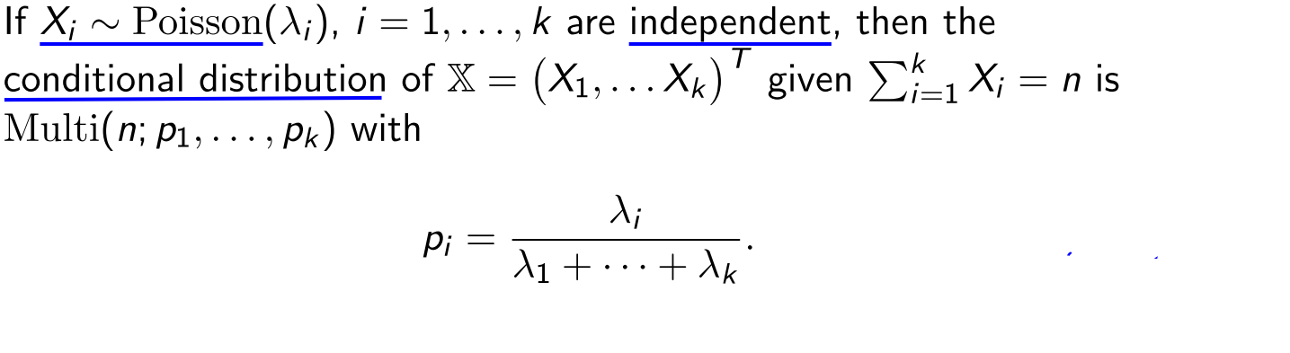

**All previous were discrete probability distributions. The following are continuous:**

**Uniform** distribution

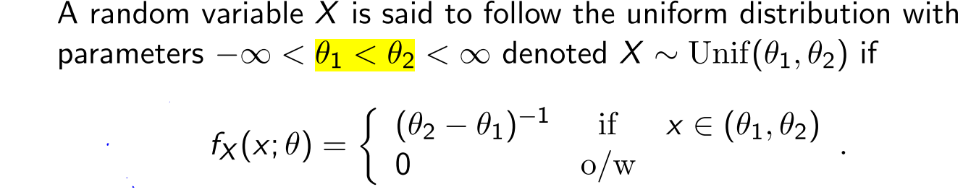

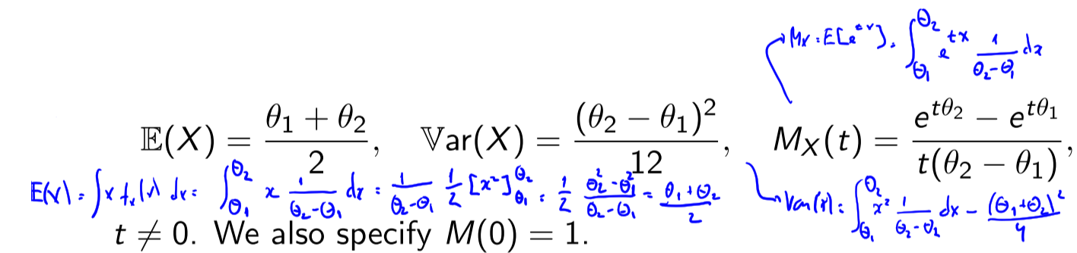

**Exponential** with parameter lambda>0 . The Poisson distribution deals with the number of occurrences in a fixed period of time, and the exponential distribution deals with the time between occurrences of successive events as time flows by continuously

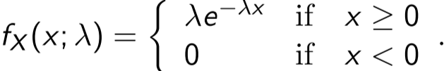

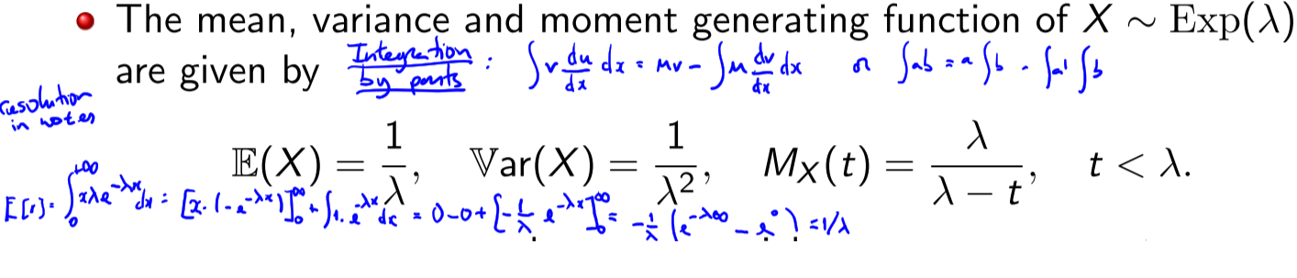

**Gamma** distribution. Exponential is a special case of the gamma distribution (next) when alpha=1 and beta=lambda.

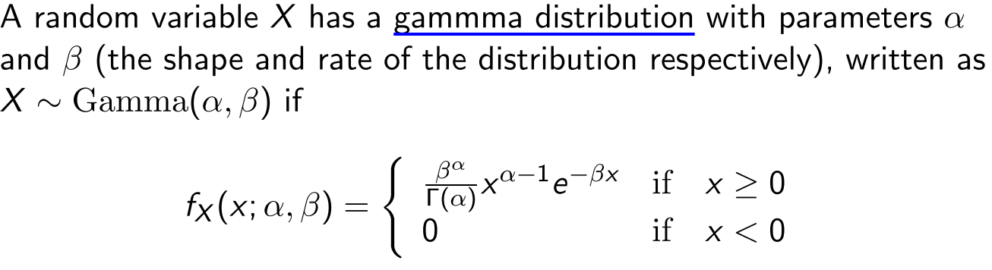



Sum of exponentials is a gama distribution.



**Chi-square**



**Normal distribution**

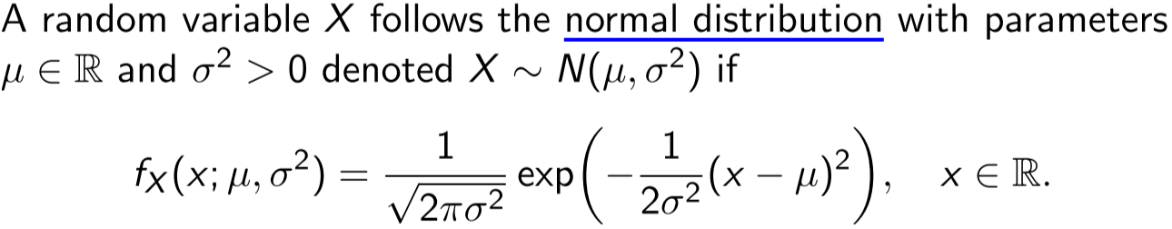



ie the variance is the square of the standard deviation

**Standard Normal distribution**

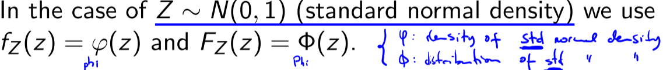

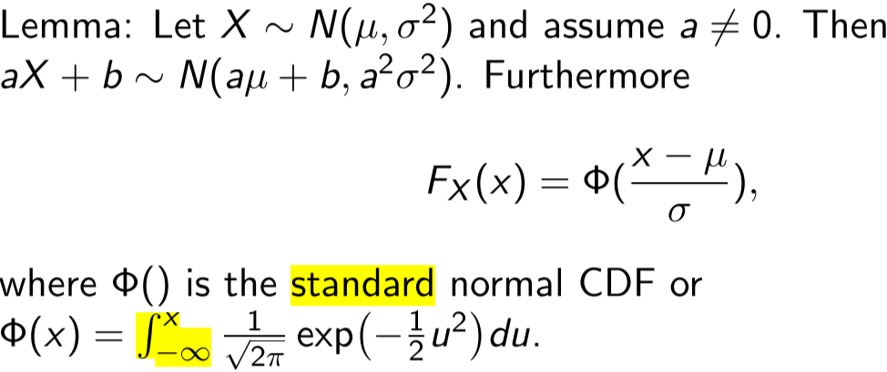

Sum of gaussians is a gaussian:

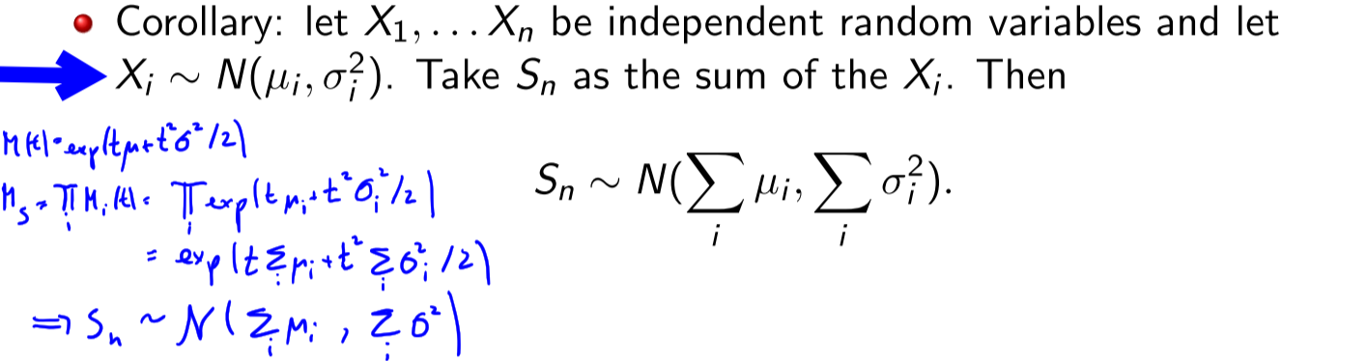

**Lecture 3 – Entropy**

The **entropy** **H(X)** is a measure of intrinsic disorder or unpredictability. the larger the entropy the less we know about X, and the least predictable a random variable is. It is related to the variance, but is not equivalent to the variance.

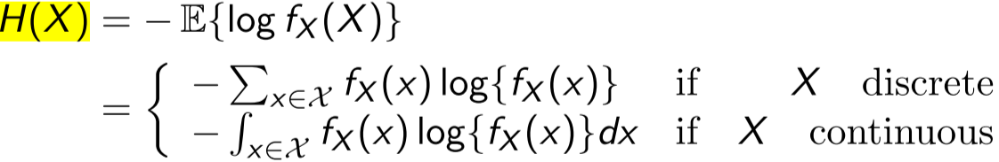

Entropy is expressed in the unit bits. If log is replaced by lg (ie base 10) then the unit is nats.

**Kullback-Leibler divergence** or **relative entropy** of q with respect to p as:

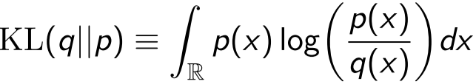

p = q ⇔ KL(q||p) = 0

KL-divergende is also an expectation:

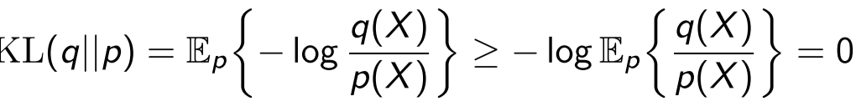

**Lecture 4**

**Conditional Entropy**

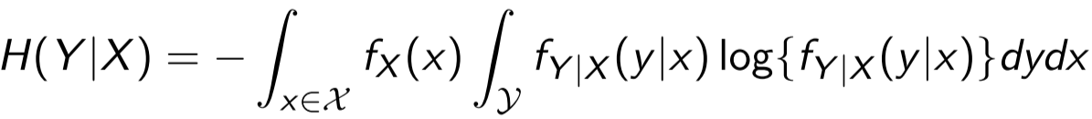

**Joint Entropy**

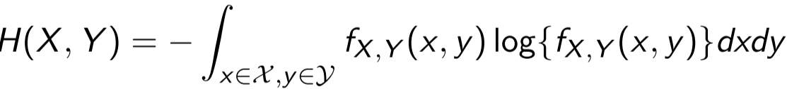

**Entropy Chain Rule**



**Mutual Information I(X,Y)**  measures the **reduction in uncertainty** of X due to knowledge of Y and is symmetric in X and Y. To know: I(X,Y) = 0 ⇔ X and Y are independent

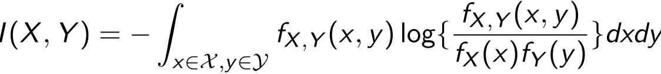

Or



**Lecture 4 – Exponential Family and Sampling Theory**

**Member of the k-parameter exponential family** are in the form:

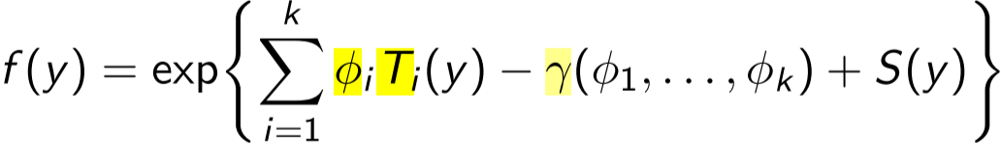

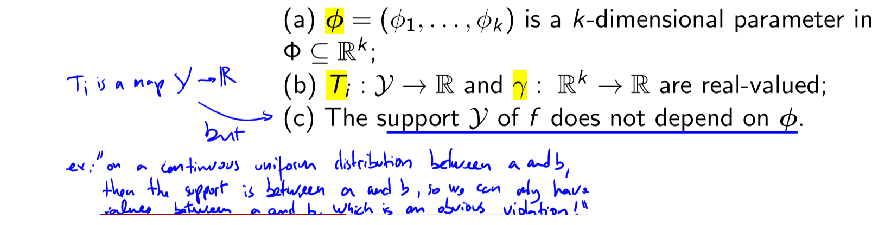

Examples: Binomial, Negative Binomial, Poisson, Gamma, Gaussian, Pareto, Weibull, Laplace, logNormal, inverse Gaussian, inverse Gamma, Normal-Gamma, Beta, Multinomial

φ is called **natural parameter.** The **usual parameter is** 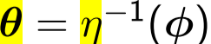

Exp. family can be written in natural or usual parameterization:

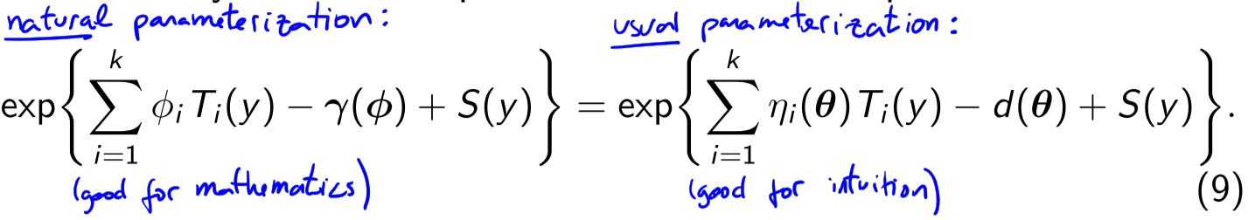

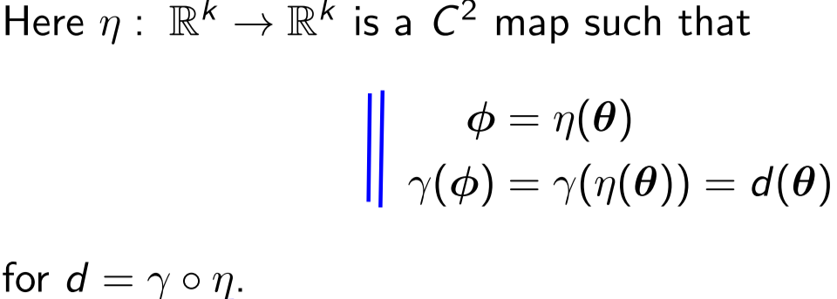

**Statistic T**

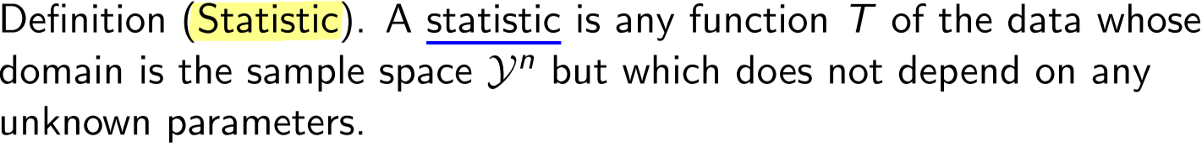

Any statistic is a random variable with its own distribution.

Wiki: is the result of applying a statistical algorithm to a set of data. Statistic or sample statistic is any quantity computed from values in a sample that is used for a statistical purpose. Statistical purposes include estimating a population parameter, describing a sample, or evaluating a hypothesis. The average (aka mean) of sample values is a statisti

**Sampling Distribution** is a probability distribution of a statistic obtained from a larger number of samples drawn from a specific population.

A probability distribution is the theorical outcome of an experiment whereas a sampling distribution is the real outcome of an experiment.

In statistics, the kth **order statistic** of a statistical sample is equal to its kth-smallest value

The sampling distribution of T under F(y1, . . . ,yn; θ) is the distribution:



Where T be a q-dimensional statistic:



Will normally write just T rather than T = T(Y1, . . . ,Yn)

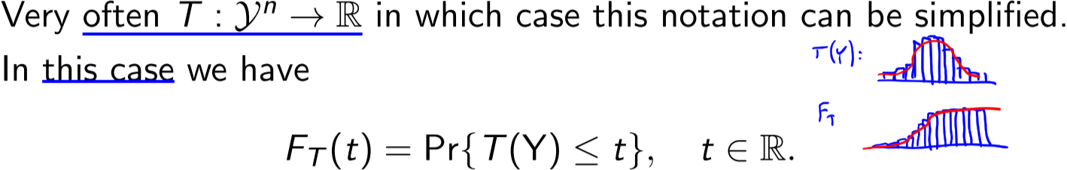

sampling distribution of T depends on the unknown θ but it can be computed from the data alone. The extent and form of this dependence is crucial for inference.

Any statistics T carries less information about θ than the original sample. So what’s a good statistic?

**Ancillary Statistics**: A statistic T is ancillary of θ if its distribution (CDF/CMF) does not functionally depend on θ

The **level sets** or **contours** of statistics T are all potential samples that could have given us the value t for T:



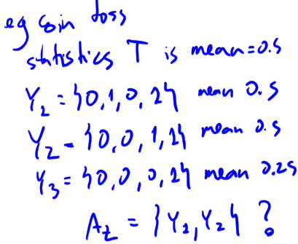

Any realization of Y that falls in a given level set is equivalent as far as T is concerned, as T reduces all these values to the same output. Any inference drawn through T will be the same within a given level set.

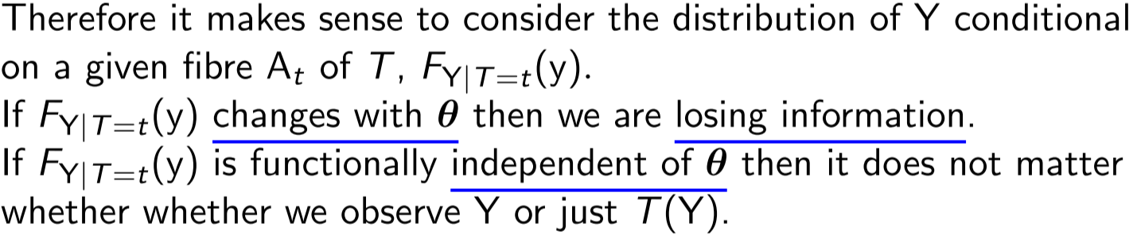

**Sufficient Statistics:** A Statistic T = T(Y) is said to be sufficient for the parameter θ if the conditional probability distribution of the sample given the statistic



does not depend on θ.

Sufficient statistics compress the data without information loss on the parameter of interest.

**Fisher–Neyman factorization theorem**: suppose that Y has a joint density or frequency function f(y; θ), where θ ∈ Θ. A Statistic T = T(Y) is sufficient for θ if and only if: (**sufficient statistics**)



**Lecture 4 – Sampling Theory**

**Minimally sufficient statistic**: A statistic T = T(Y) is said to be minimally sufficient for the parameter θ if it is sufficient for θ and for any other sufficient statistic S = S(Y) there exists a function g(·) with T(Y) = G(S(Y)). I.e. any other minimally sufficient statistic S(Y) can be transformed into T(Y).

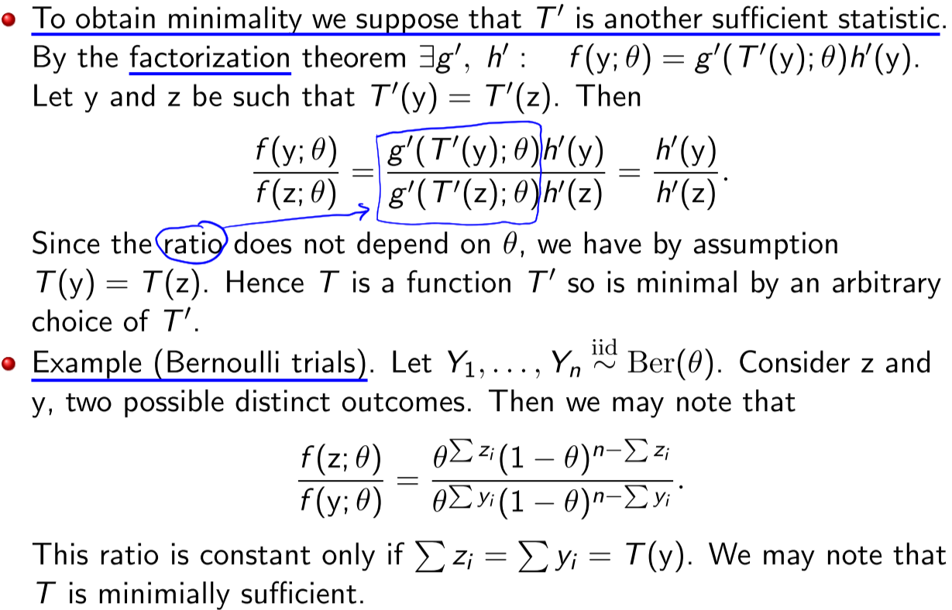

**Lecture 4 – Sampling Distributions**

**Random sample**

By studying sampling distributions we aim to determine what different information do different forms of T carry about θ.

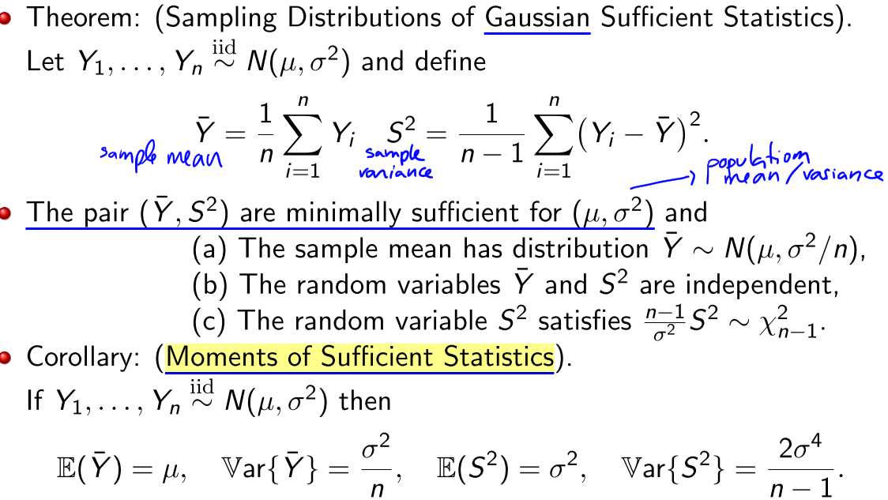

Theorem (Sum of Gaussian Squares) Let (Z1, . . . , Zk) be iid N(0, 1) random variables. Then

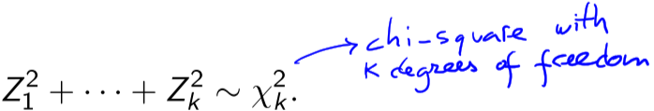

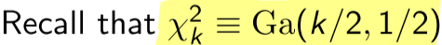

**Student’s statistic** and its sampling distribution (t-student with n-1 degrees of freedom)

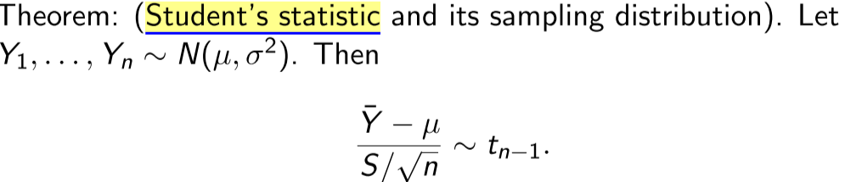

**Lecture 5**

**t-student** on k degrees of freedom

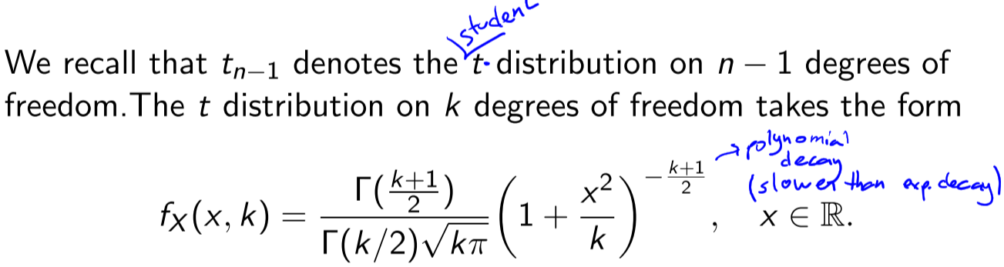

For k>2 : 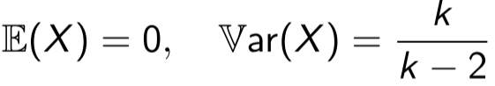

**Fisher F distribution**

(Reminder: Sum of squares of i.i.d normals minus their mean, is a chi-square distribution)

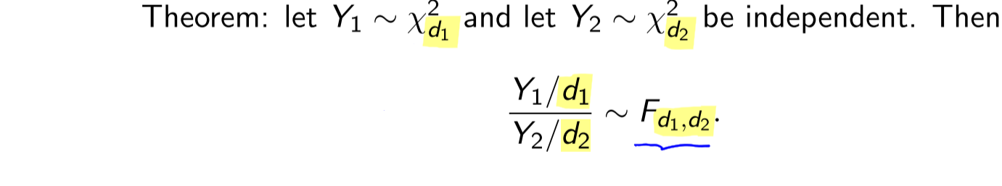

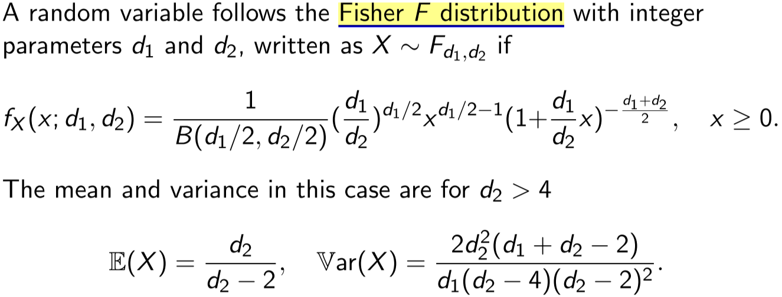

Theorem: **Sampling from an Exponential Family**

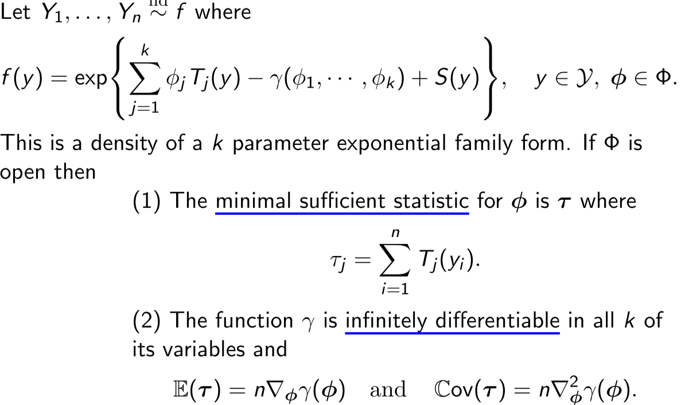

**Convergence in Distribution (Weak Convergence)**

* Converges to a **distribution eg poisson:**
* 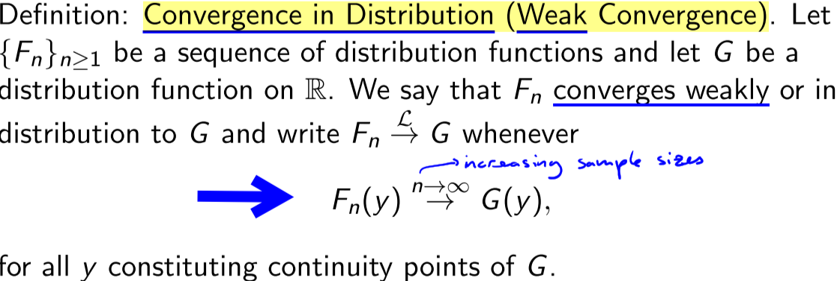

**Convergence in Probability**

Note: it converges in probability (from 0 to 1)

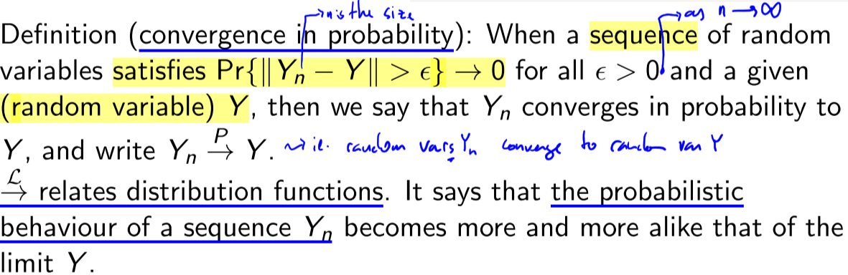

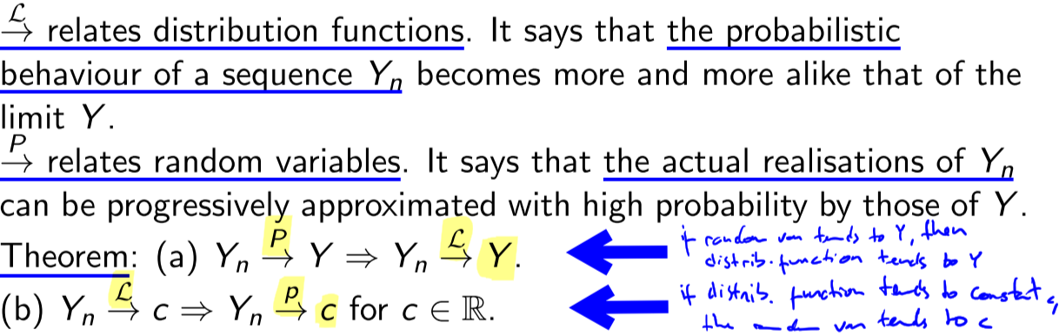

**The Continuous Mapping Theorem**



**Lecture 5 – Limiting Distributions**

A **Limiting Distribution** (also called an **asymptotic distribution**) is the hypothetical distribution — or convergence — of a sequence of distributions (eg after large n iterations)

**Slutsky Theorem**

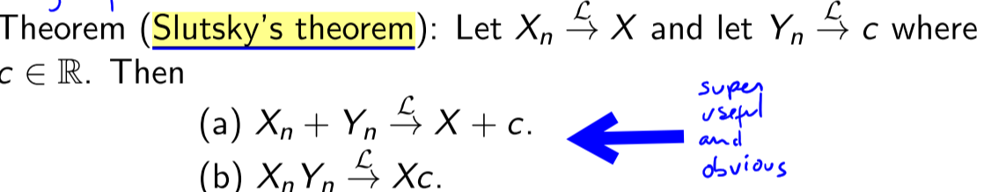

**Law of large numbers**

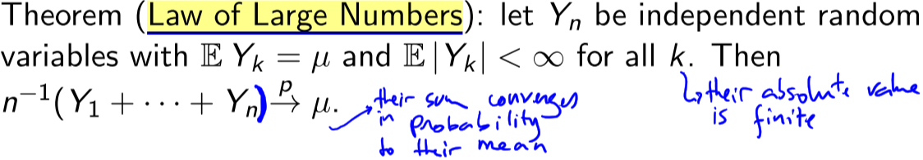

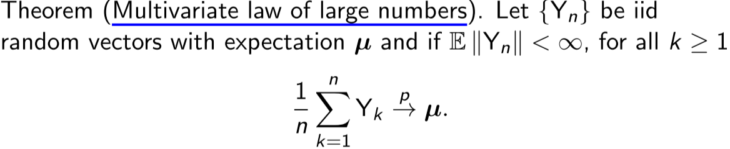

**Central Limit Theorem**

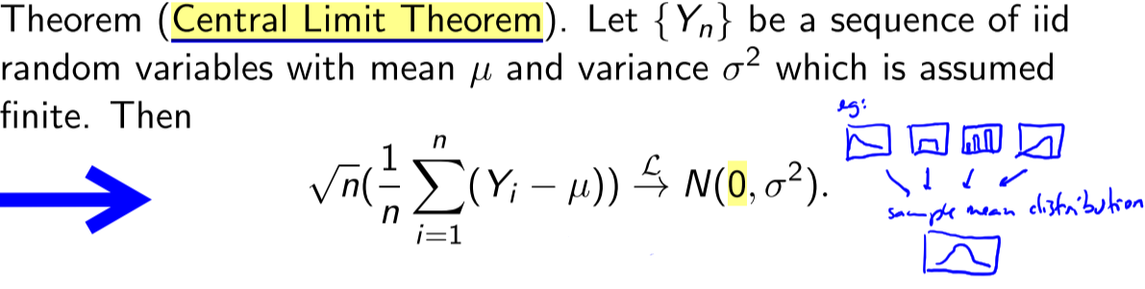

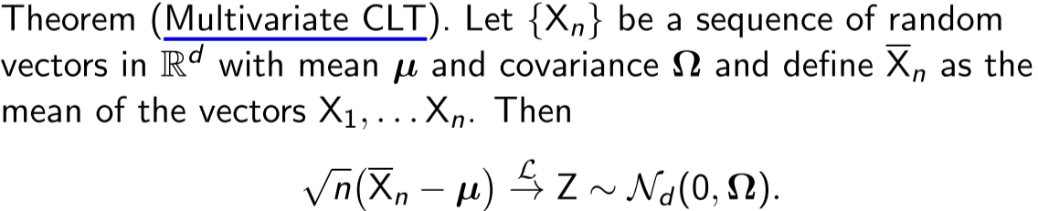

**Delta Method**

(a_n is a deterministic sequence)

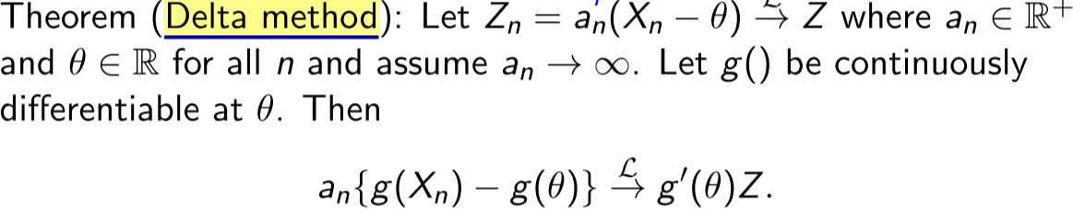

**Convergence in Distribution FOR VECTORS**

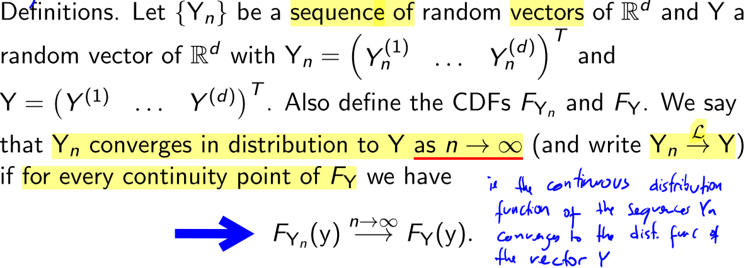

Convergence in probability also easily generalizes to the vector case

**Theorem Cramer–Wold Device** says it still holds if we multiply it by a vector:

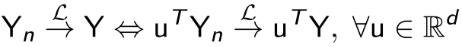

**Lecture 5 – Estimation**

Point estimation corresponds to producing a decent estimator of θ

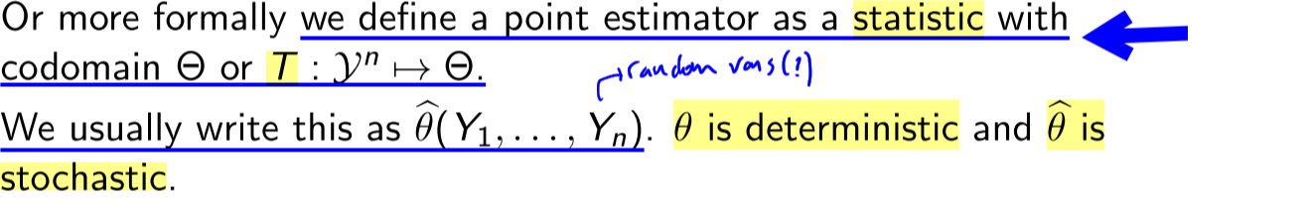

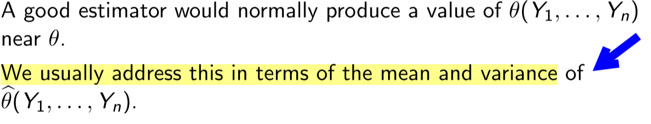

**Mean Square Error**

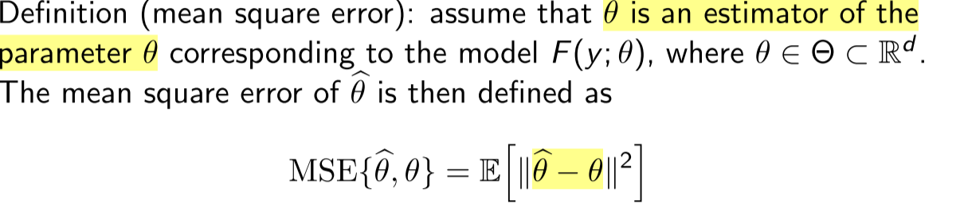 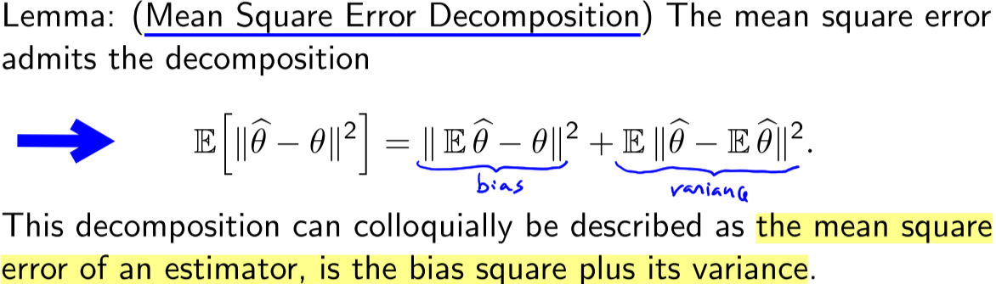`

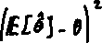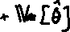

**MY NOTES -------------------------**

As estimatior with bias 0 is called **unbiased**. Bias is the diff between extimator’s expected value and the true value of the estimater being estimated.

To compare 2 estimators: compute variance and with that, check the MSE of both versus the original \theta. Take the ratio of both (ex 10.1.d)

To find EXPECTED VALUE and var of MLE estimator: break down until E[Y_i] term eg if bernoulli:

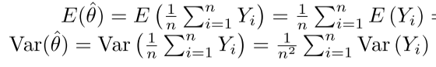

**Optimal value of estimator** is when MSE is minimum ie derivation MSE =0 and d’’ MSE >0 (to be unique)

**Expected Loss** of an estimator is the expected value of the loss function ie E[L (\theta, \theta hat)]

-------------------------------------

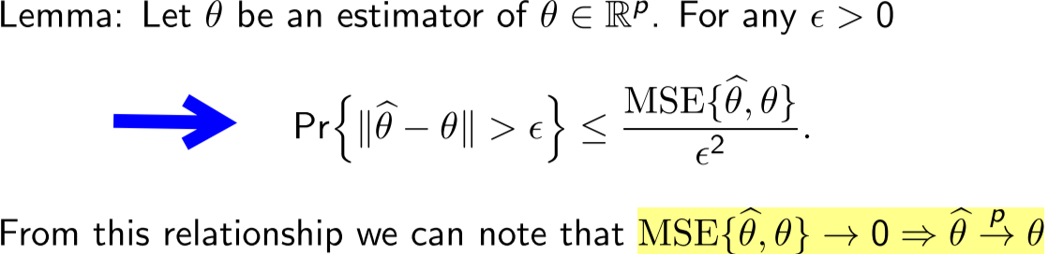

An **estimator is consistent** if it has this property**:**



**Model Identifiability**

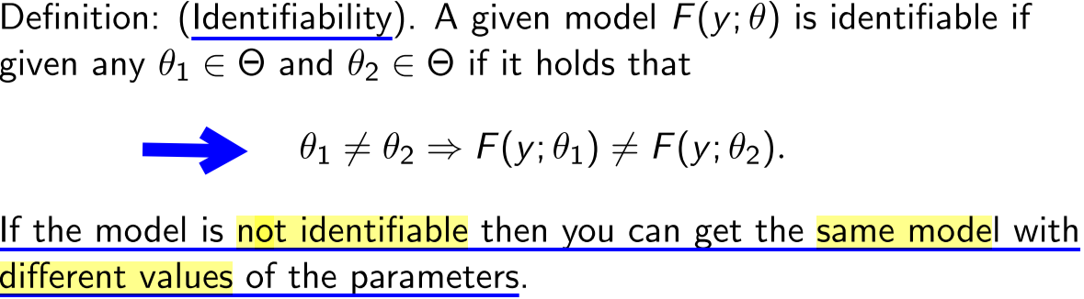

**Cauchy–Schwarz inequality**

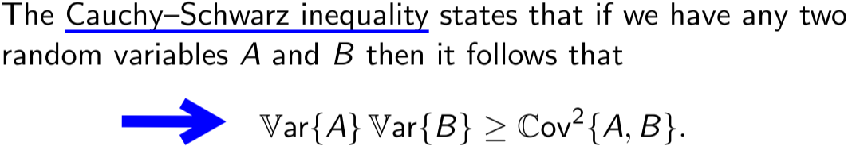

**The Fisher information**

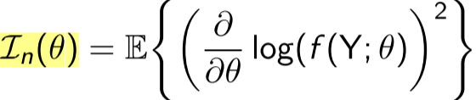 or 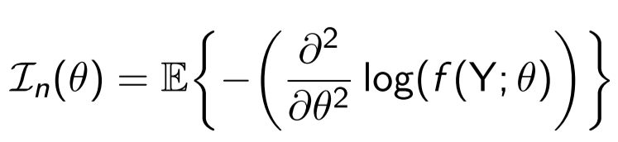

Then the **Cramer–Rao** lower bound on the variance of unbiased estimator θ^(y) states that

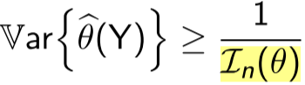

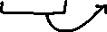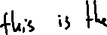

**Rao-Blackwell Theorem**

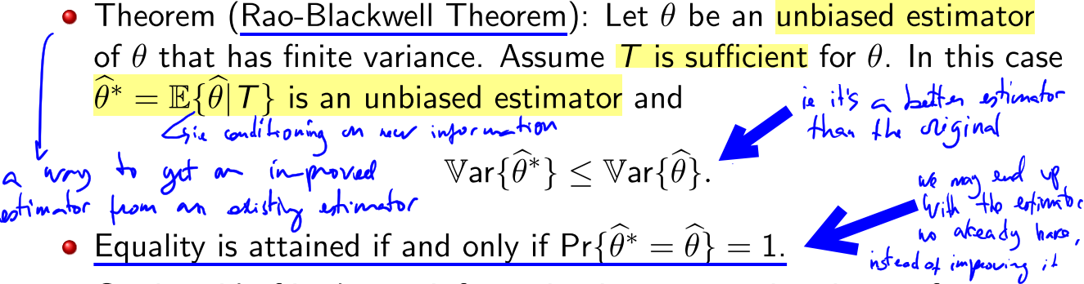



**Minimum Variance Unbiased Estimator(MVUE)**

2 ways to find it:

* Use the Cramer-Rao Lower Bound. This sets a lower bound for the variance. If you can find an estimator that meet this condition, you’ve found the MVUE.
  + Ie compute Var(\theta(Y)), compute In(\theta) and do \theta = …
* Find a sufficient statistic and then use the Rao-Blackwell theorem.

**Lecture 6**



**Lecture 6 – Maximum Likelihood Estimator**

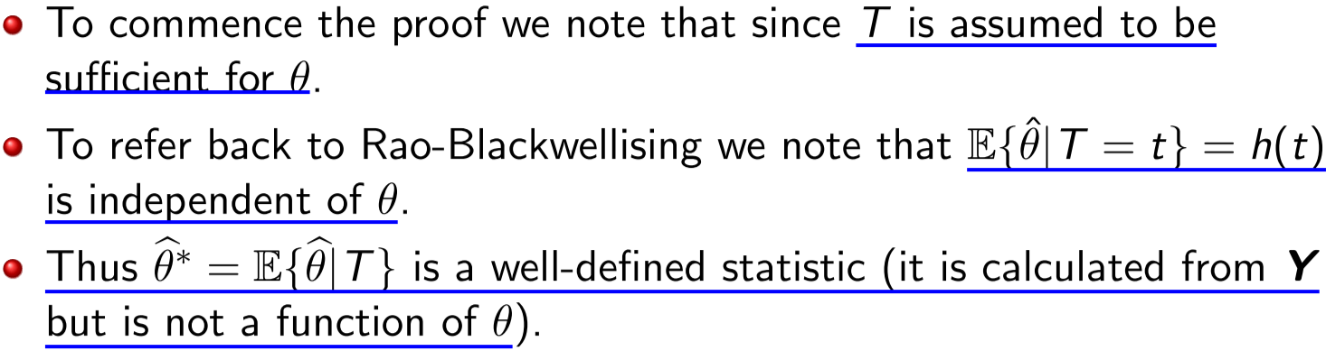

The MLE principle is to select a value of θ that makes the observations most likely.. How the probability varies as a function of θ or the model.

**Likelihood:**

It is is the joint density/frequency of the sample, but viewed as a function of θ. It is not the prob of θ.

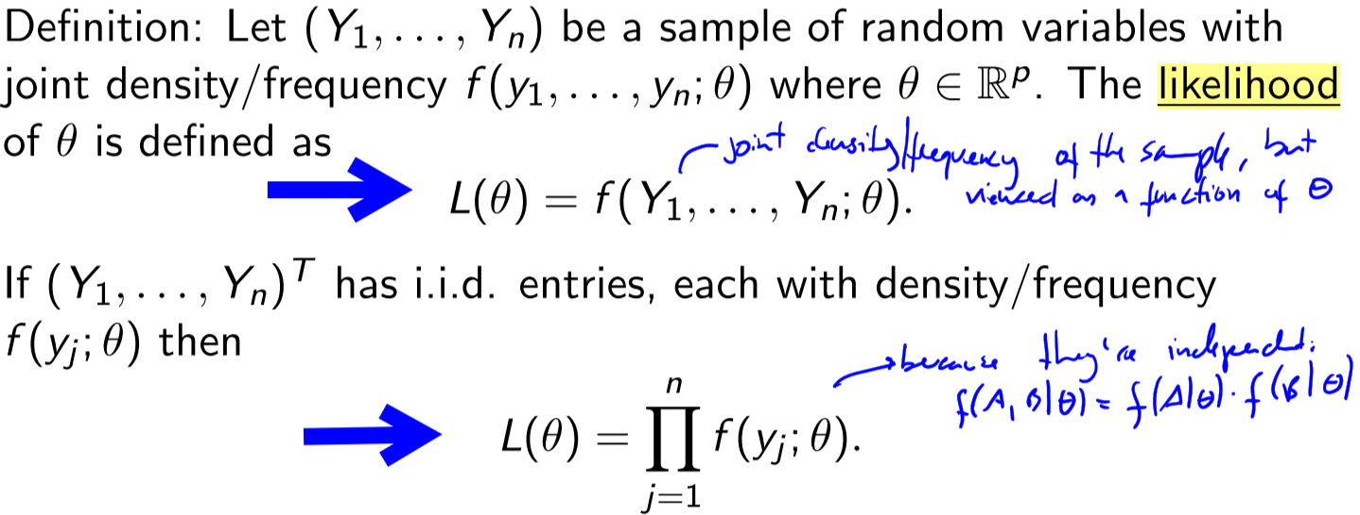

**MLE:**

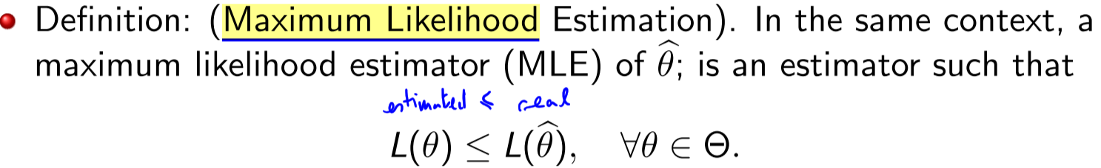



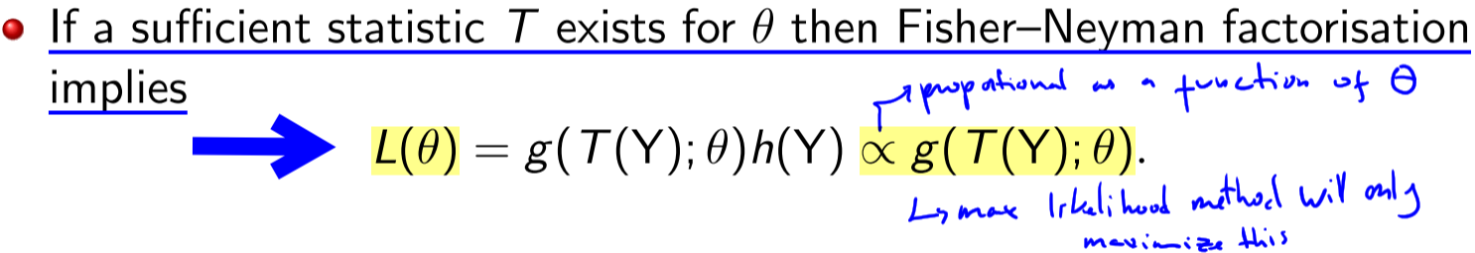

Any MLE depends on data only through a sufficient statistic. Since the sufficient statistic was arbitrary, if a minimally sufficient statistic exists, the MLE will have used an estimator that has achieved the maximal sufficient reduction of the data

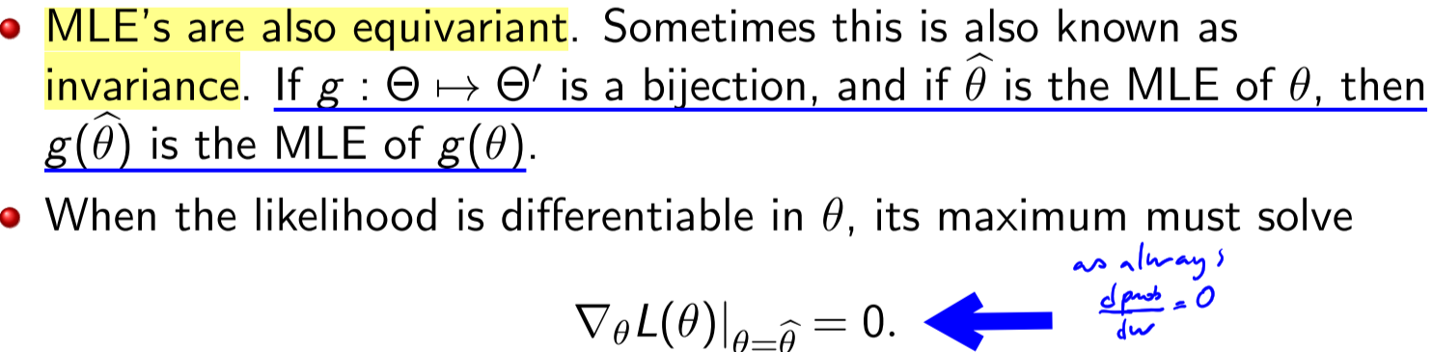

**Log-likelihood** of independent variables:

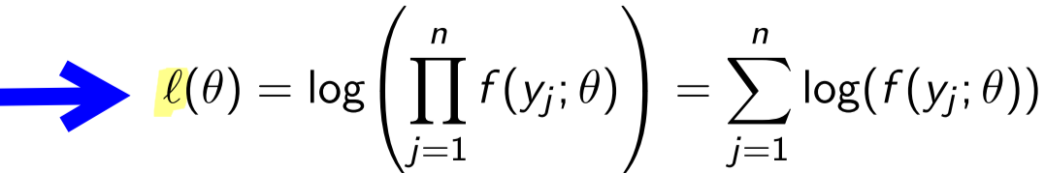

under twice differentiability, verification of a maximum can be checked again by whether or not



**Equi–variance or invariance of MLE**.

Invariance and equi-variance allows us to create new estimators that are also MLE estimator.

If g(θ) is a bijection, recall that if we are attempting to estimate τ = g(θ) . We can use the chain rule to determine… TODO OMMITED, slide 22-23

**MLE estimation from exponential family**

Assume that Y1, . . . ,Yn are all drawn from the distribution f which is specified by

We set φ as the natural parameter, and φ = η(θ) where φ is the usual parameter

Assume that η : Θ → Φ is a differentiable bijection



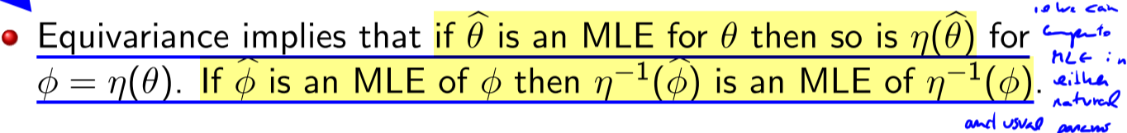

**Expected value and variance of estimator (my notes)**

If we find \theta^ = 123x, then we do E[\theta^] = \int theta^ 123x d\theta

**Lecture 7**

There is Consistency of MLE in θ ∈ R. Assuming we can get consistency, we can focus on understanding the sampling distribution of the MLE.

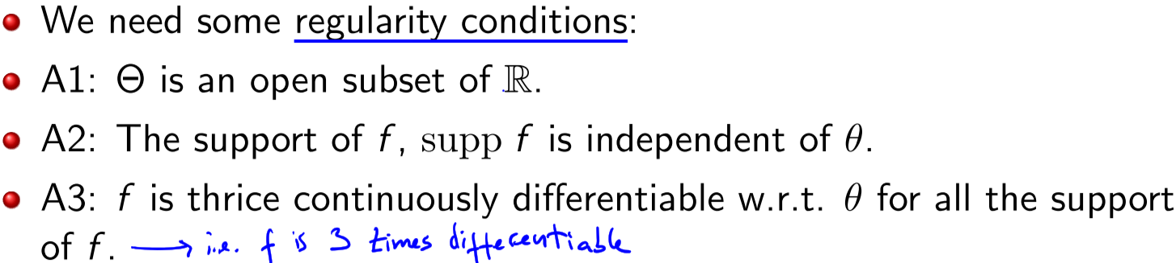

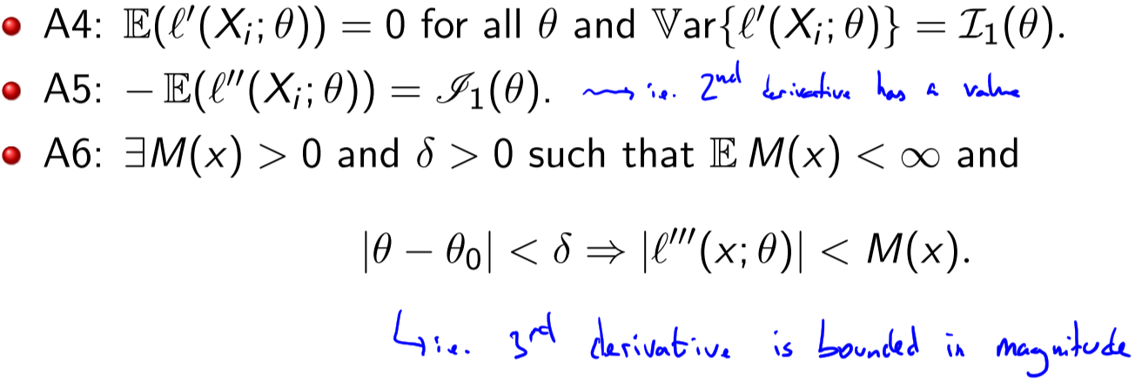

for large enough samples, the MLE is approximate Gaussian, approximately unbiased, and approximately achieving the Cramer–Rao lower bound.

Can we deduce from this result that maximum likelihood estimators are optimal? Well this is an asymptotic result, e.g. it holds eventually in n. For a fixed value of n things are less clear.

Also we have assumed that we are comparing unbiased estimatorswhat can be gained by relaxing this assumption?

**Shrinkage Estimator / Stein’s set-up**



This is not quite a “standard” problem as the number of parameters is growing with the sample size. The performance of the MLE deteriorates as n increases. Can we do better?

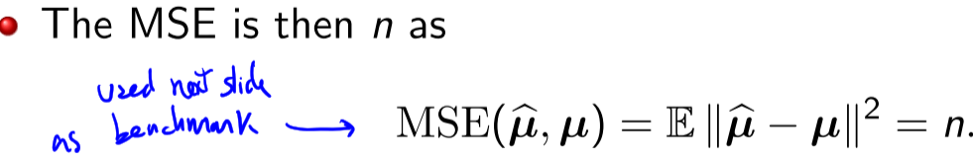

Goal of shrinkage estimator is to decrease variance. It performs MLE. The Stein estimator takes the MLE and “shrinks” its magnitude (norm or length).

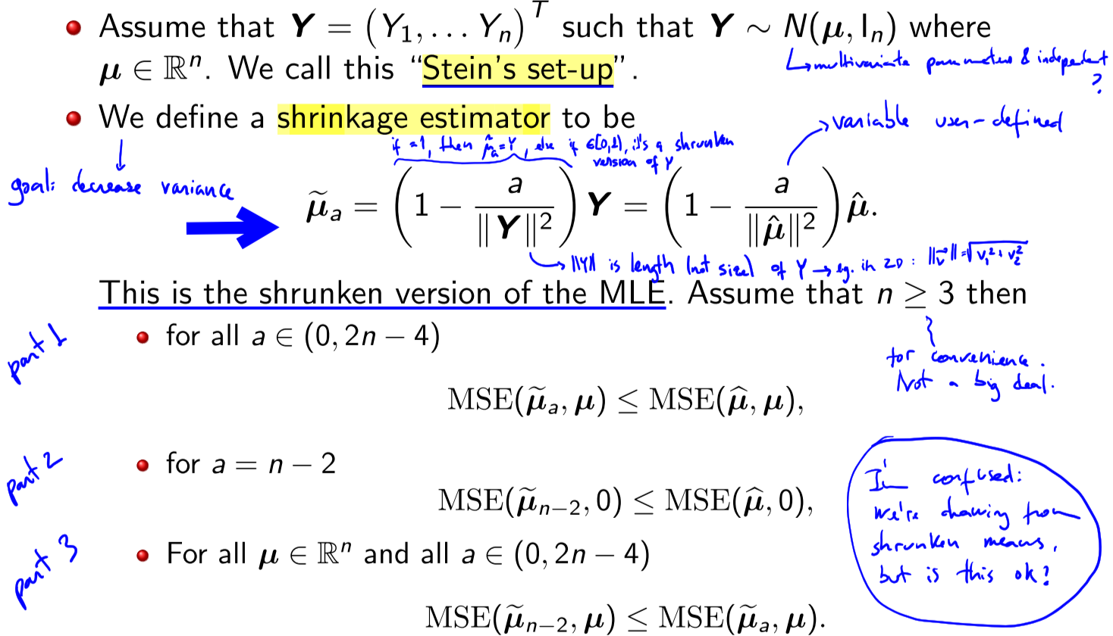

This estimate takes the estimate of µ_j into account when estimating µ_i

**Risk:**

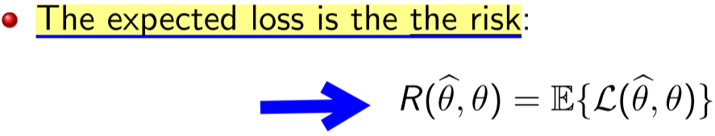

**Lecture 8 – Decision Theory**

decision theory views inference as a game between nature and the statistician. The decision theory framework formalises step 4 (of observing Y1…Yn to make asserting of true value of …) to include estimation, testing, and confidence intervals

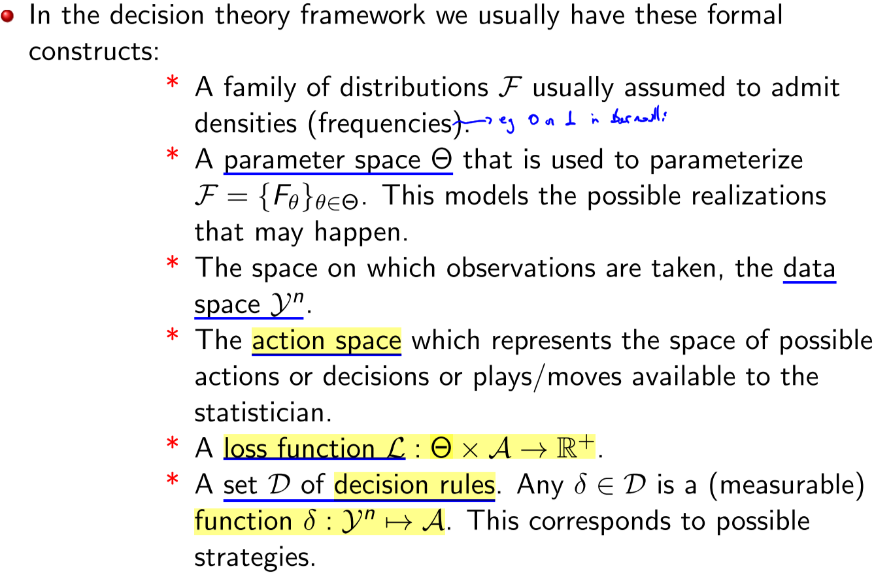

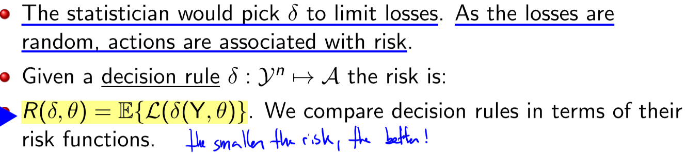

The statistician would pick a decision rule δ to limit losses.

Risk is not uniform, but depends on θ the true state of nature. So we can compare risks with

* Uniform comparison (hard), seek dominance everywhere in θ
* Minimax (relaxed, conservative). Compare worst-case risks over θ
* Bayes (relaxed). Compare average risk over θ
  + quite attractive as they can nearly never be uniformly dominated

**Lecture 8 – Hypothesis testing**

**Hypothesis testing**

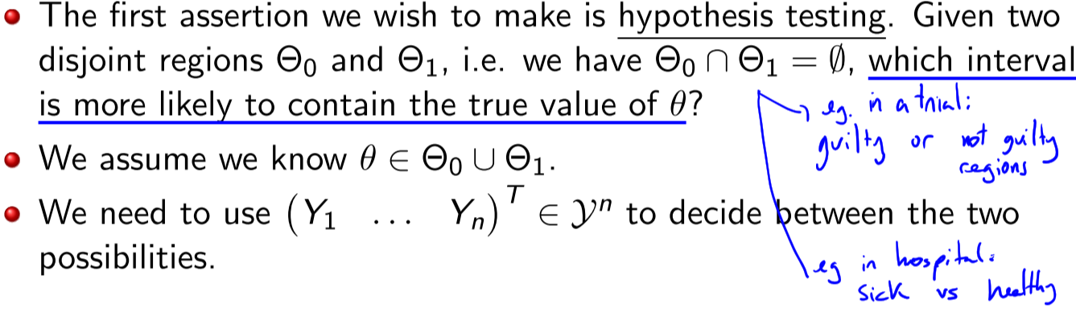

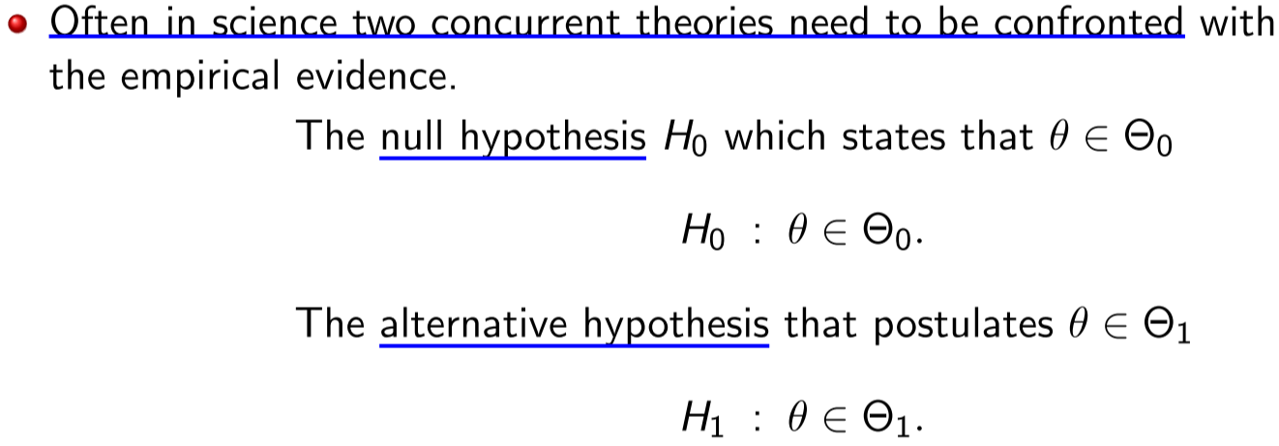

**Test Function**

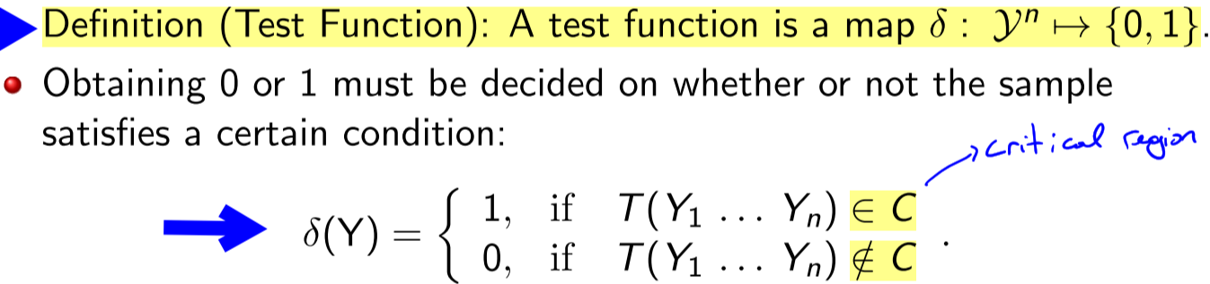

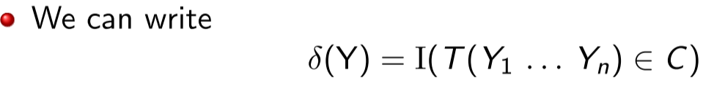

T is a statistic called a **test statistic** and

C is a subset of the range of T and is called the **critical region**

δ has a Bernoulli distribution. So a good test function must have a sampling distribution concentrated around the right decision

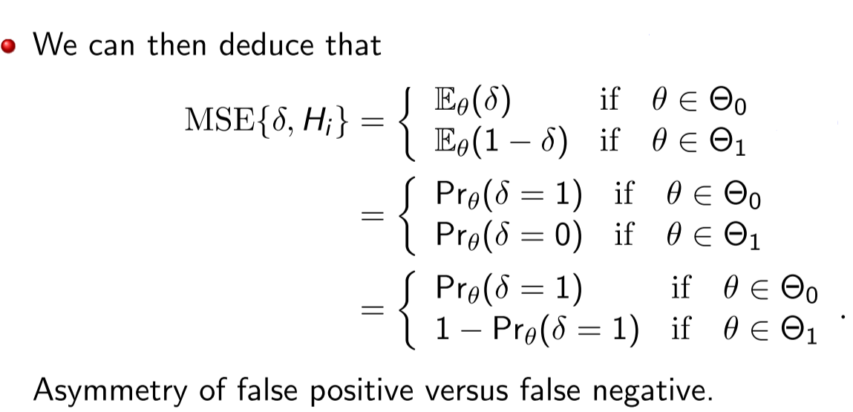

the **action space** is A = {0, 1} and the loss function is the so-called **“0-1” loss**

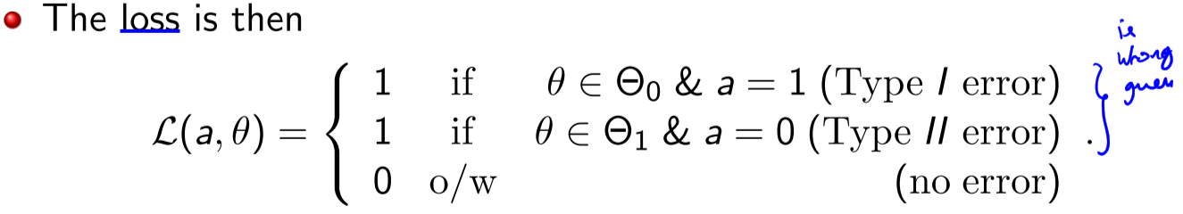



Can we simultaneously control both errors??? NO:

* Suppose we wish to reduce the type I error probability
* To do that we replace the critical region C by a subset of it.
* By reducing the type I error probability we increased the type II error probability.

Consider only test functions that respect it, and focus on minimising type II error (i.e. maximising power)

**Neyman-Pearson Framework / significance level (alpha)**

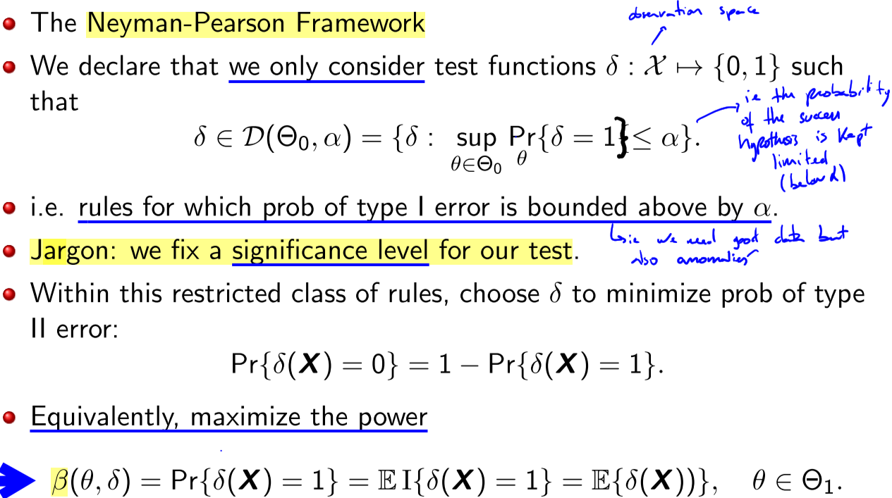

**Lecture 9**

**Neyman-Pearson Lemma / Most Powerful (MP) test**:

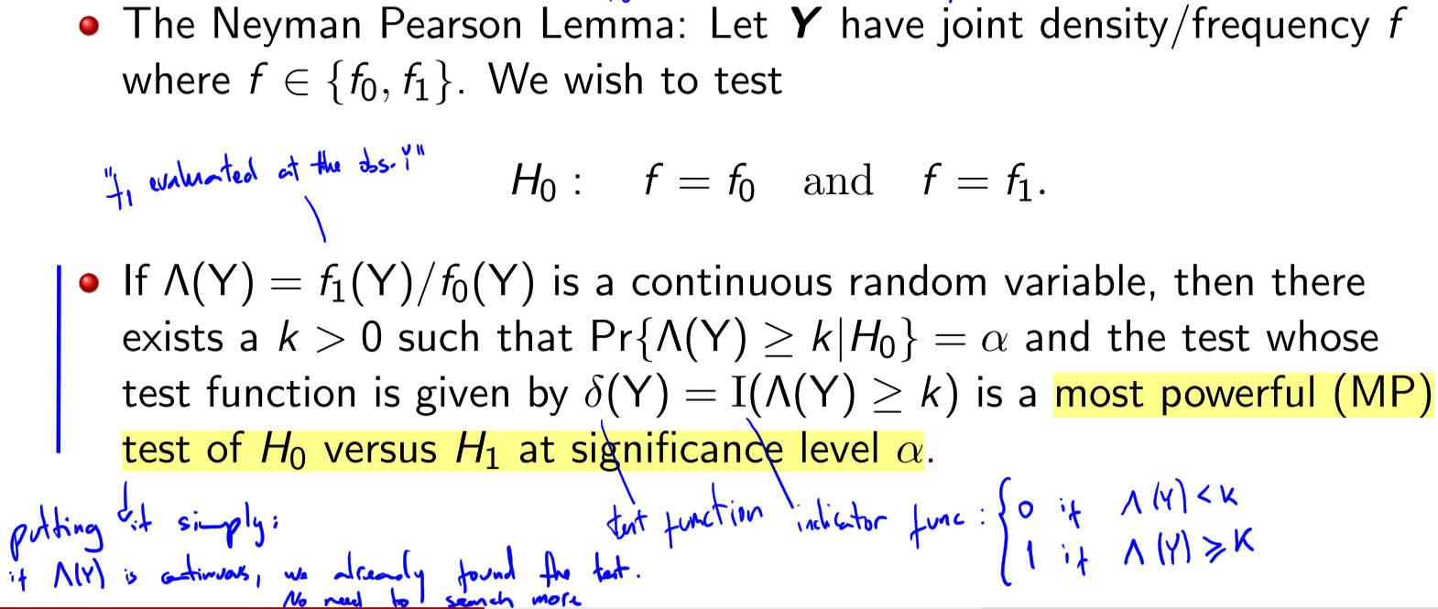

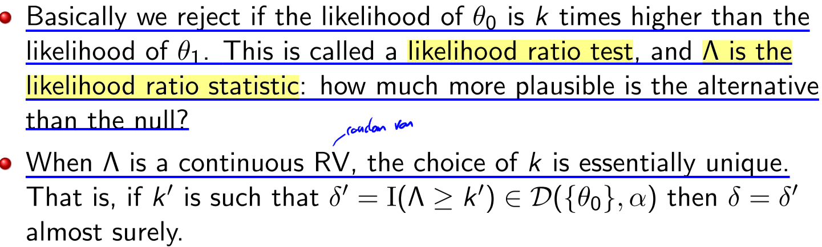

When Λ is a continuous RV, the choice of k is essentially unique. The resulting most powerful test is not necessarily unique. Unless Λ is continuous, the most powerful test is not necessarily guaranteed to exist.

**Monotone Likelihood Ratio**

When Θ0 is in the form of an interval (−∞, θ0] or [θ0,∞) and Θ1 is its complement, then there are often uniformly most powerful tests depending on the underlying model

For example, in one-parameter exponential families, one simply uses the Neyman-Pearson lemma, taking the null to be θ = θ0 and an alternative of θ = θ1 for any θ1 ∈ Θ1. The form of the test depends only on the direction of the null and the boundary of the null. This generalises to families admitting a so-called “monotone likelihood ratio”. In the absence of the “monotone likelihood ratio” property, one can seek locally most powerful tests, near the hypothesis boundary.

**Likelihood Ratio (statistic?)**

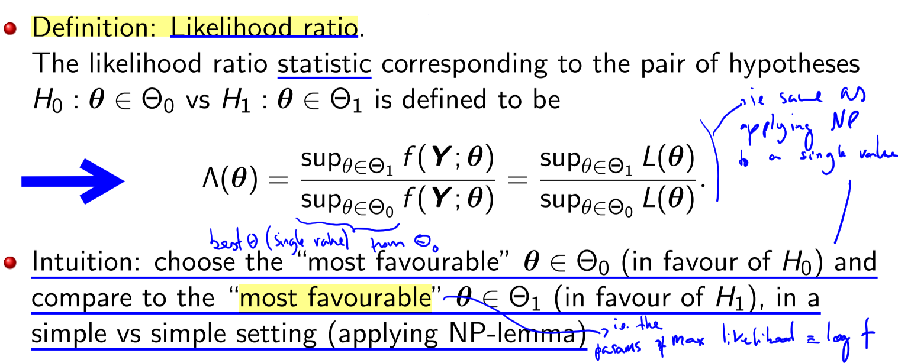

So reject when Λ > k where k is found from the null distribution

**Lecture 10 – Wilk’s Theorem**

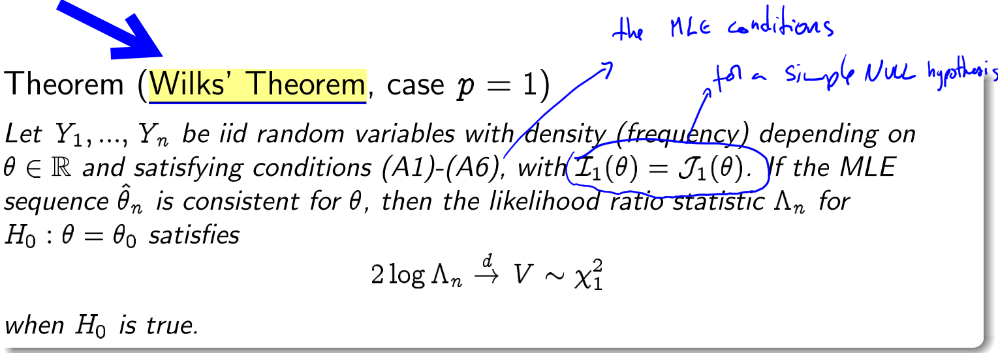

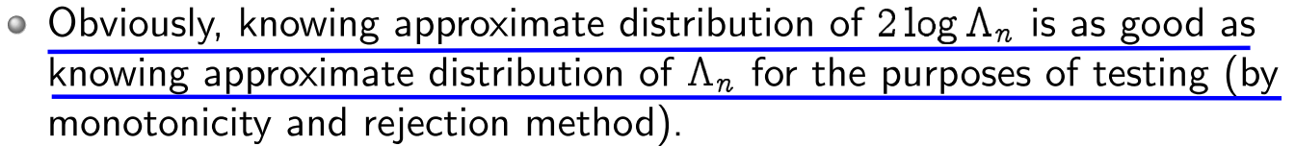

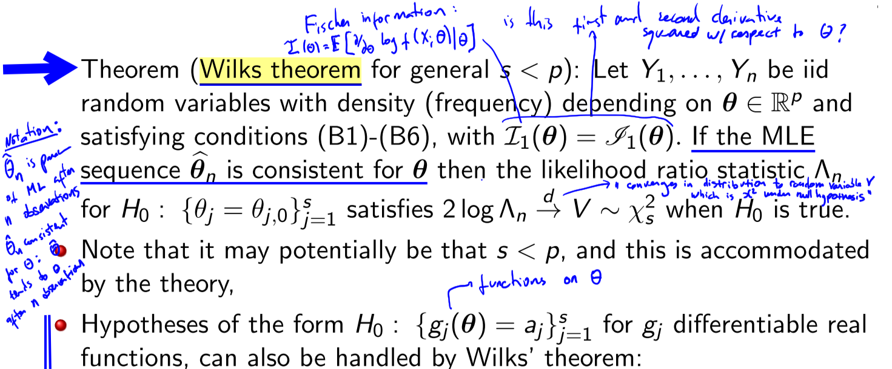

**Lecture 10 – The infamous p-value**

Wiki: a **p-value** or **significance level** is a measure of the probability that an observed difference could have occurred just by random chance. The lower the p-value, the greater the statistical significance of the observed difference. For example, a p value of 0.0254 is 2.54%. This means there is a 2.54% chance your results could be random (i.e. happened by chance).

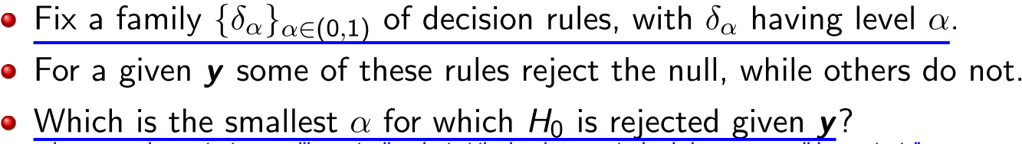

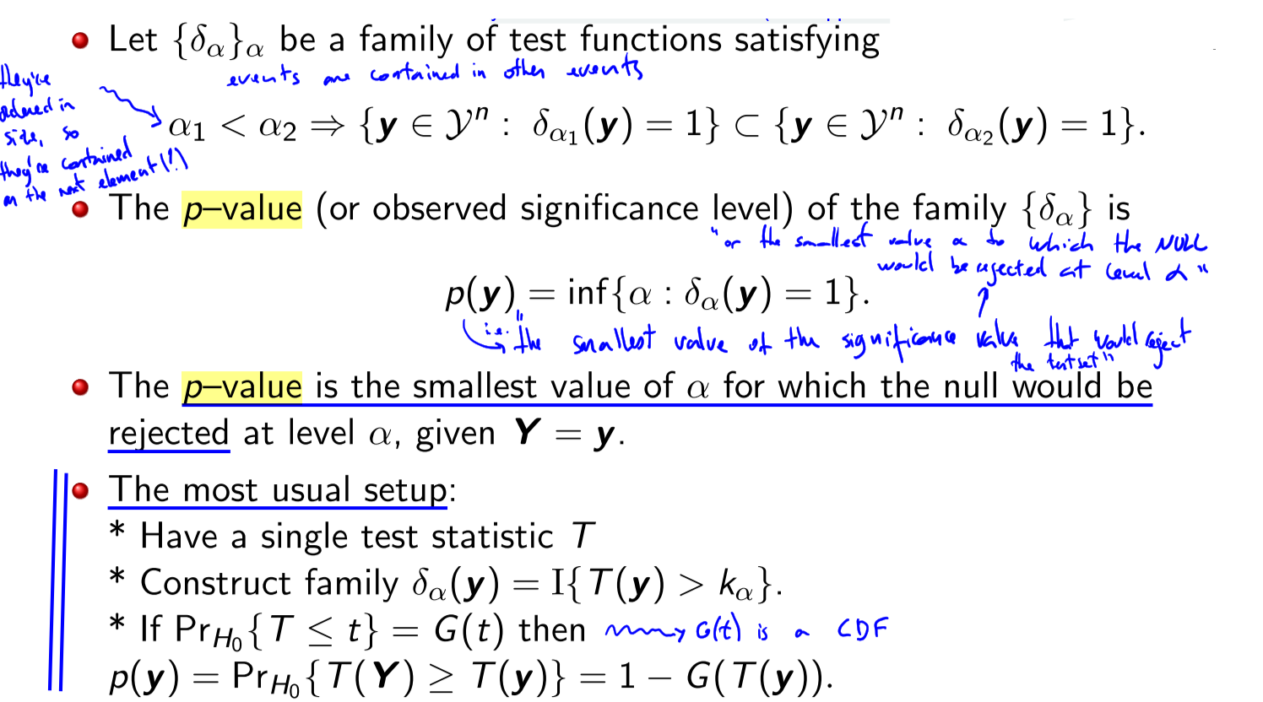

contrary to Neyman Pearson-framework did not make explicit decision! (in NPF we reject of not the null hypothesis). Here we simply give a quantitative measurement (a p-value).

Small p–value provides evidence against H0 i.e. it’s highly significant. Large p–value provides no evidence against H0. A small p–value can simply reflect our “confidence” in rejecting a null.

**Lecture 10 – Interval Estimation**

**Confidence Interval, Coverage Probability, Confidence Level**

a confidence interval (CI) is a type of estimate computed from the statistics of the observed data. This proposes a range of plausible values for an unknown parameter (for example, the mean). The interval has an associated confidence level that the true parameter is in the proposed range. The confidence level is chosen by the investigator.

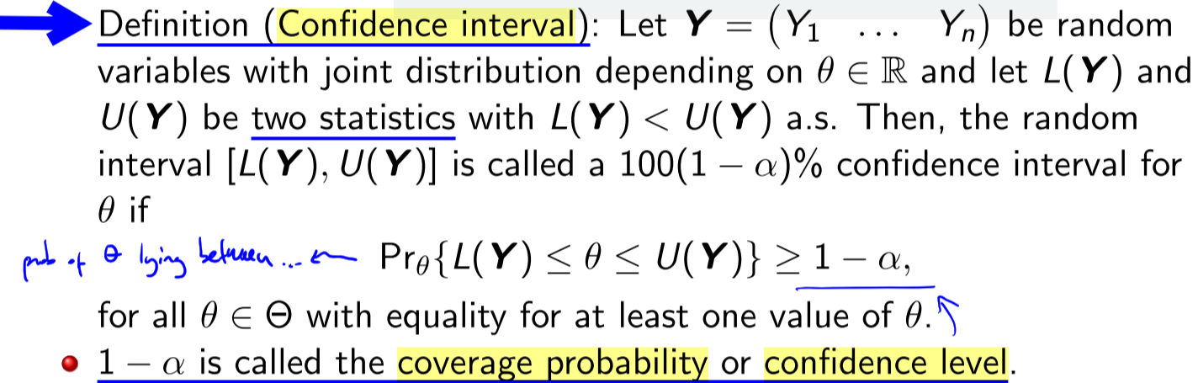

Statement is about interval: probability that the interval contains the true value is at least 1 – α

One of those rules that people just know: 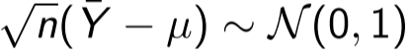

**Pivot**

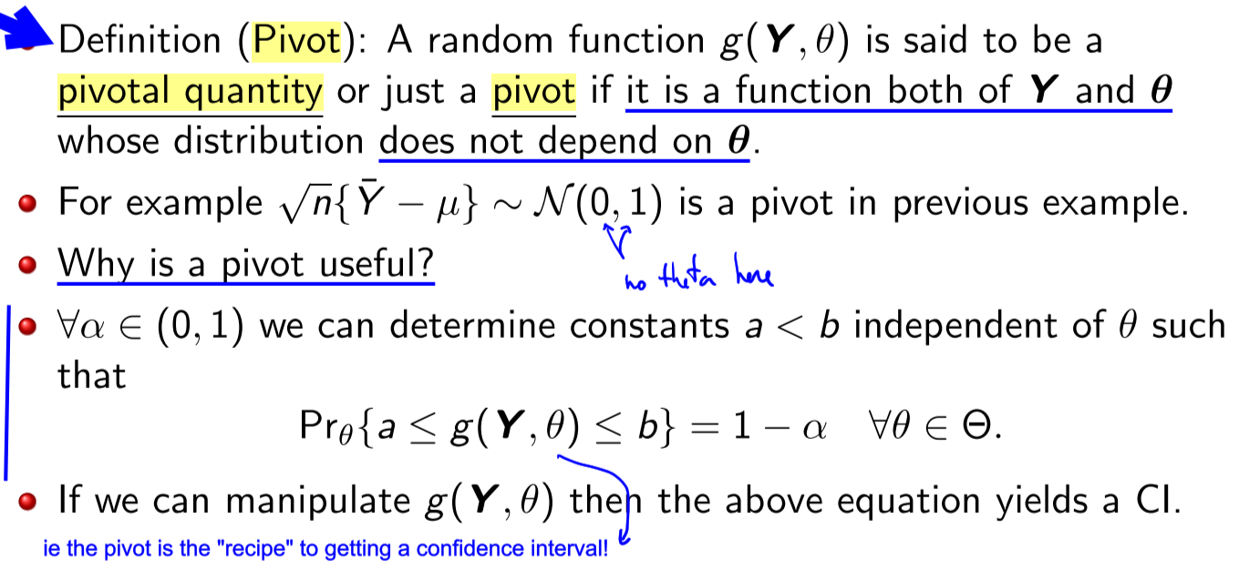

See examples in slide 14

**Confidence Region** for higher dimensional parameters of interest:

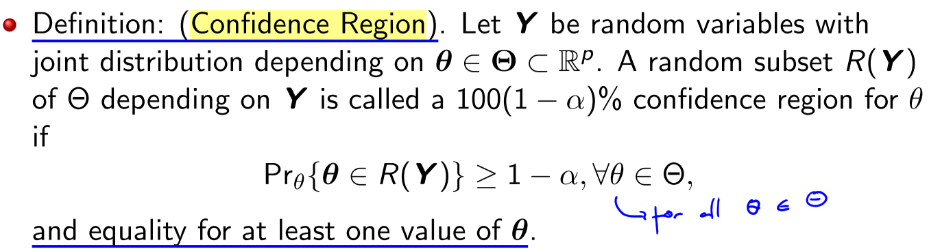

**Lecture 11 – More Testing**

From before:

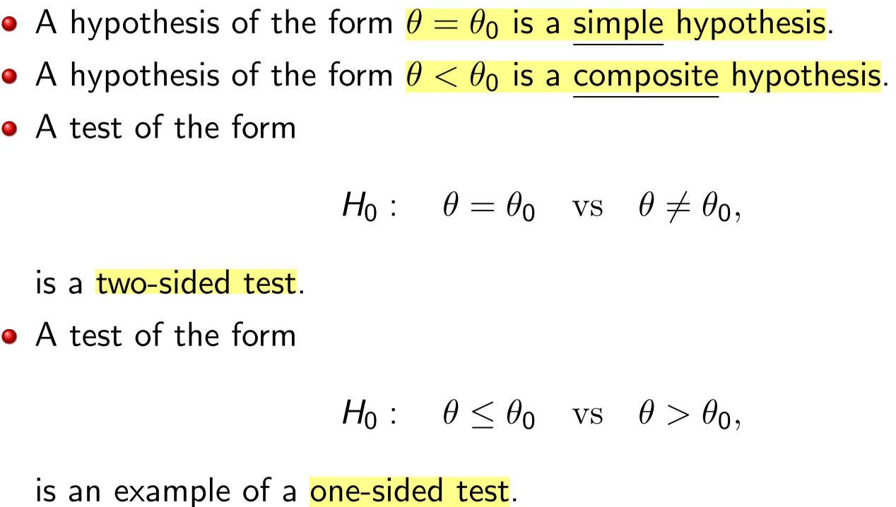

**Side of test, power function:**

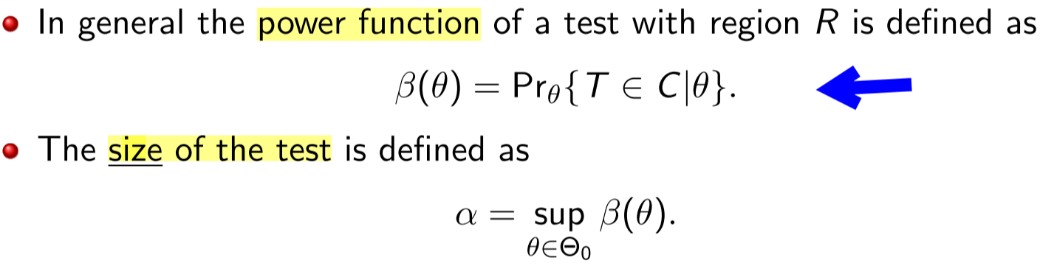

**The Wald test of size alpha:**

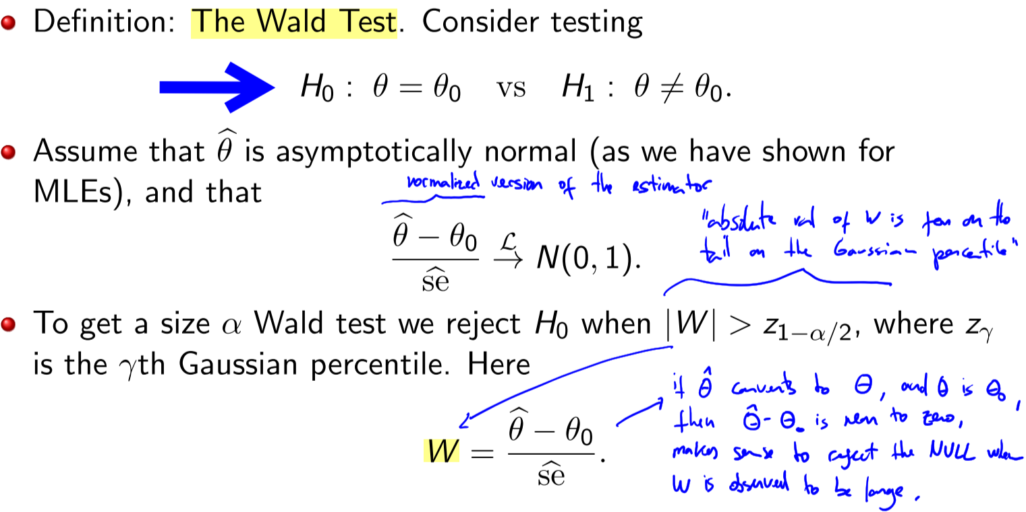

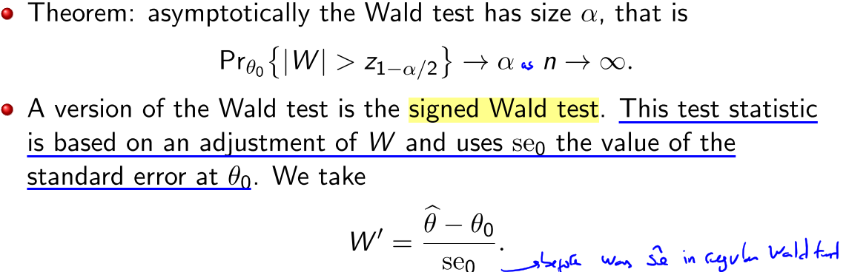

Note: standard error: 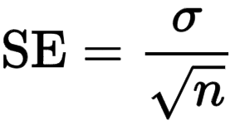

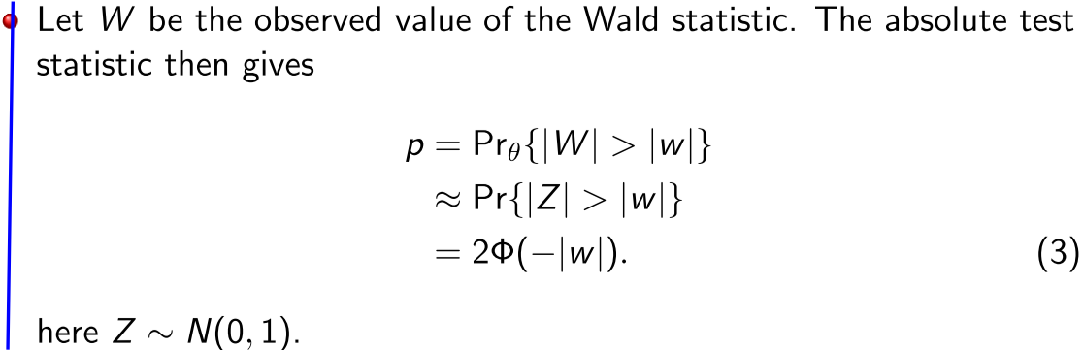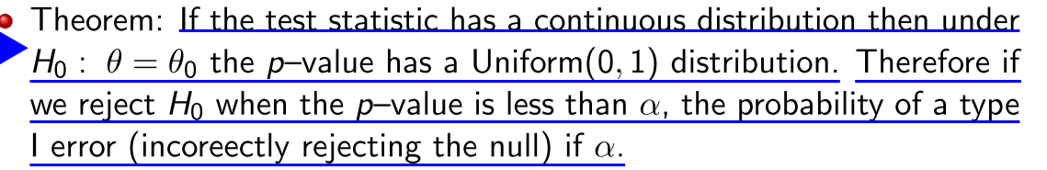

Or when H0 is true, the p–value is like a random variable drawn from a U(0, 1) distribution

TODO see exercise solved on slide 11

**Lecture 11 – Multiple Testing**

Consider the m hypothesis testing:

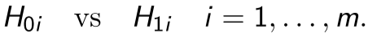

To make these tests simultaneously: the bonferri method (slide 13) or The Benjamini–Hochberg Method (slide 15) or Holm’s procedure (slide 17)

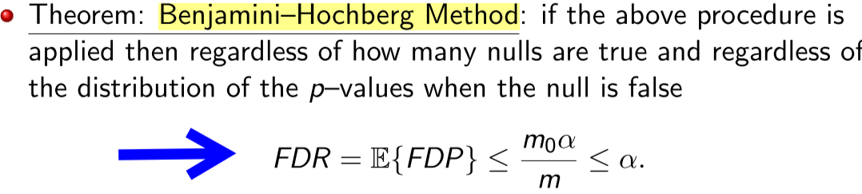

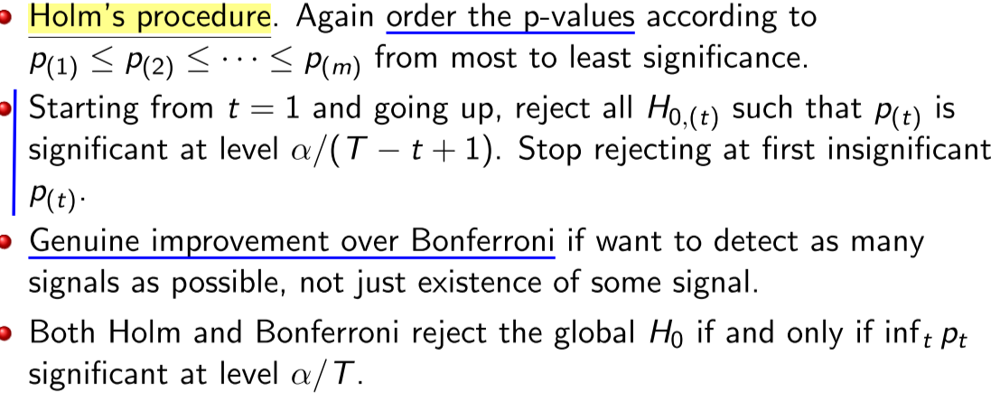

**Lecture 11 – Non-Parametric Testing**

Can we estimate the distribution F itself from the data without assuming a parametric form? Termed nonparametric estimation as there is no specific parameter θ.

**Empirical Distribution Function**

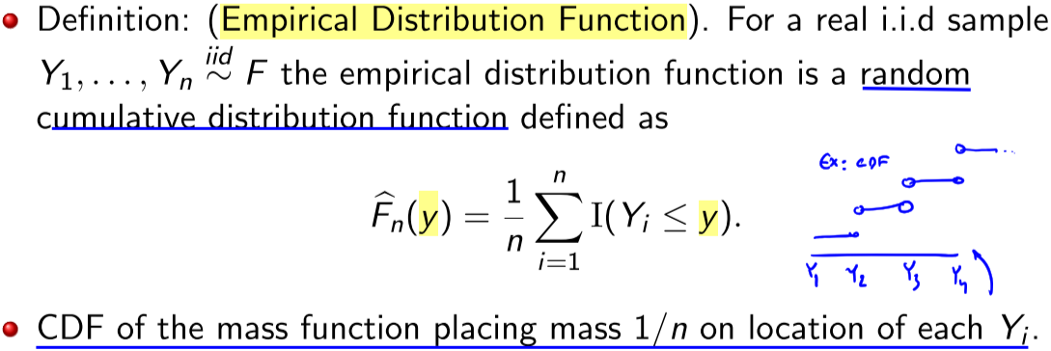

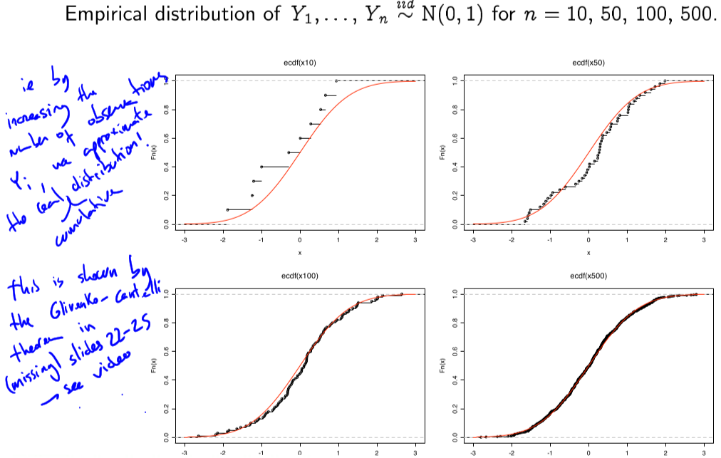

**Glivenko-Cantelli Theorem**

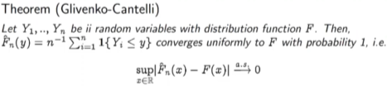

**Lecture 12**

If we’d still like to estimate a parameter, can use the plug-in principle , eg

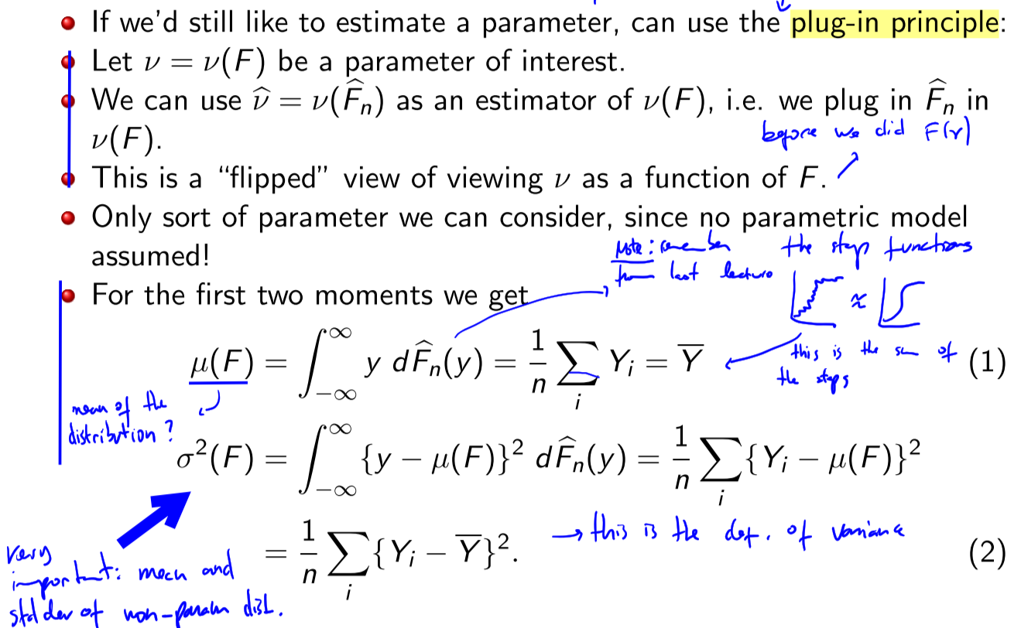

Computing densities (PDF) as before it is easy, now we work on Distributions CDFs:

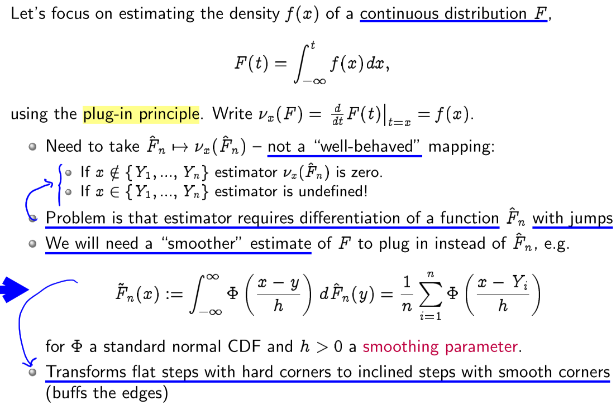

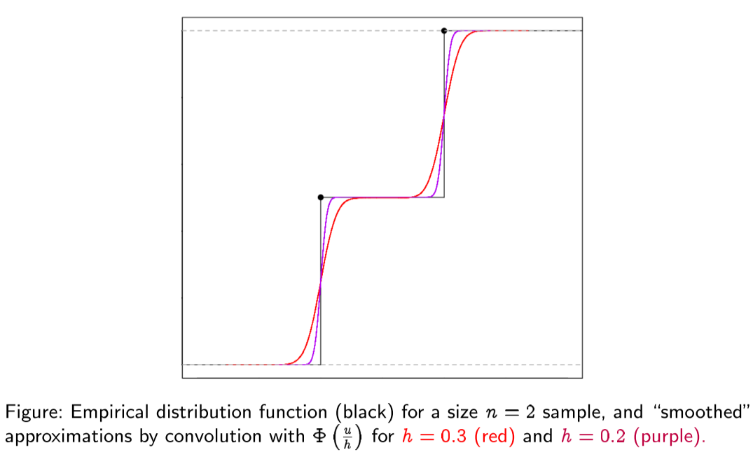

At the level of density, this yields the smoothed plug-in estimator.

**Kernel Density Estimator, KDE** (follows from before)

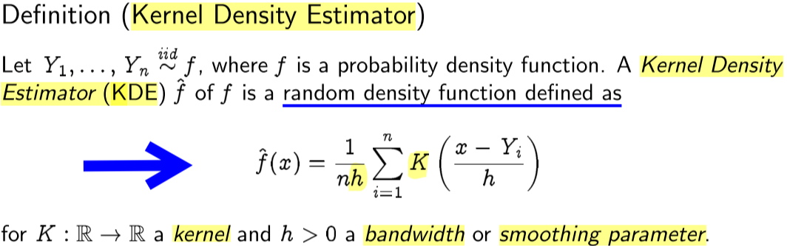

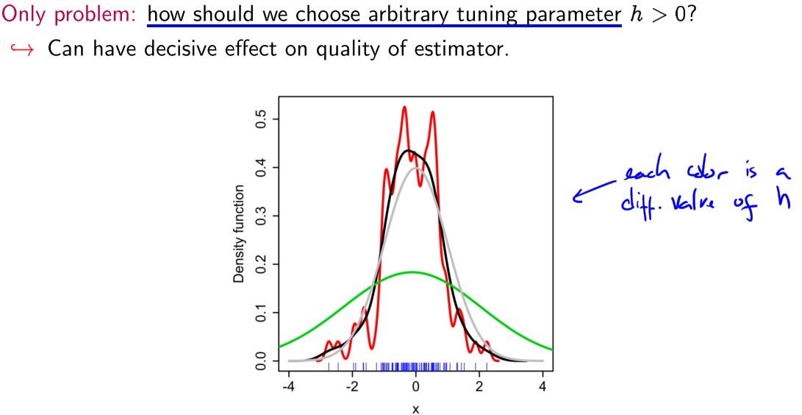

Large h: flattened estimator, higher bias, low variance.

Small h: wiggly estimator, lower bias, high variance

Bias as variance correspond to the values on integrated mean square error:

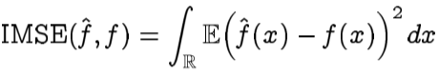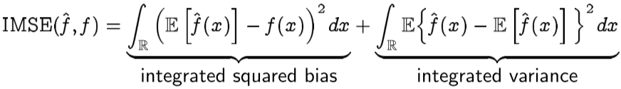

To choose h in practice: **Least-squares cross-validation** or **unbiased risk estimation**

try to construct an unbiased estimator of the IMSE after all, it is an expectation. Then choose to minimise the estimated IMSE. So we include *only* the bias in the IMSE below:

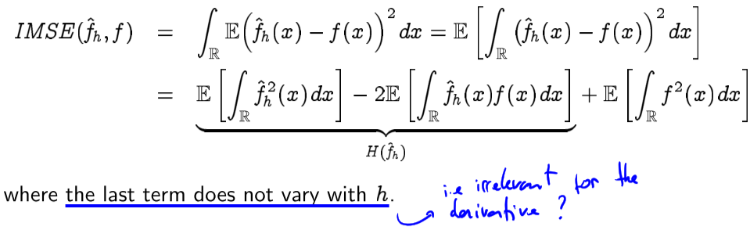

Strategy: choose h by minimising LSCV(n) aka “leave-one-out” (slides ??-18)

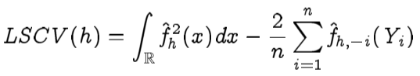

Which satisfies 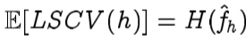

**Multidimensional kernel**

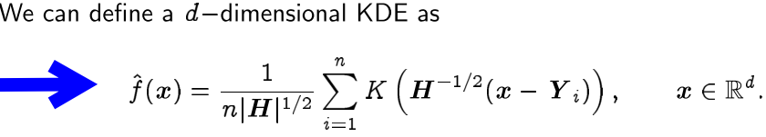

**Lecture 12 – Bayesian Statistics**

 and 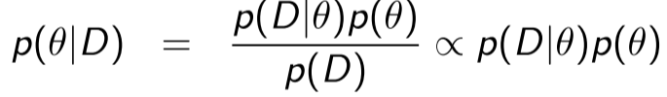

where D = (X1, . . . , Xn) and p(·) is either a pmf or pdf

p(D) is not a function of θ and is given by (marginalizing): 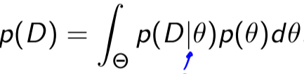

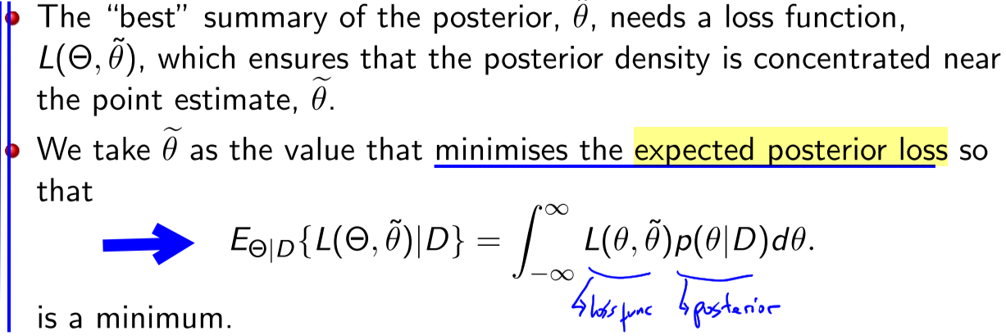

**Expected Posterior Loss**

We may want an interval which will contain Θ with probability that include the most concentrated areas of p(θ|D). We can do this by determining the **100γ% credible interval** which is an interval which contains 100γ% of the total density in the posterior distribution.

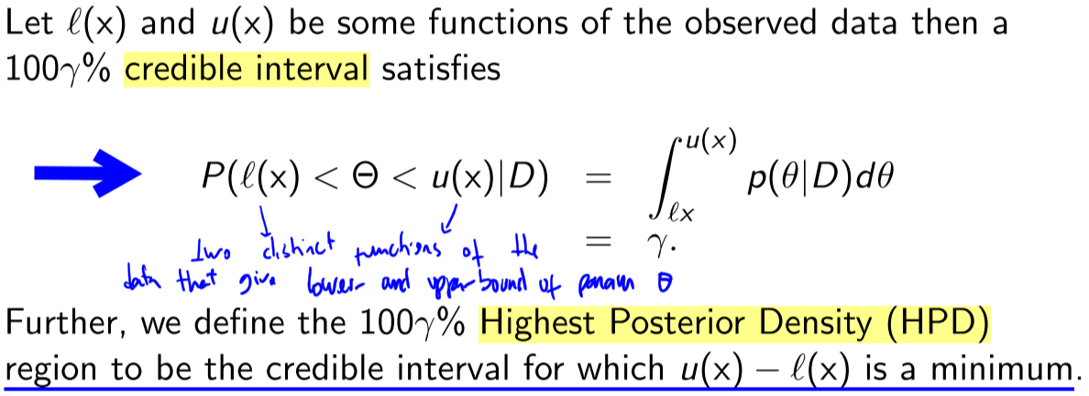

* NOTE: it’s the integral over the posterior!!!

Example (reminder):

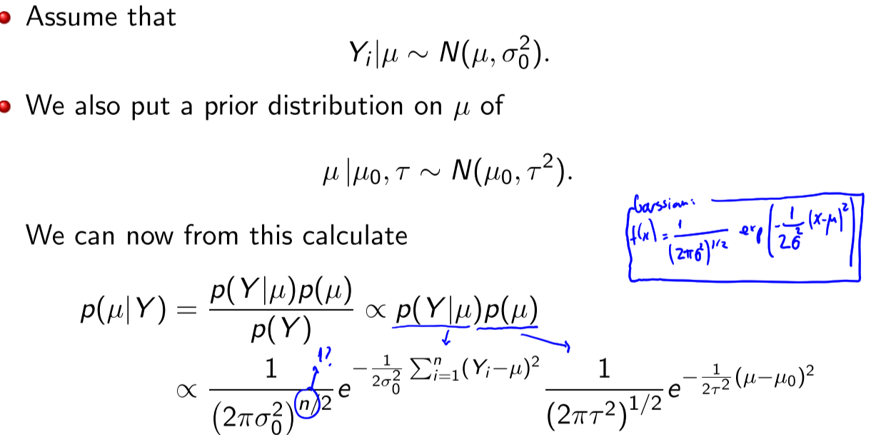

**Lecture 13 – Linear Regression**

**Linear model** notation

* E [ Y ] = X \beta
* X is the design matrix
* Beta is the parameter vector
* We will assume p ≤ n (full rank)
  + Rank = number of linearly independent columns

We assumer second-order assumptions : var(Y) = σ^2 In (ie diagonal matrix), uncorrelated Yis

**Noise**: 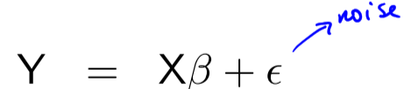

where E(noise) = 0 and var(noise) = σ2In.

**Residual Sum of squares**

the residual sum of squares (RSS), also known as the sum of squared residuals (SSR) or the sum of squared estimate of errors (SSE), is the sum of the squares of residuals. Find beta that minimizes

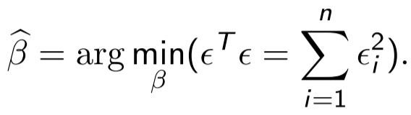

The **Least Square Estimate (LSE)** is the θ = Xβ that minimizes ||Y − θ||^2

* Closed form solution if X^TX is invertible: 

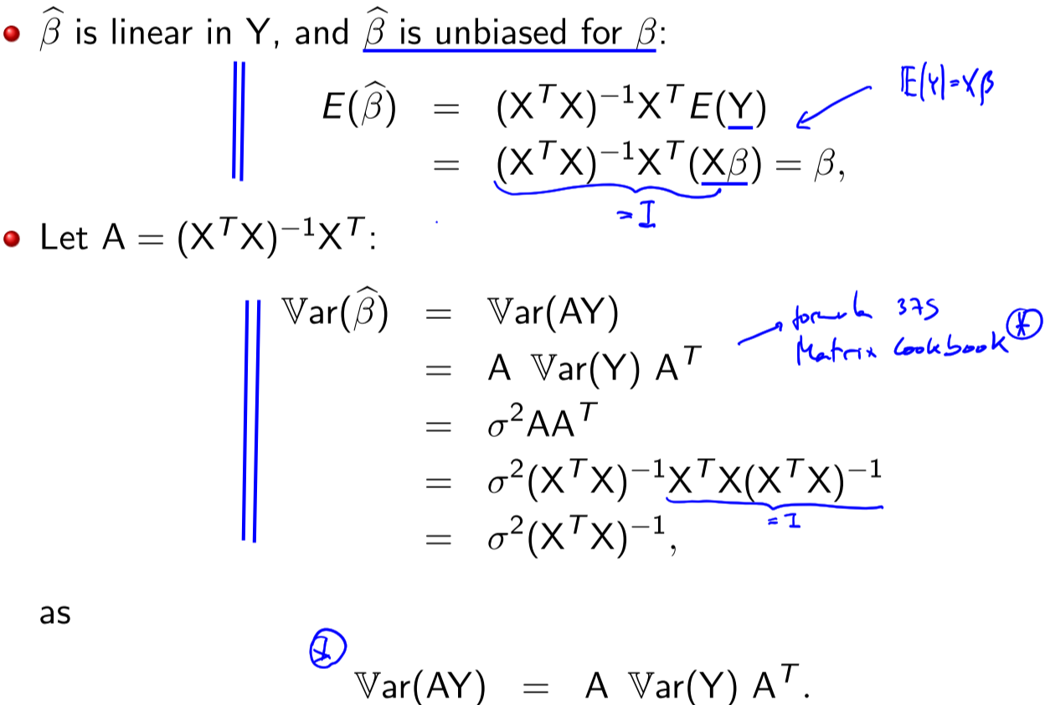

Adding bias term, to compute 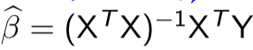:

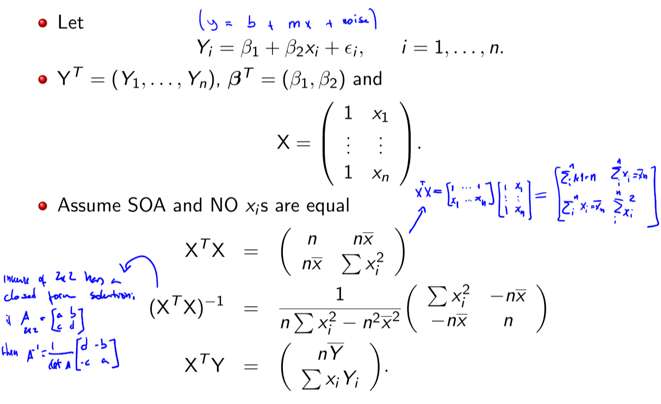

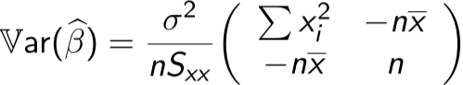

The **residuals** of the model are given by the difference between the observed and fitted values so that:

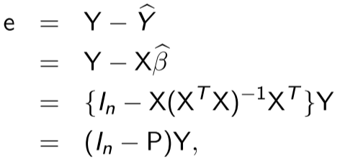

P = X(XTX)−1XT is known as the **hat matrix** or **projection matrix(?)** and relates the fitted and observed responses as Y^ = PY (called hat matrix because puts a “hat on Y”)

* P is a symmetric n × n matrix 2.
* P is idempotent so that P^2 = P
* The rank of Pis the same as rank X
  + and rank(I − P) = n − rank(P) = n − p and that (I − P) is also idempotent as
* 
* 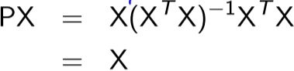

Theorem The residual sum of squares is an unbiased estimator of (n − p)σ^2

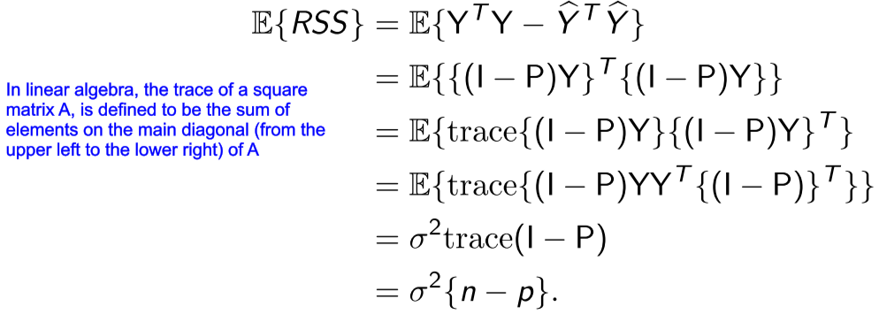

Gaussian Linear regression has the same mean as Least Squares, and variance is RSS:

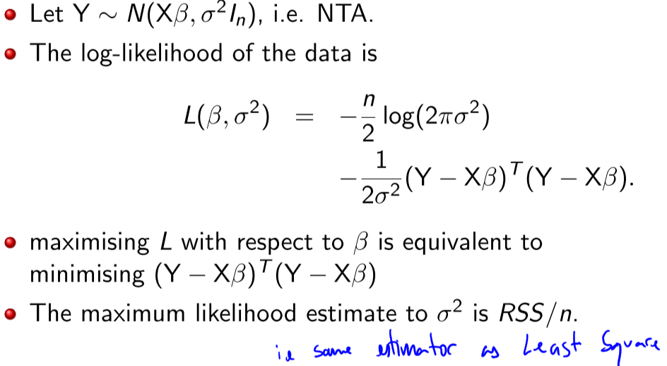

**Lecture 14 – Distributional Checks**

**QQ-plot**

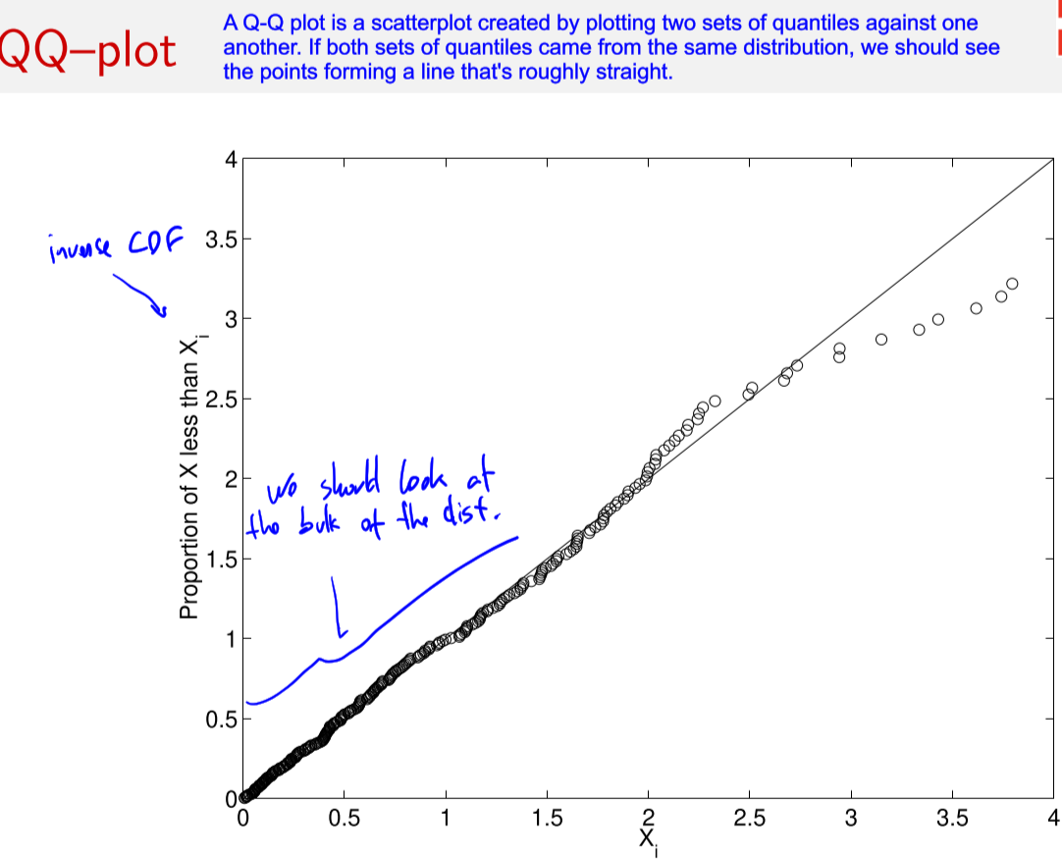

**Weighted Least Square**

**TODO will come in the exam! Sheet 11 ex 13: “find the MLE of the parameters of the model” (the weights are root 2 in the exercise)**

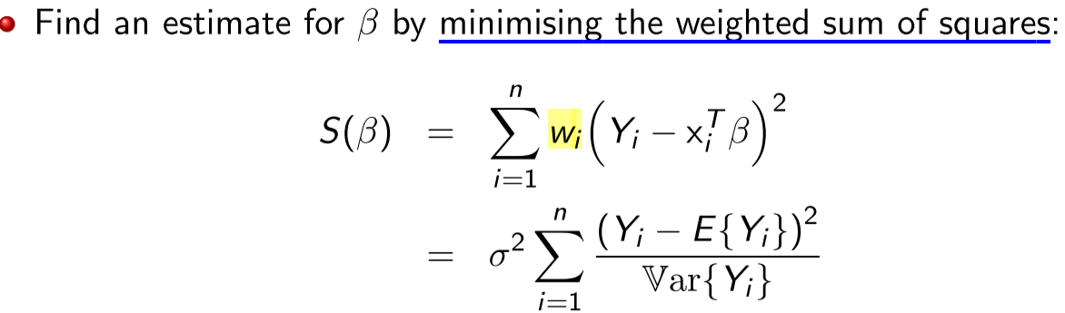

In vector form we have

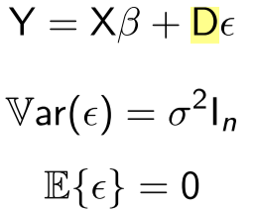 where 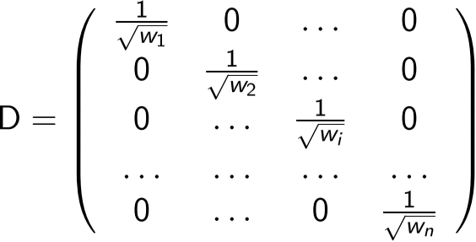

With solution that becomes the same as a linear model

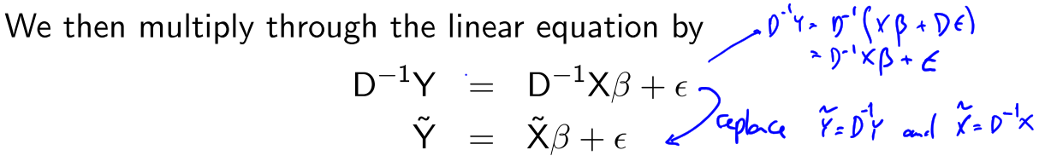

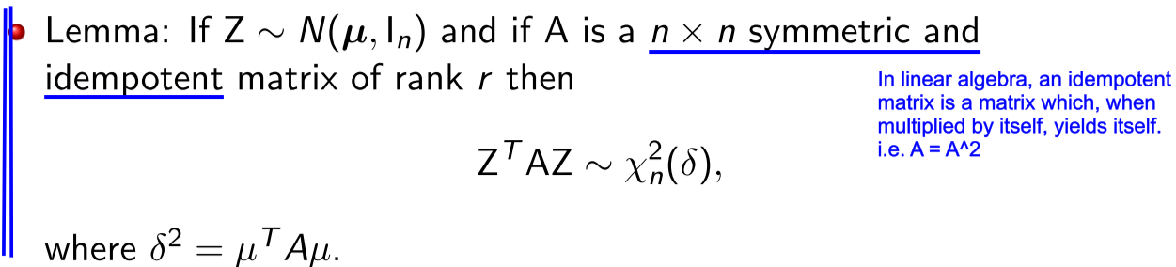

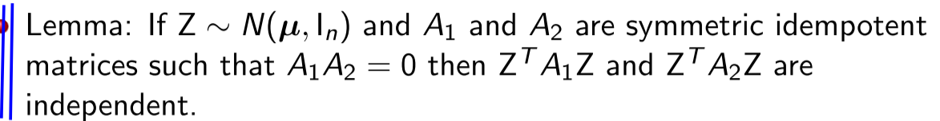

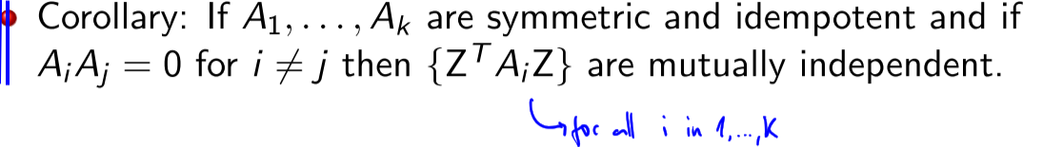

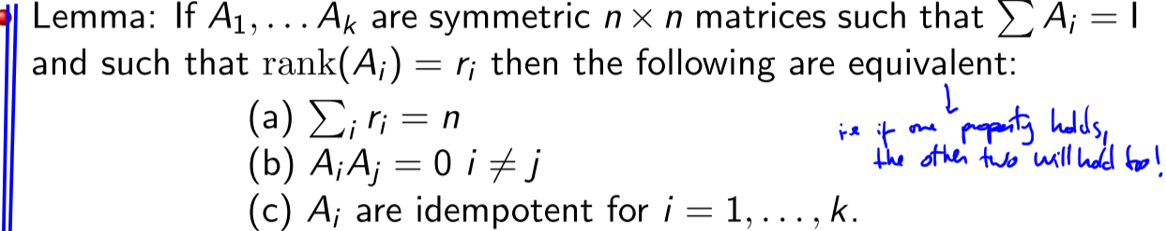

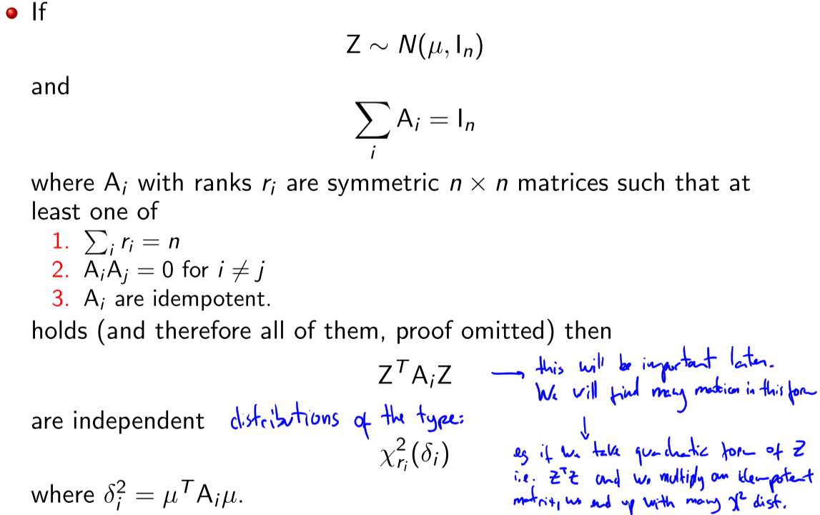

**Testing of Least Squares Set-up**

**ANOVA (Analysis Of Variance), F-distribution**

Wiki: **Analysis of variance** (**ANOVA**) is a collection of [statistical models](https://en.wikipedia.org/wiki/Statistical_model) and their associated estimation procedures (such as the "variation" among and between groups) used to analyze the differences among group means in a [sample](https://en.wikipedia.org/wiki/Sample_(statistics)). The ANOVA is based on the [law of total variance](https://en.wikipedia.org/wiki/Law_of_total_variance), where the observed [variance](https://en.wikipedia.org/wiki/Variance) in a particular variable is partitioned into components attributable to different sources of variation.

**TODO UNDERSTAND!** These are the total sum of squares (TSS), residual sum of squares (RSS), sum of squares for testing H_0 and the sum of squares due reduction due to β_0

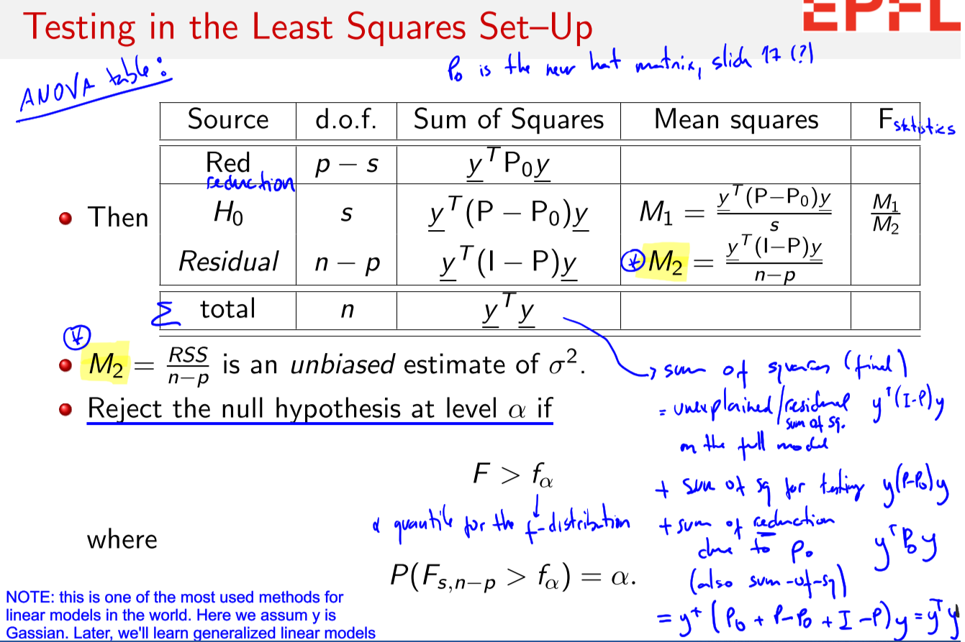

**F-statistic**

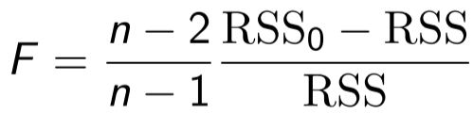

**Assumptions in the Least Square (not weighted):**

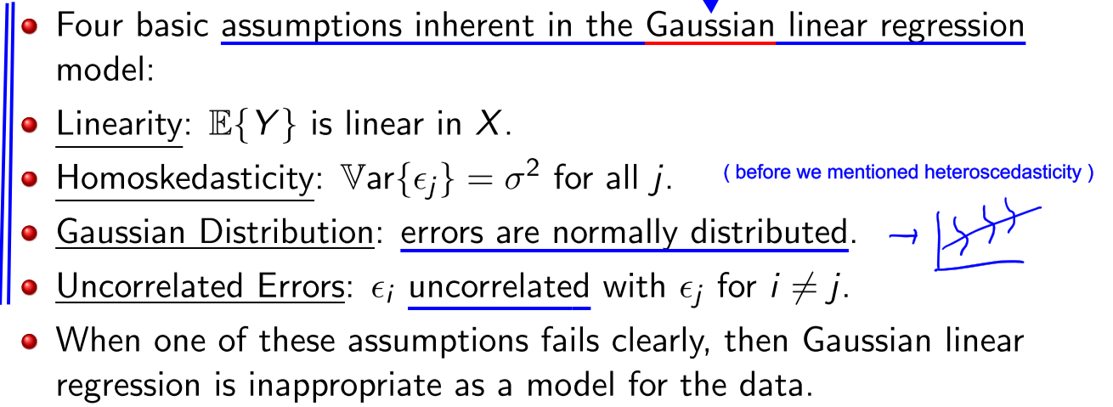

**Outliers**

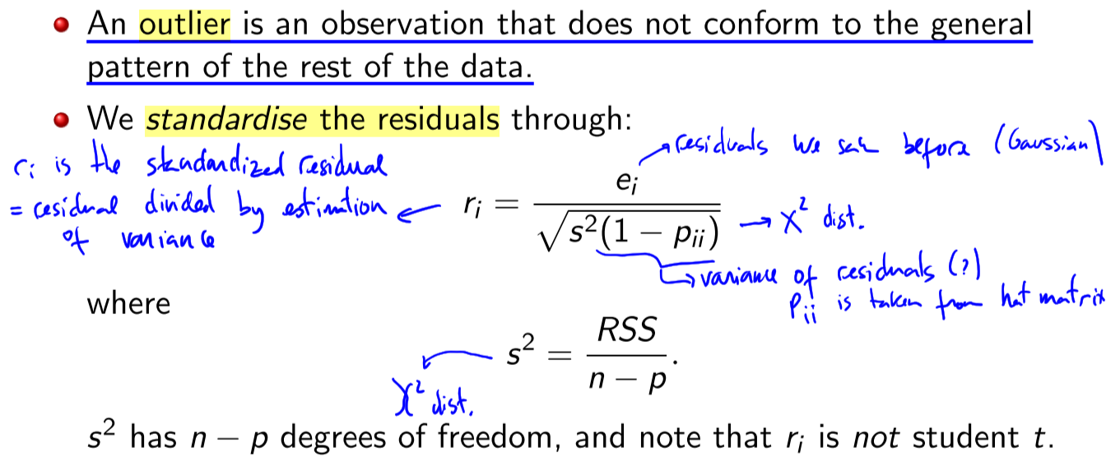

Outliers may be influential: they “stand out” in the “y-dimension”. However an observation may also be influential because of unusual values in the “x–dimension”. These are hard to find through plotss



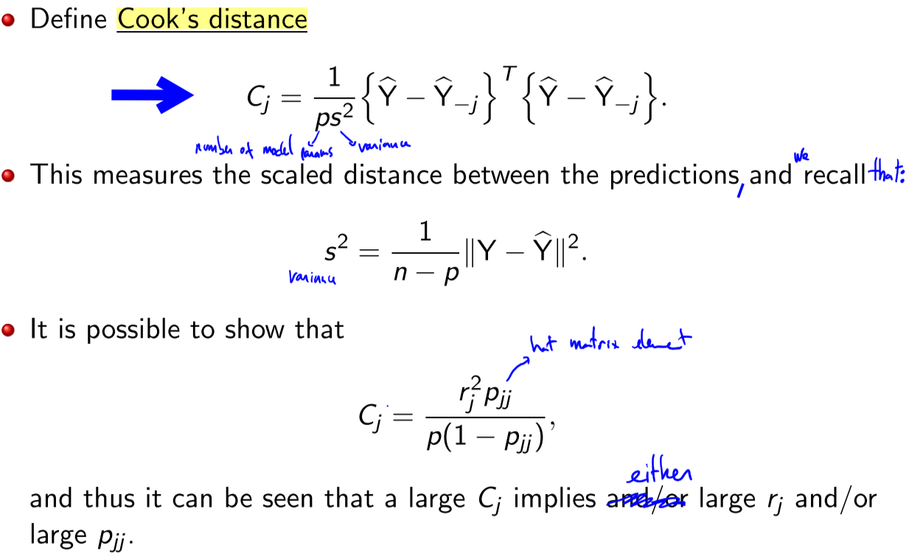

Cases with Cj > 8/(n − 2p) are considered large. We therefore plot Cj against j and compare with this cut-off.

How do we diagnose If model appears to be fitting well:?

* We plot Y against columns of X to check for linearity and outliers.
* We plot the standardized residuals r against the columns of X.
* We plot the standardized residuals r against covariates we left out.
* We plot r against ^Y to check homoscedasticity.
* We make qq plots to check distribution.
* We make the Cook distance plot to check for influential observations.

**Lecture 15 – Linear Algebra**

**column space (or range)**

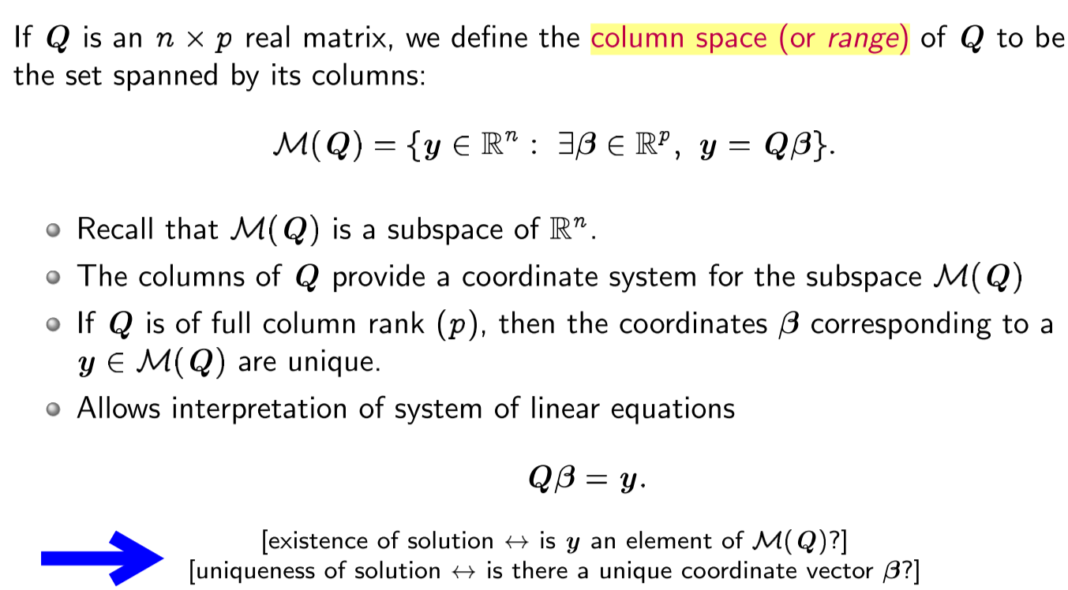

**Null space (or kernel), Orthogonal component**

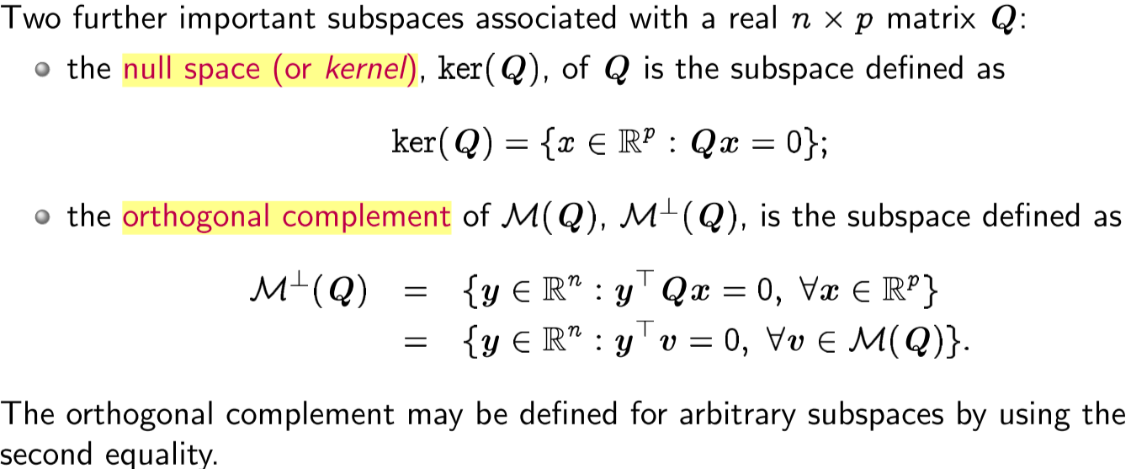

**Spectral Theorem**

A square matrix with real numbers or elements is said to be an orthogonal matrix, if its transpose is equal to its inverse matrix. Or we can say, when the product of a square matrix and its transpose gives an identity matrix, then the square matrix is known as an orthogonal matrix.

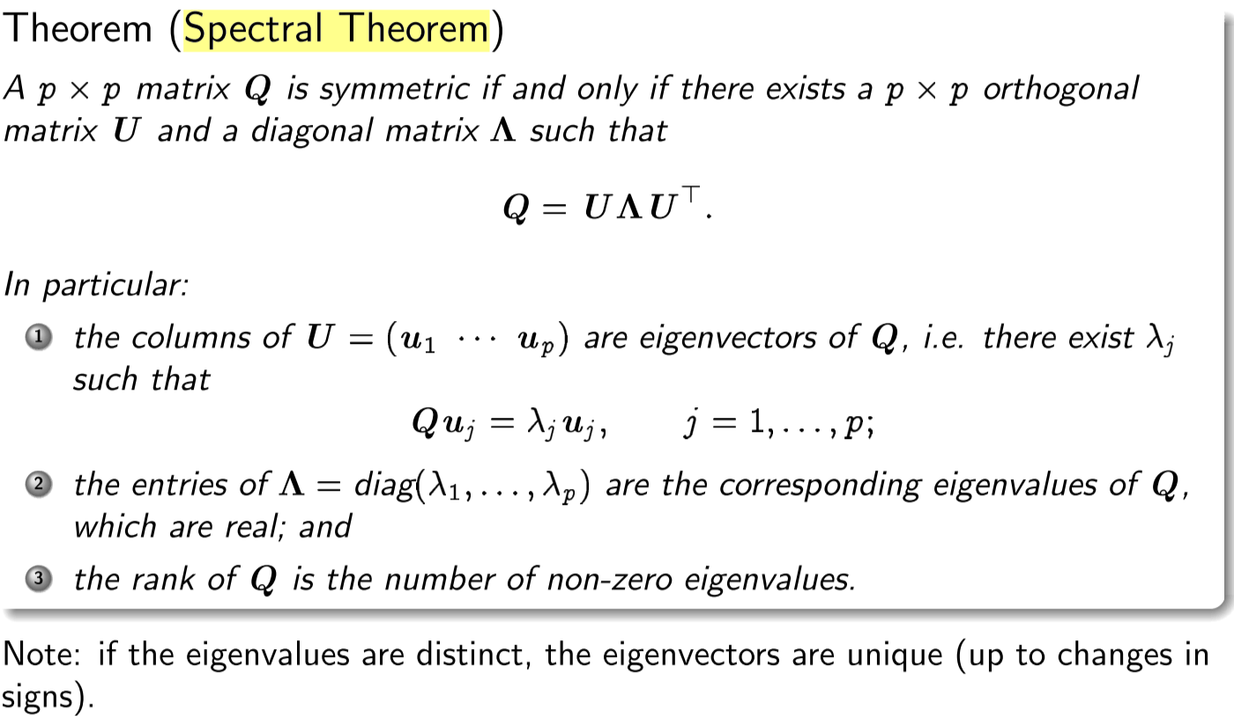

**Single-Value Decomposition**

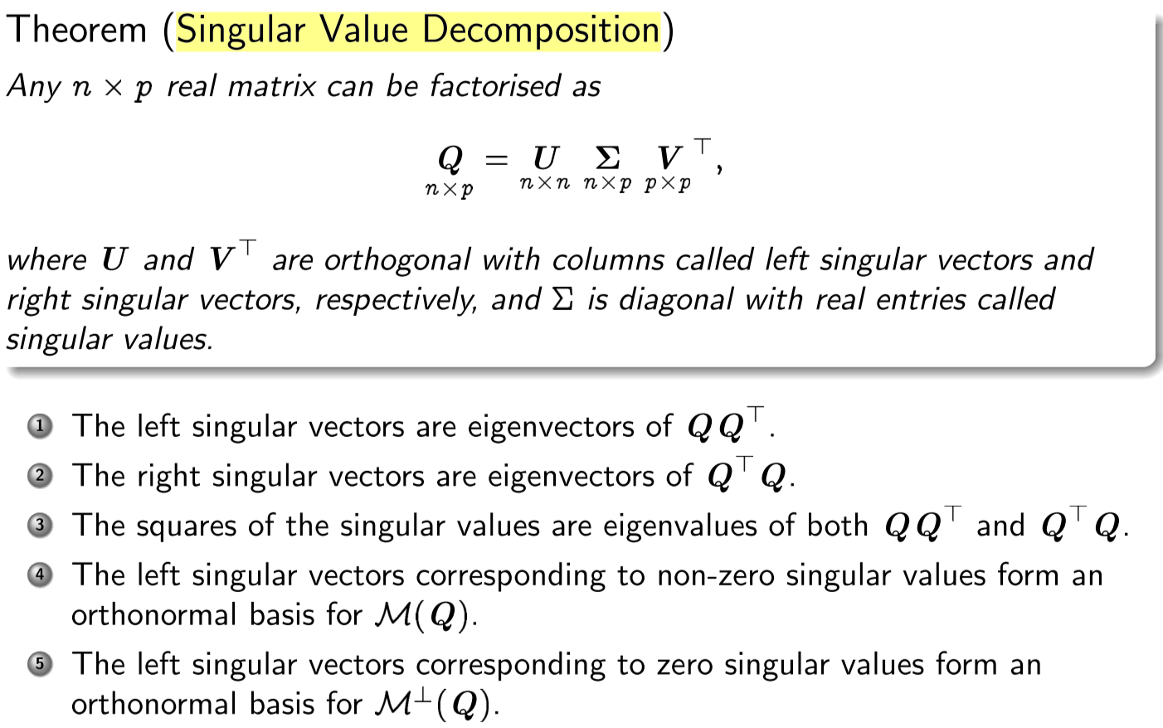

**Idempotent, Projection, Orthogonal Projection**

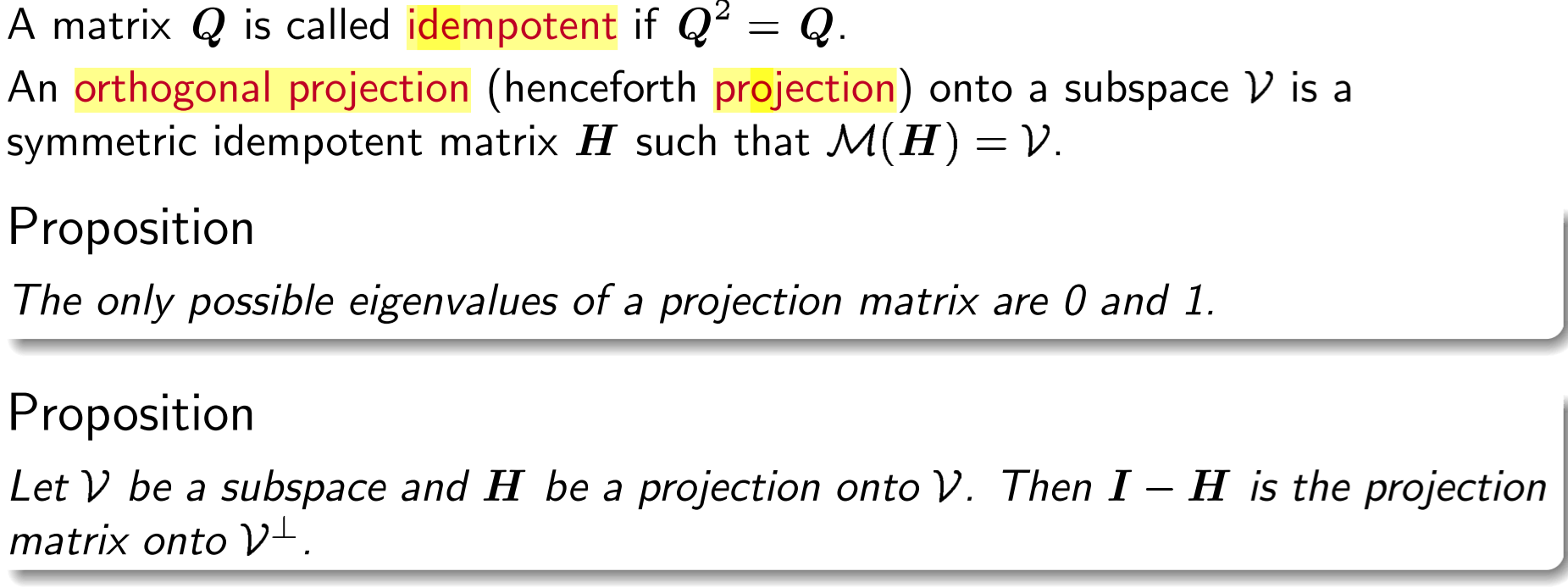

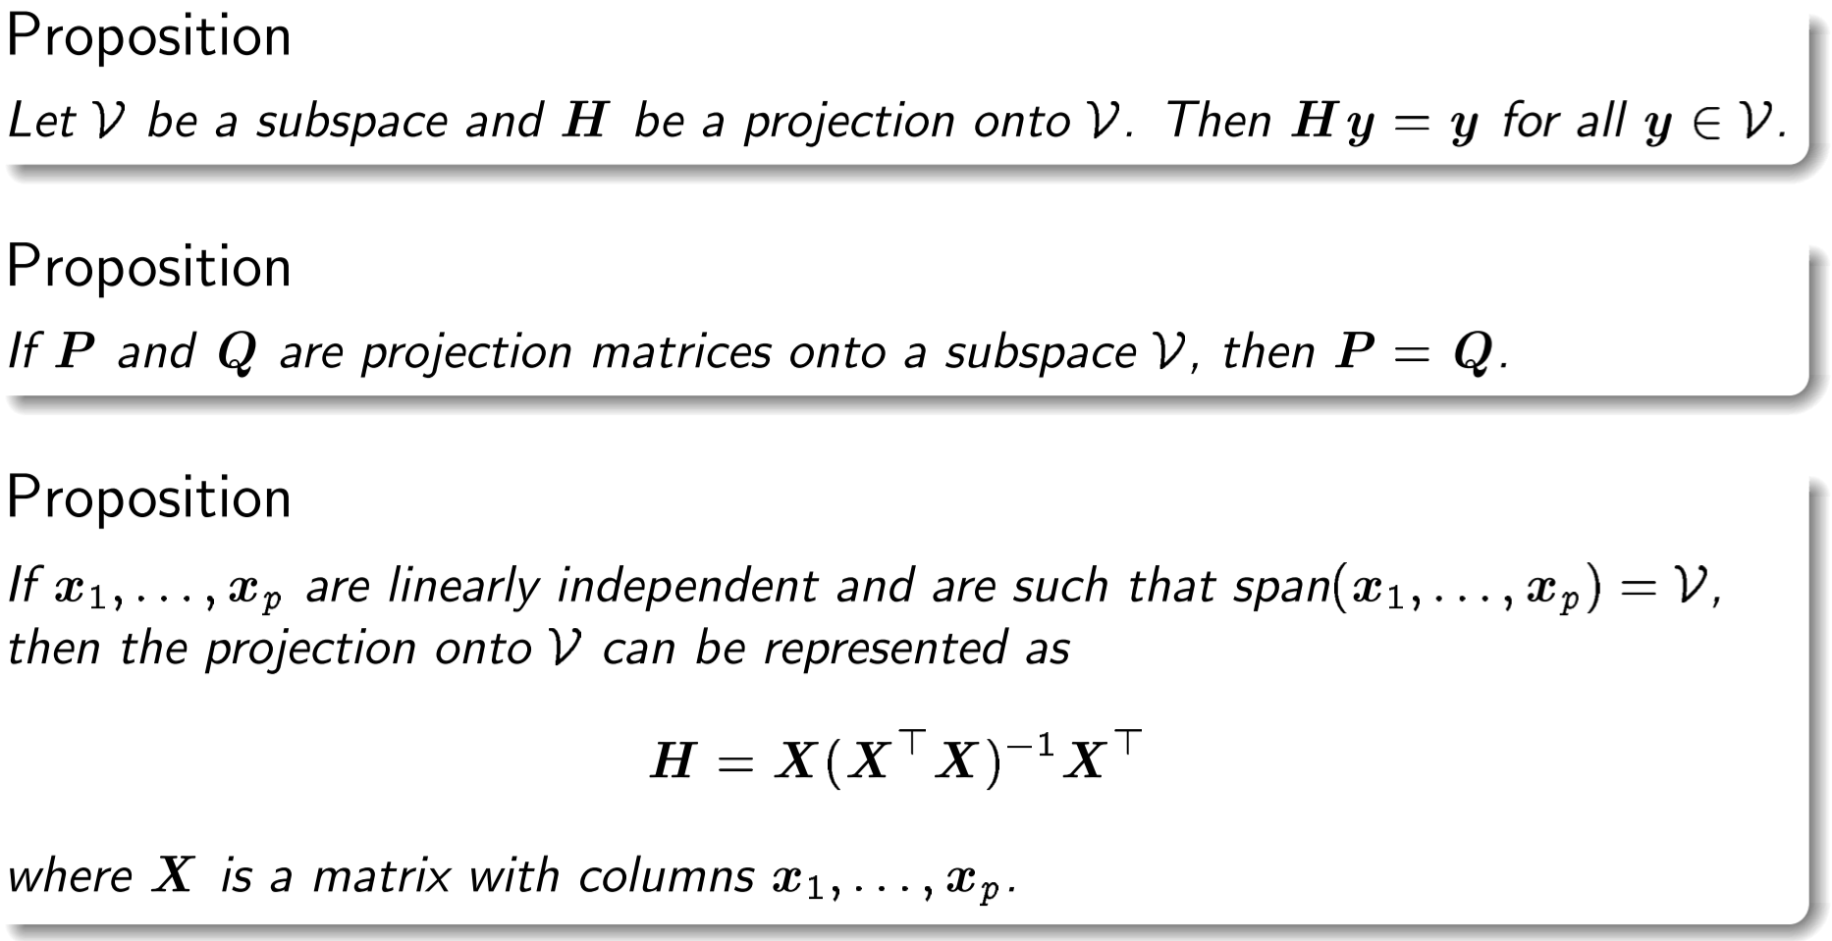



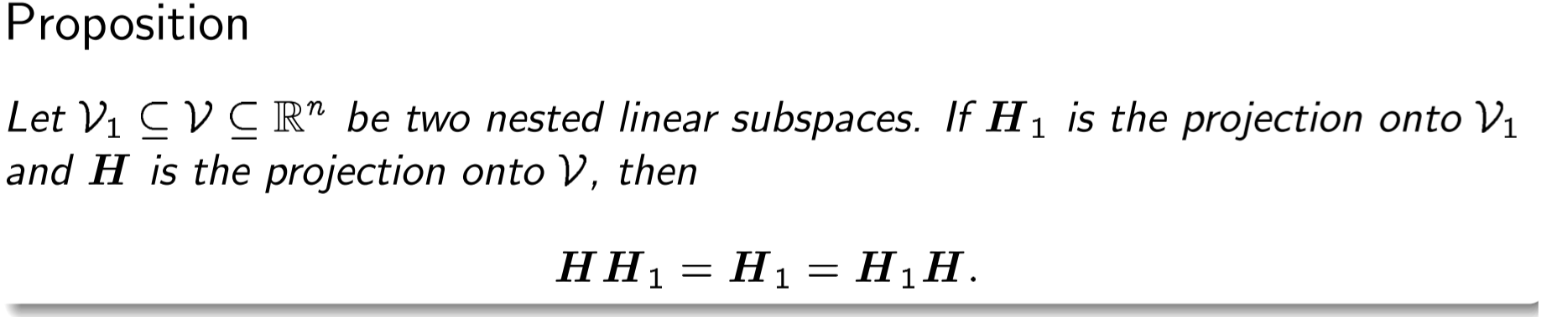

**Positive/Negative definite**

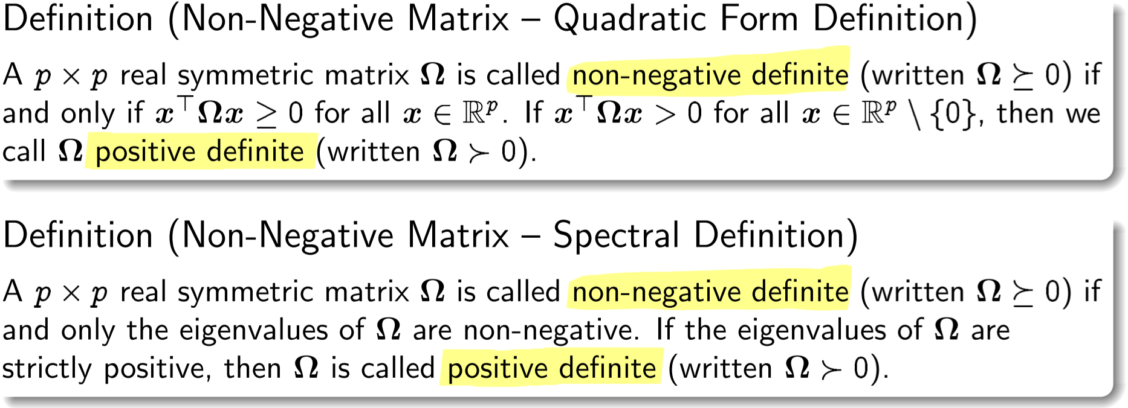

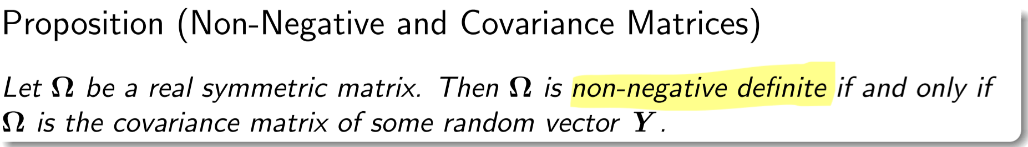

Variance of projection: 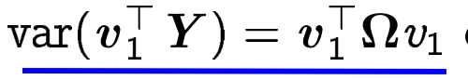

**TODO** Understand resolution in slide 15

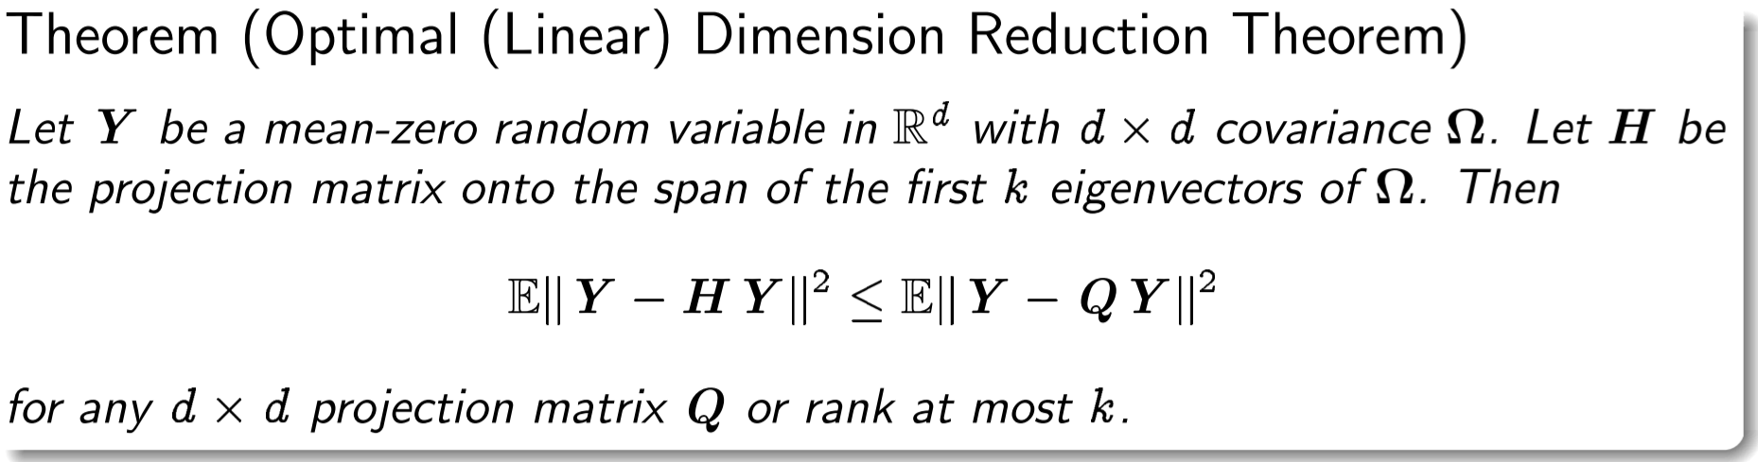

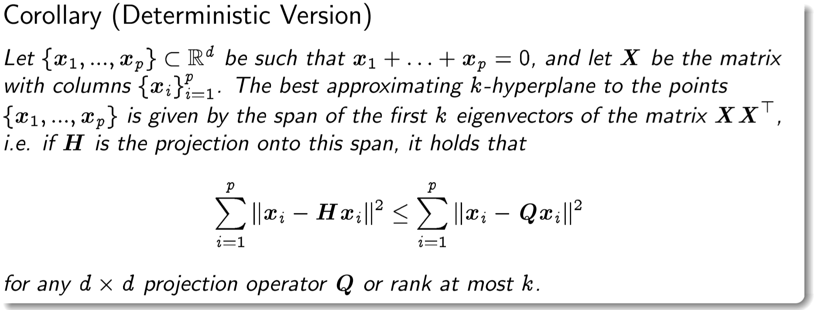

Characterise the distribution of a random vector

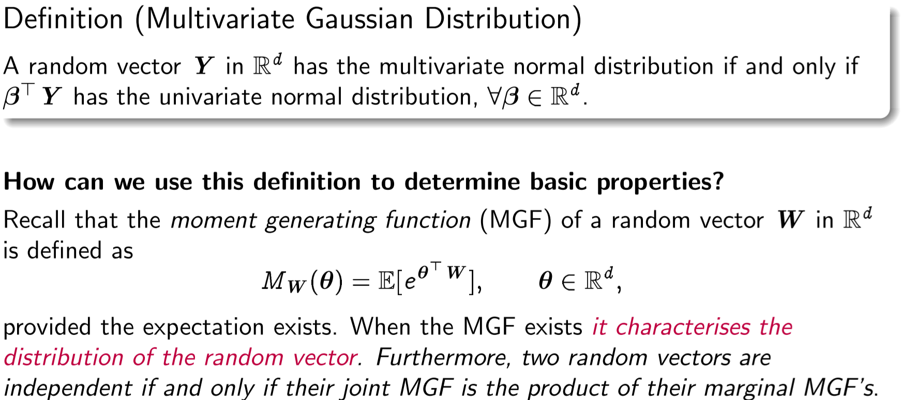

**Gaussian Distributions in Vector Form**

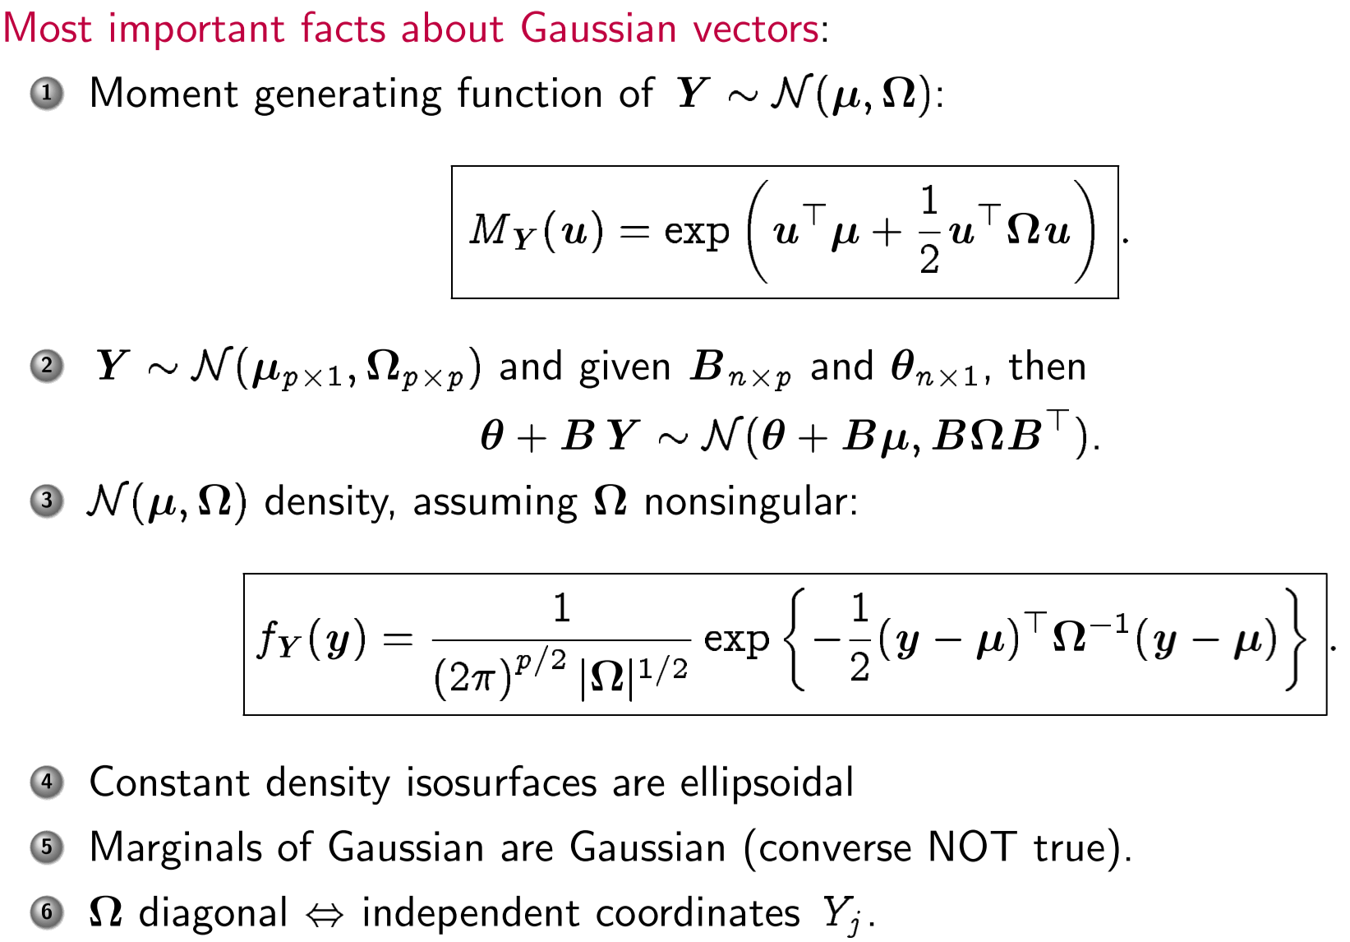

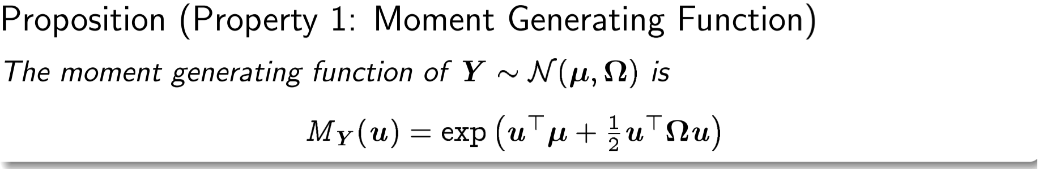

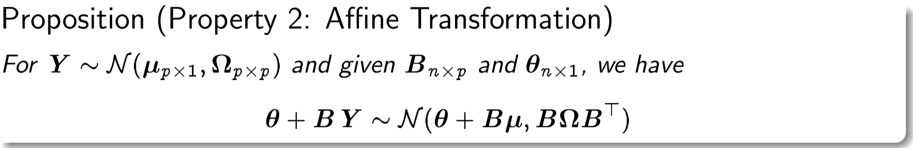

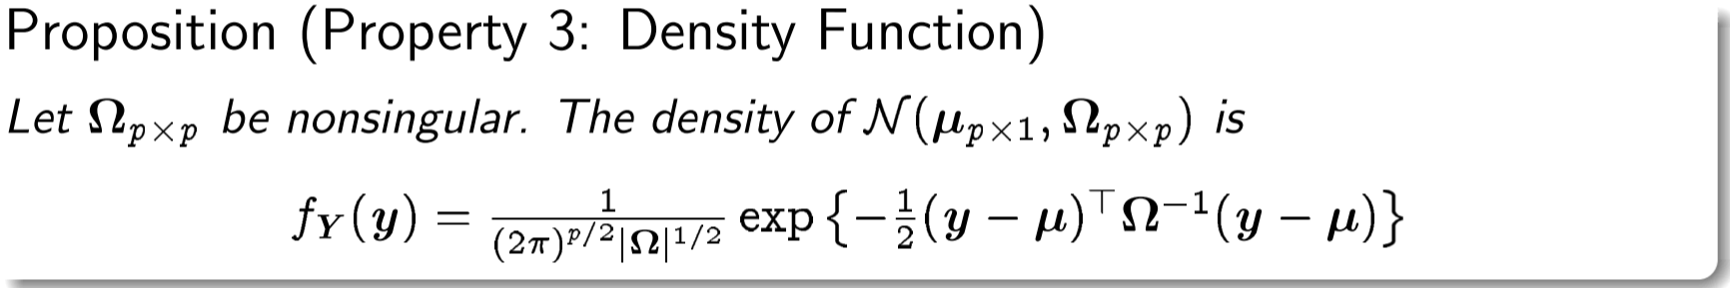

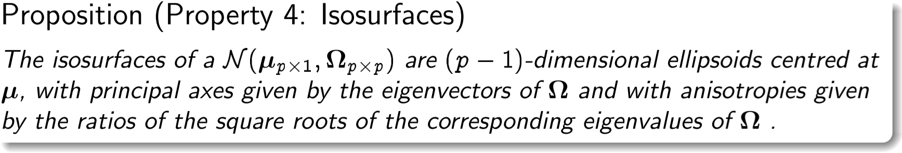

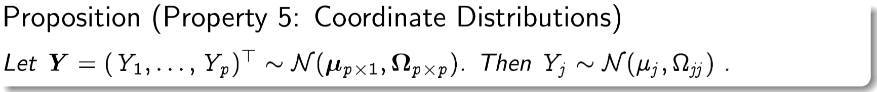

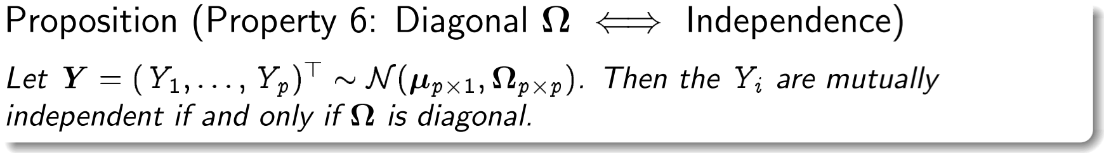

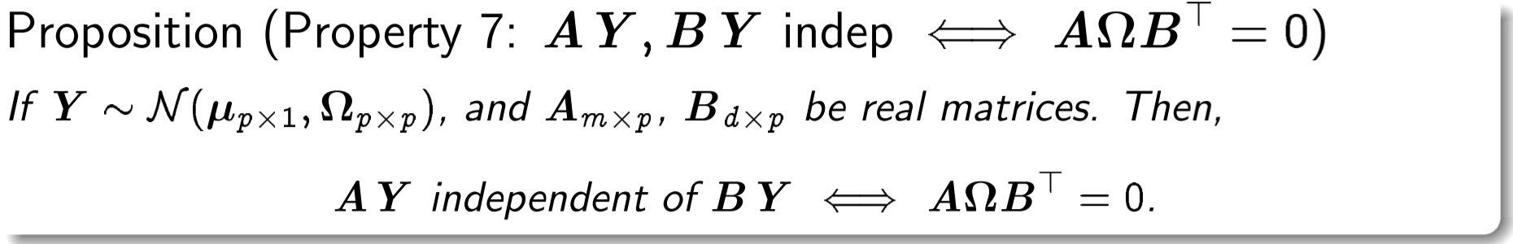

**Lecture 16 – How do we make a linear model?**

How to select the most appropriate subset of columns in X that give a good linear relationship to Y, in linear expression? Brute Force complexity 2^n (**powerset**)

**TODO comes in the exam!**

**Model selection:**

* **Forward Search-stepwise regression (forward selection)**: start with a constant, and add a new feature at the time and pick the one with the lowest residual sum of squares. Then do it for the remaining.
* **Backward elimination-stepwise regression**: start with all features, test all features and remove the one with largest p-value. Do it recursively for the remaining features.
* **Stepwise (**?) see below!

Up until now we assumed the model had full rank. Sometimes it’s not possible. (see example slide 8)

So we cant solve least squares at X^TX is not invertible.

Note: The following properties are equivalent for a square matrix A:

* + A has full rank
  + A is invertible
  + the determinant of A is non-zero

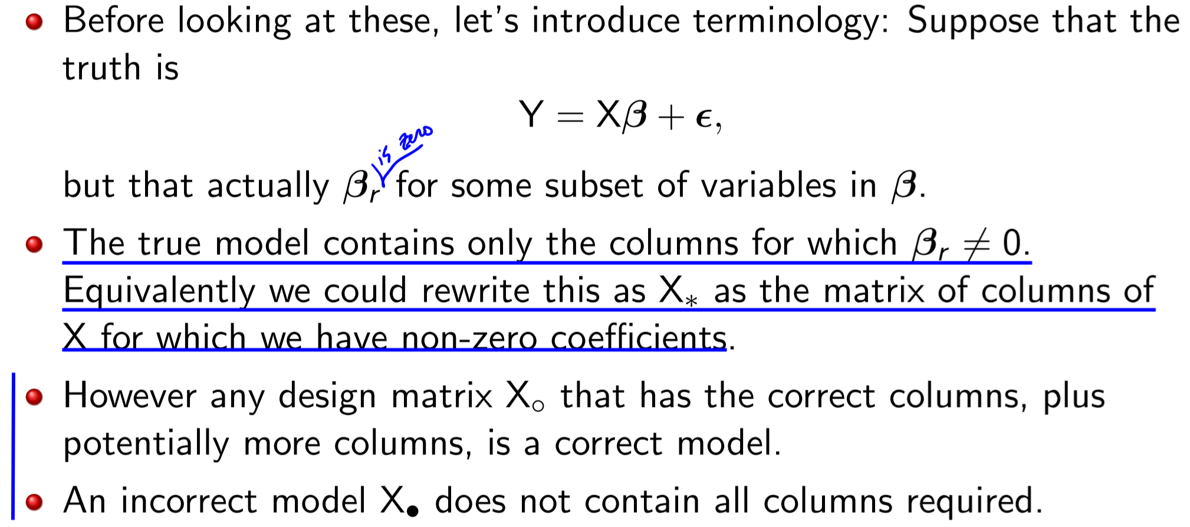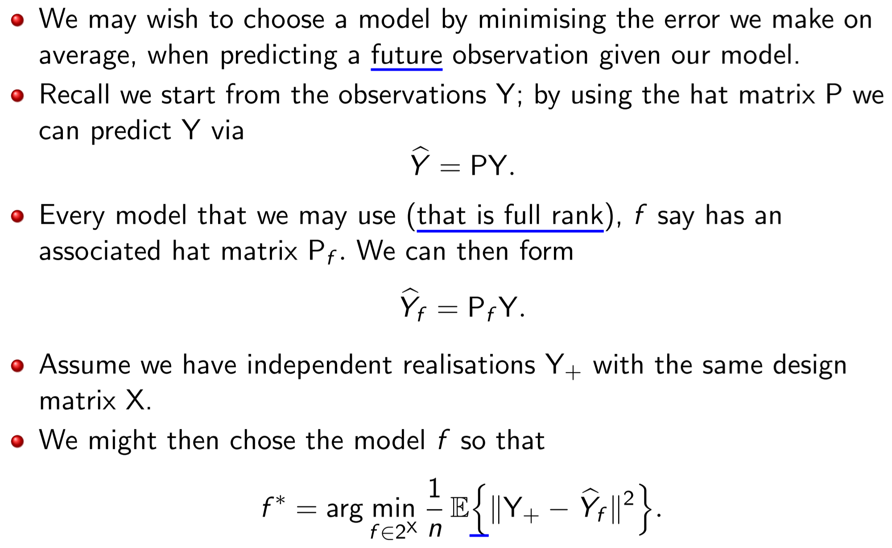Ad

See previous slides

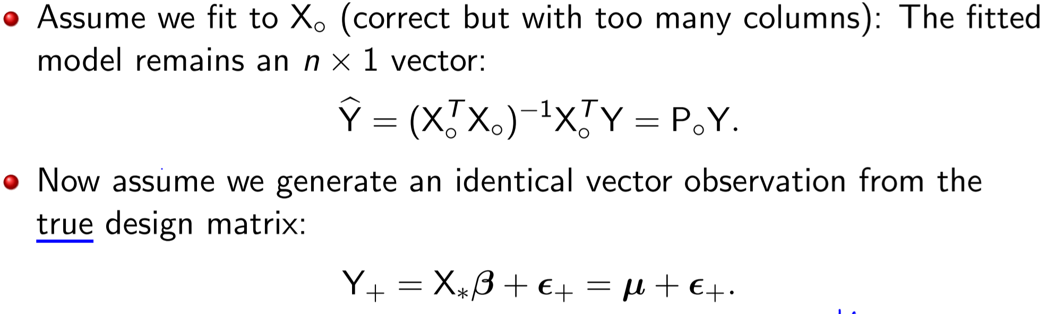

Best model has only few columns (correct ones)

Ok model is the original with all columns, including correct ones

Worst model doesn’t include all correct columns(?)

**Leave-one-out cross validation**

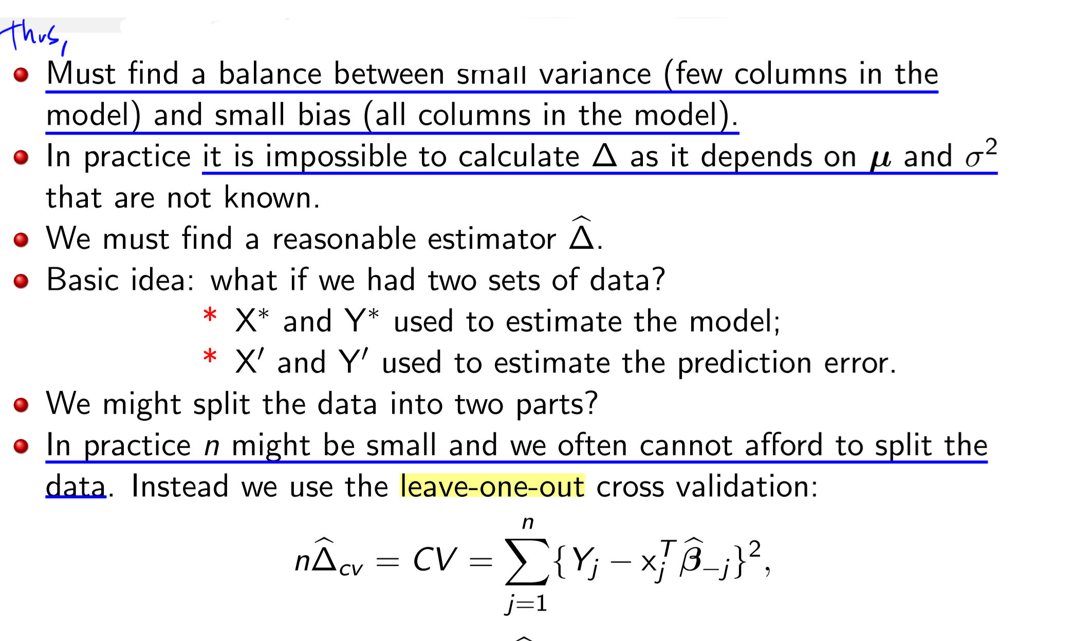

**Generalized Cross-validation**

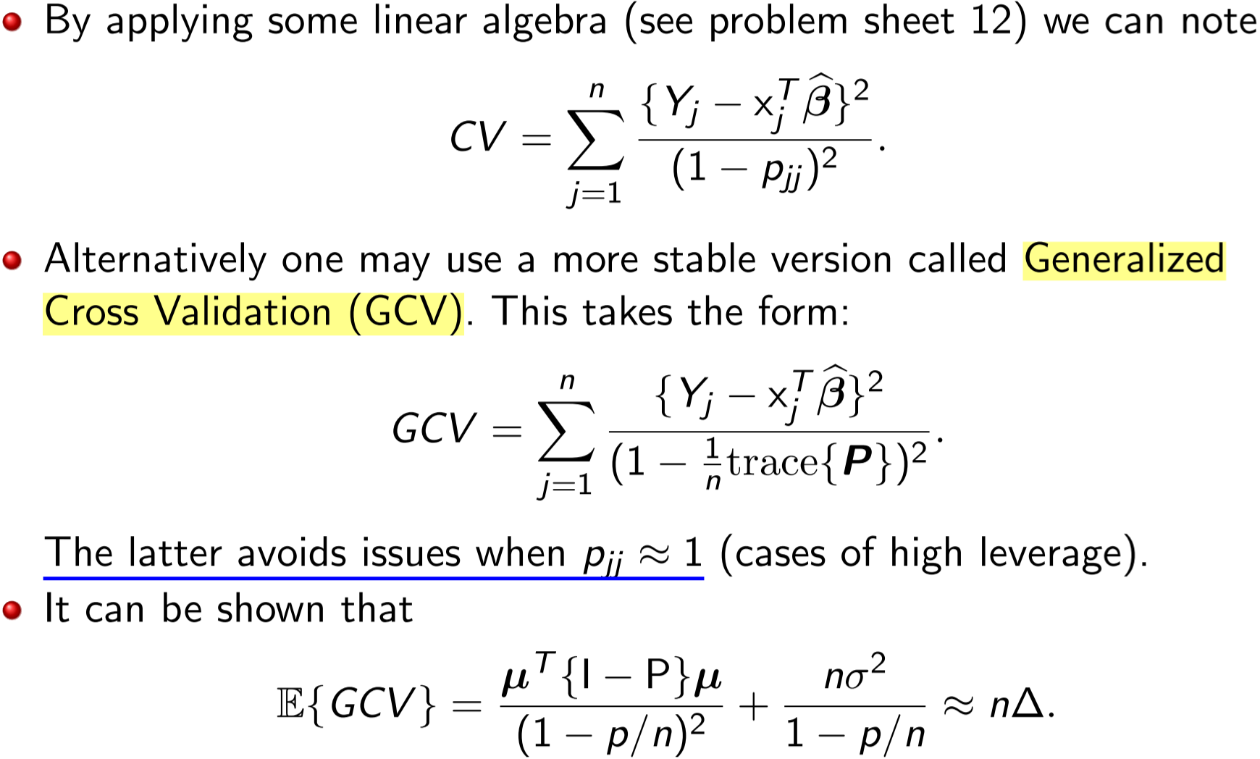

Other criterion: **Aikake Information Criterion (AIC)**

Similar to Variational Inference, pick a candidate model that KL-divergence minimizes to true model, slide 16,17

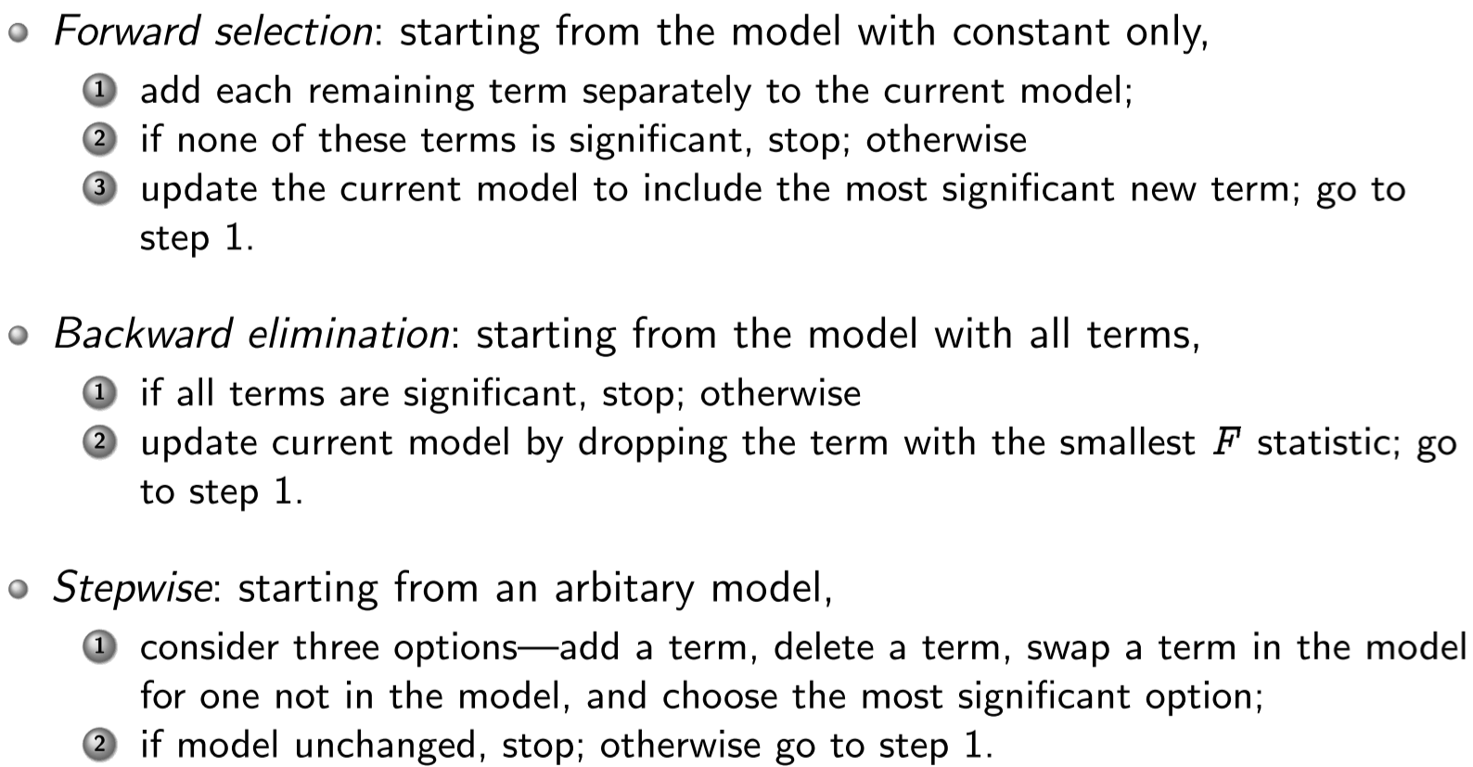

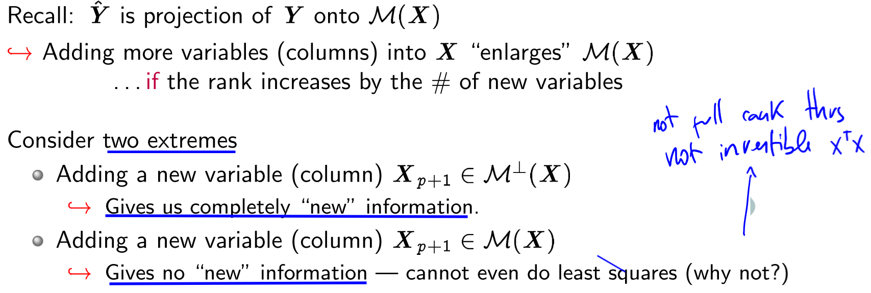

**Multicolinearity** Slide 23

* When p covariates concentrate around a subspace of dimension q<p
  + Eg: x1+x2 as model, but x1=2*x2
* Wiki: is a phenomenon in which one predictor variable in a multiple regression model can be linearly predicted from the others with a substantial degree of accuracy.
* Leads to huge variance, individual coefficients insignificant
* Interpretation: how much the variance is inflated when including variable as compared to the variance we would obtain if X_j were orthogonal to the other variables—how much worse are we doing as compared to the ideal case

Solution, look at **Variance Inflation Factors (VIF):**

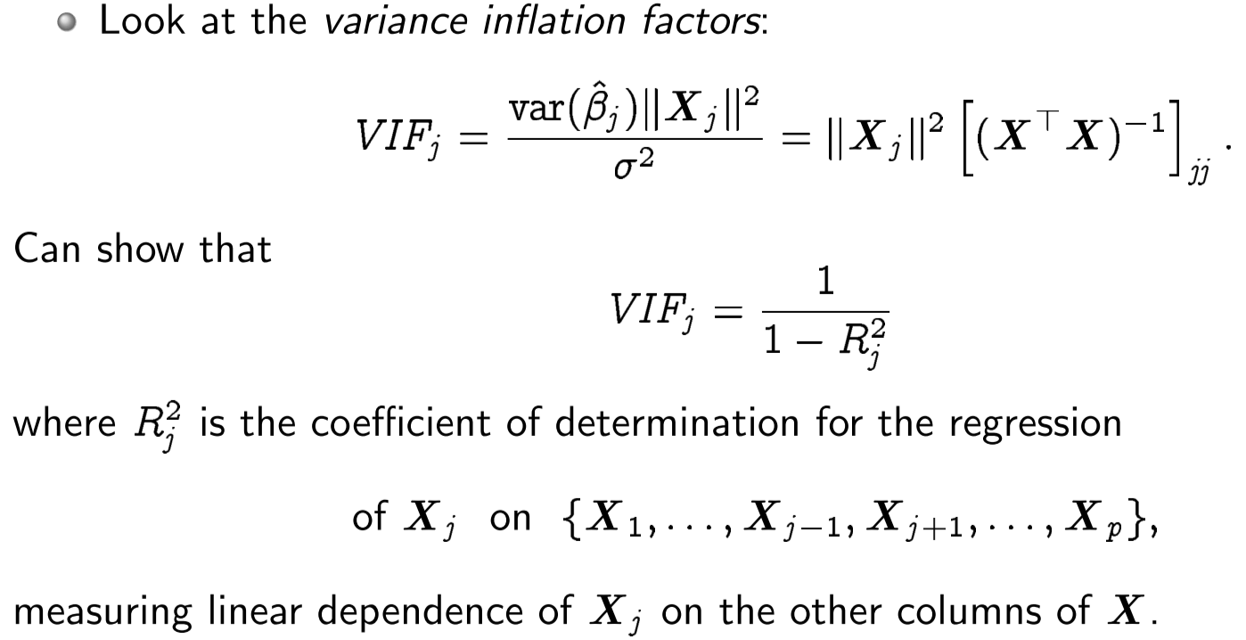

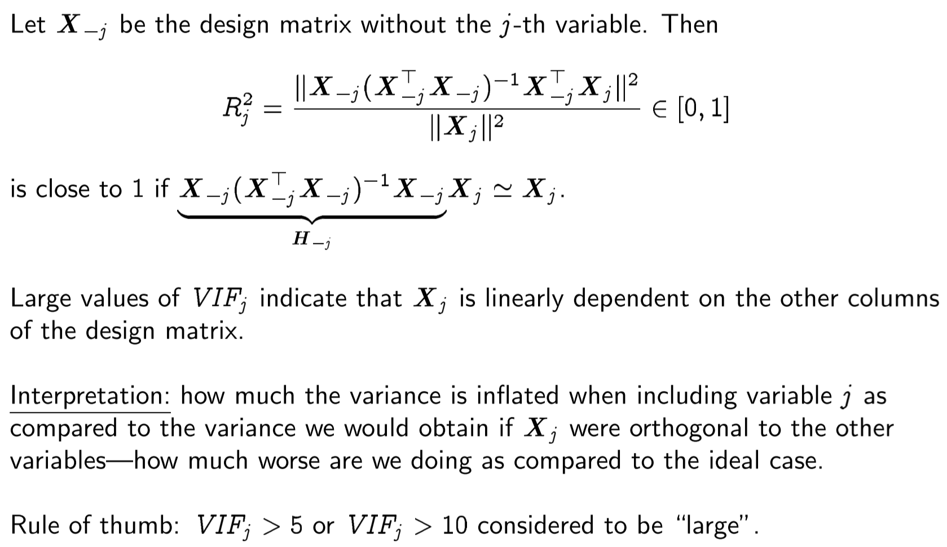

Also condition index and condition number tricks on slide 26:

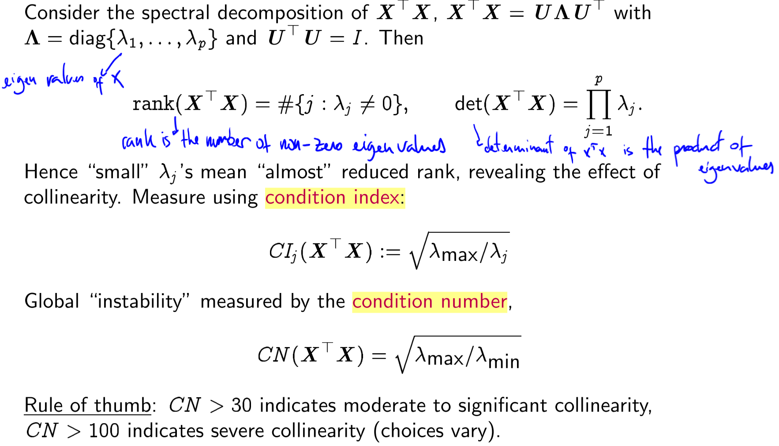

Rescaling, standardizing

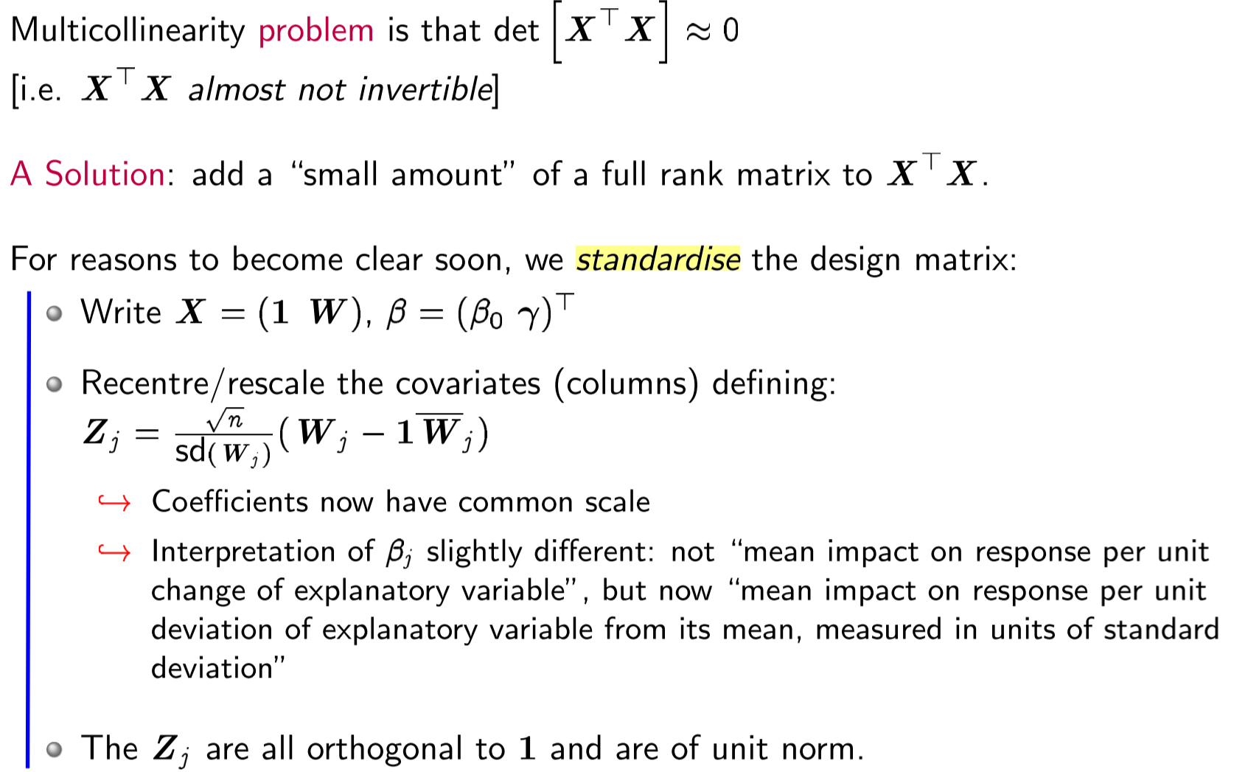

Ridge Regression

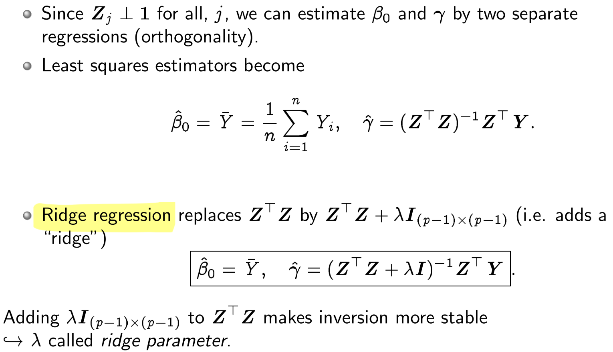

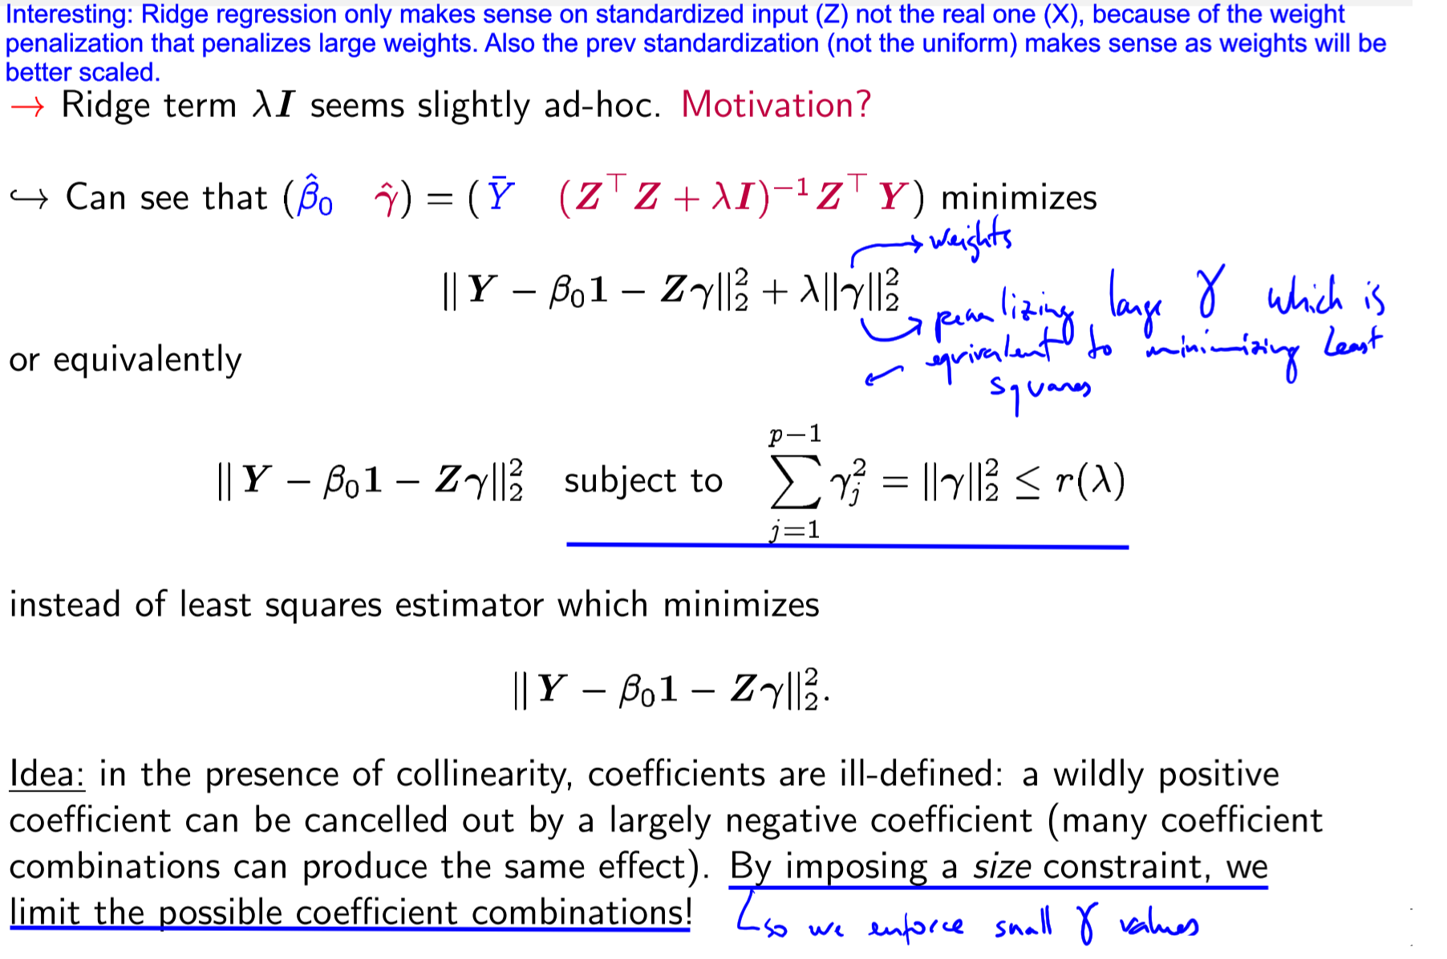

**Lecture 17 – Shrinkage**

**Ridge regression** is a form of **shrinkage**

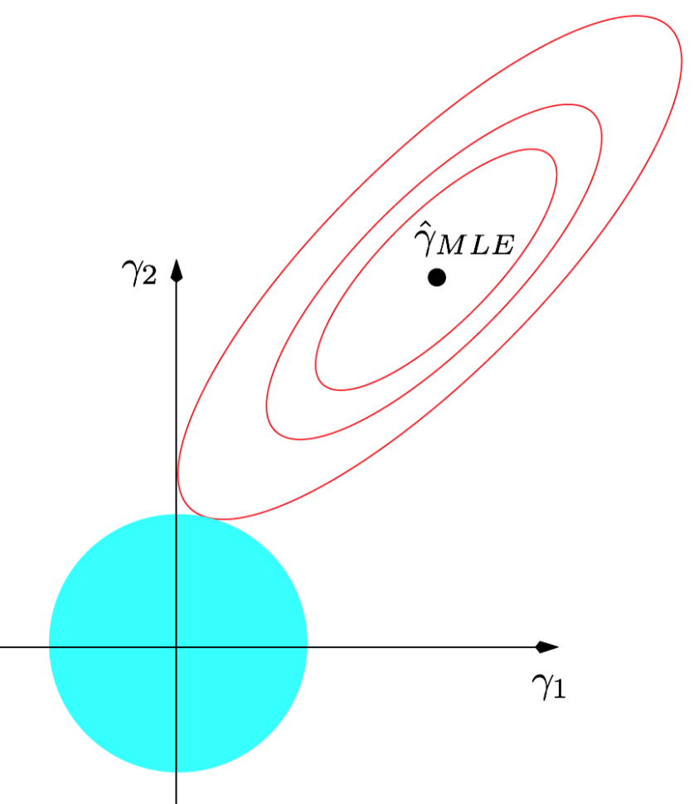

Closed-form solution (minimizer) for ridge regression:

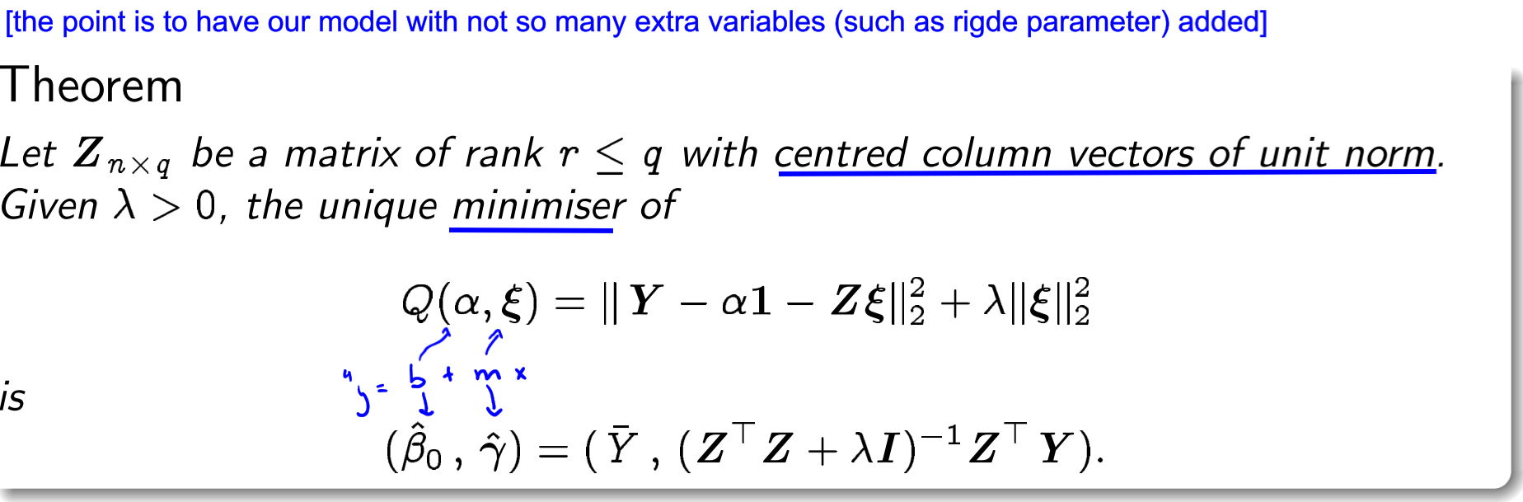

Because we have a closed form expression we can computer the bias

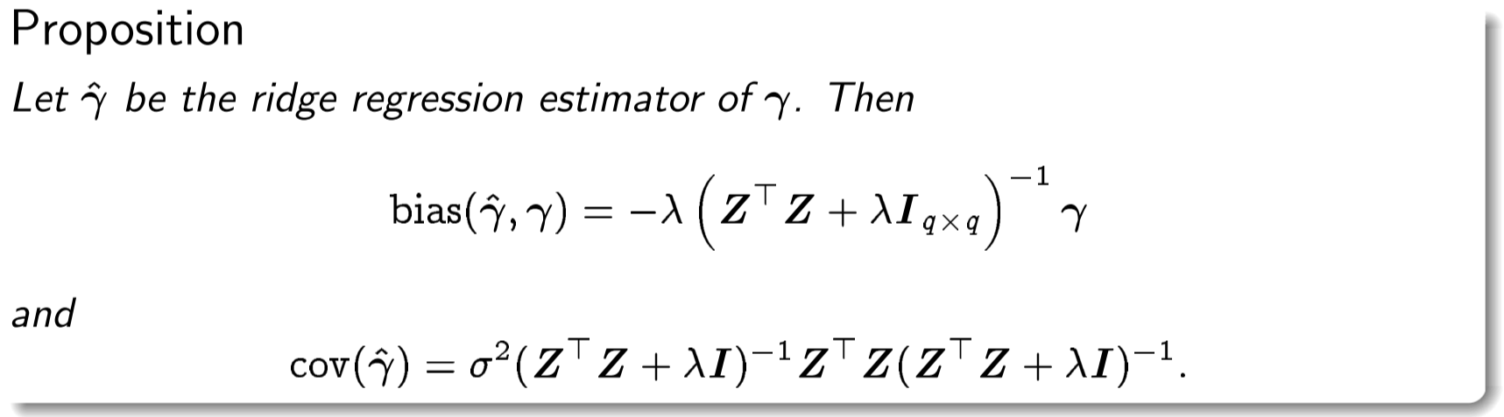

Ridge regressions uniformly better than least squares (slide 8)

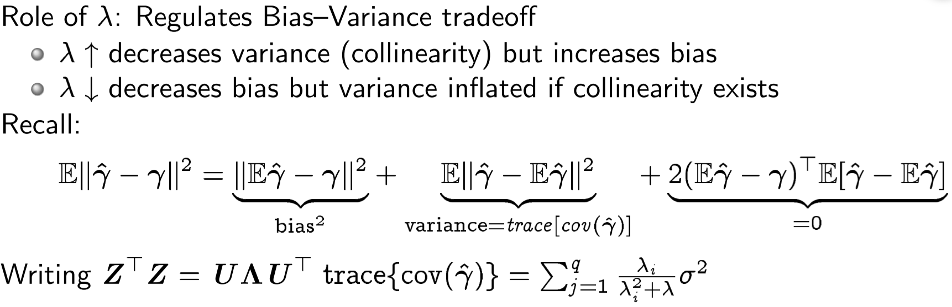

**Lasso Regression**

Eg for images where we smooth colours but keep edges.

Used for model selection (as it drops weights), exactly performs model selection via thresholding

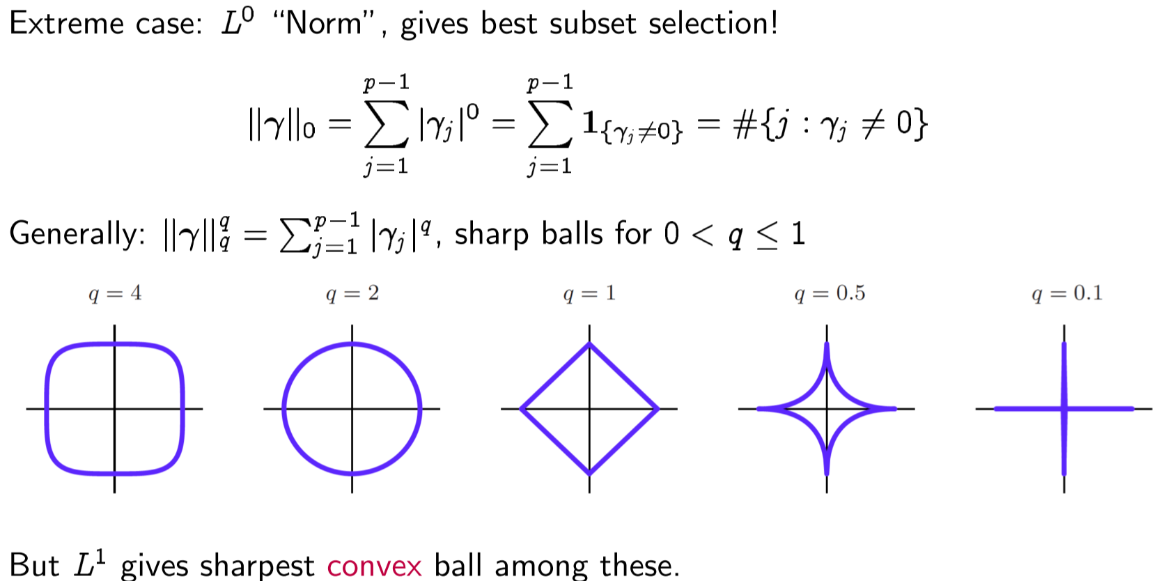

**Lecture 17 – Generalized Linear Models**

A ` is a linear model that allows to have other distributions than Gaussians!

Generalised Linear Models: regression with exponential family responses!

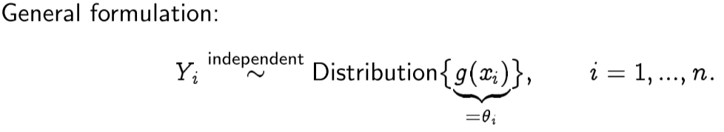

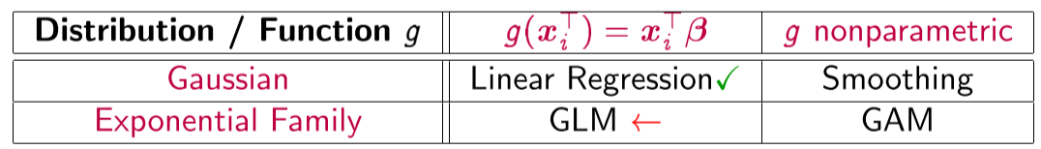

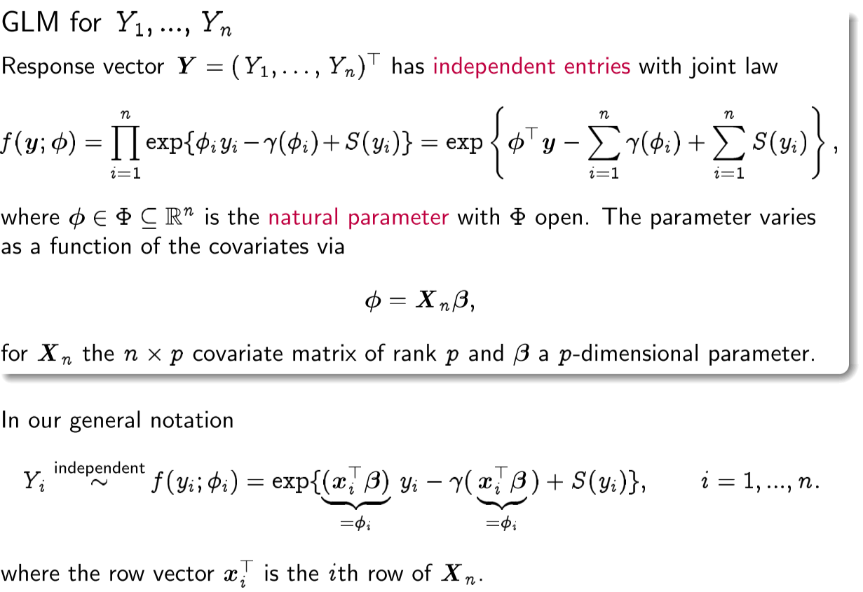



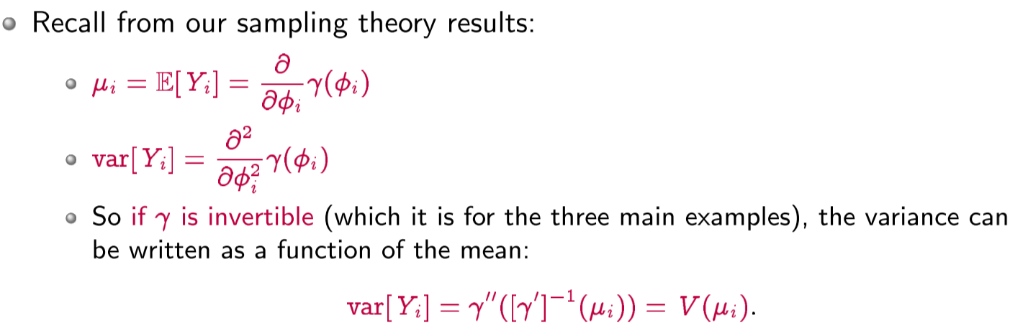

**Linear predictor, natural link function, link function**

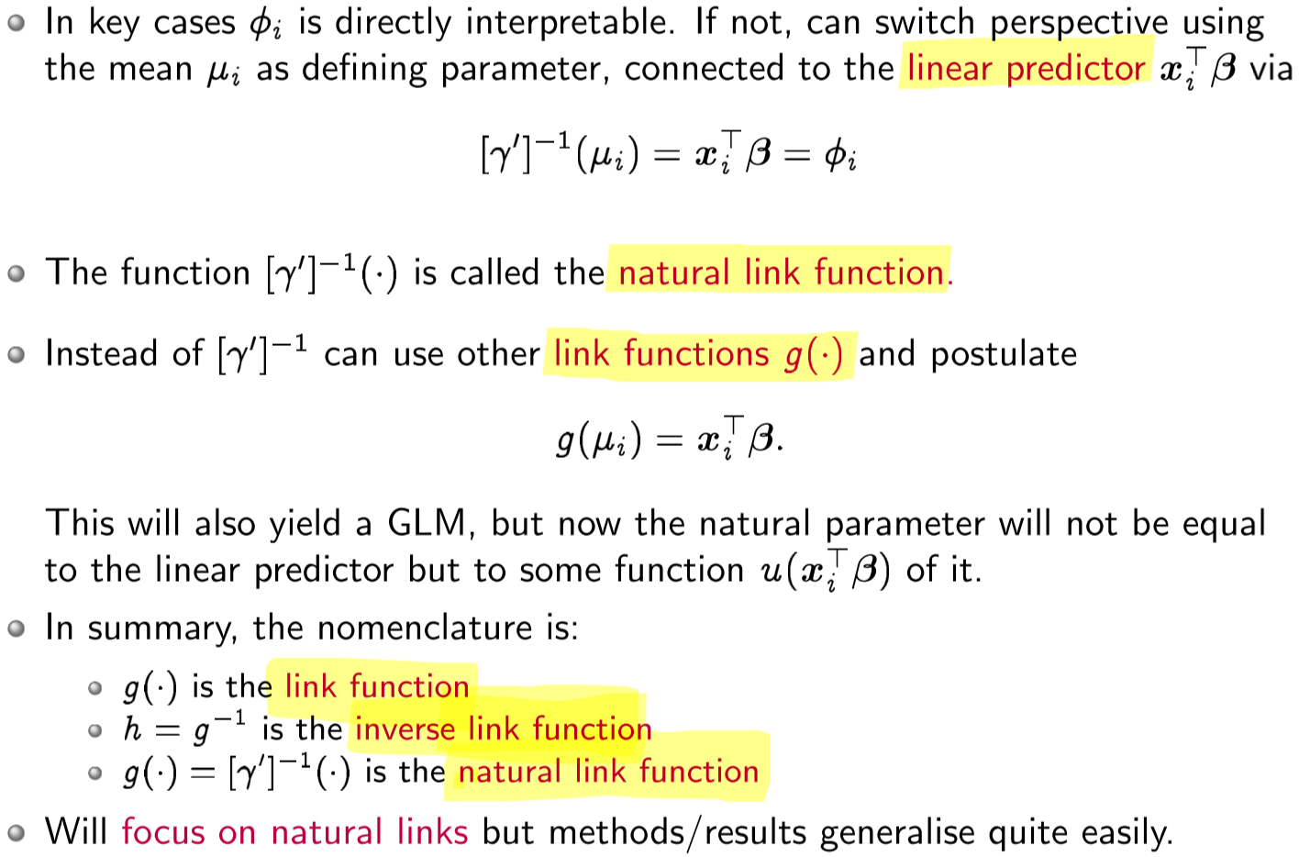

Note: in the following, once we know the function g, we can apply GLMs to most distributions in exponential family

Log likelihood, derivative, covariance, of GLMs

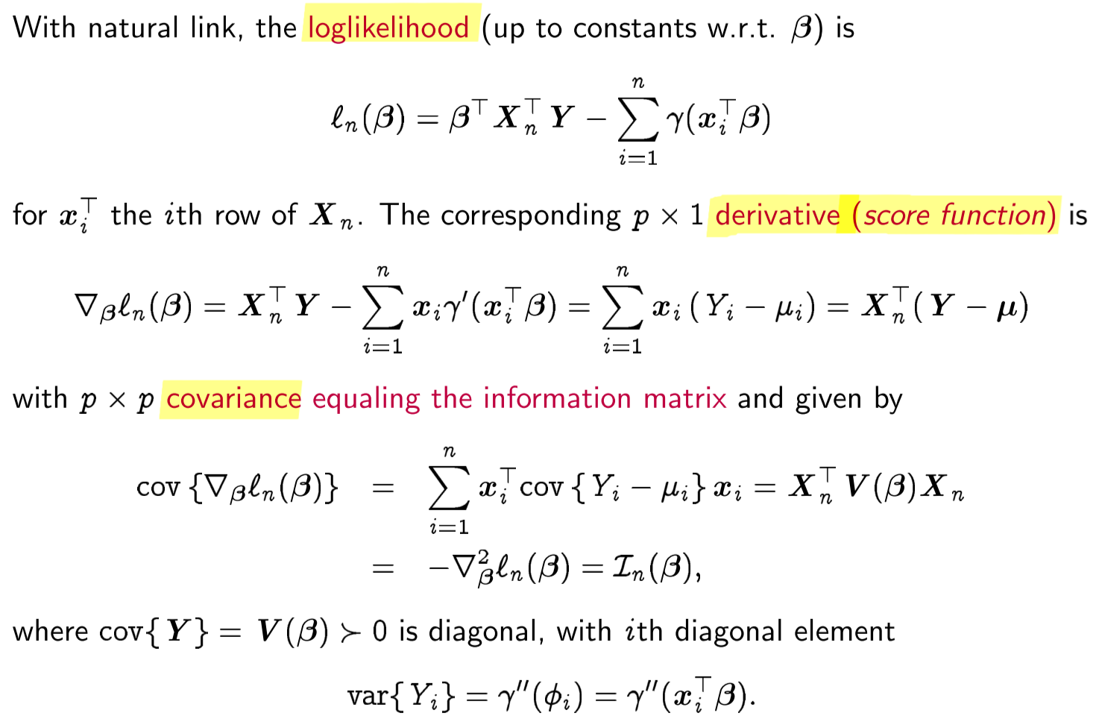

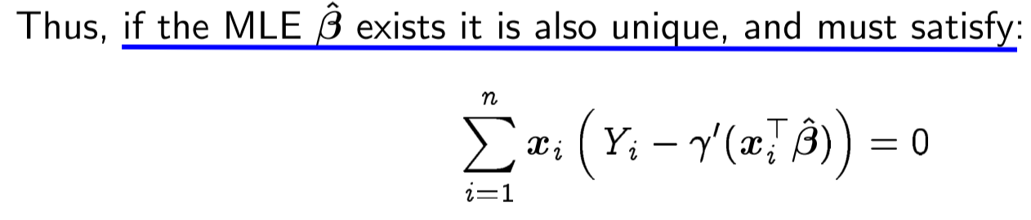

Applying Taylor series we get this:

ILRS (Iteratively Reweighted Least Squares)

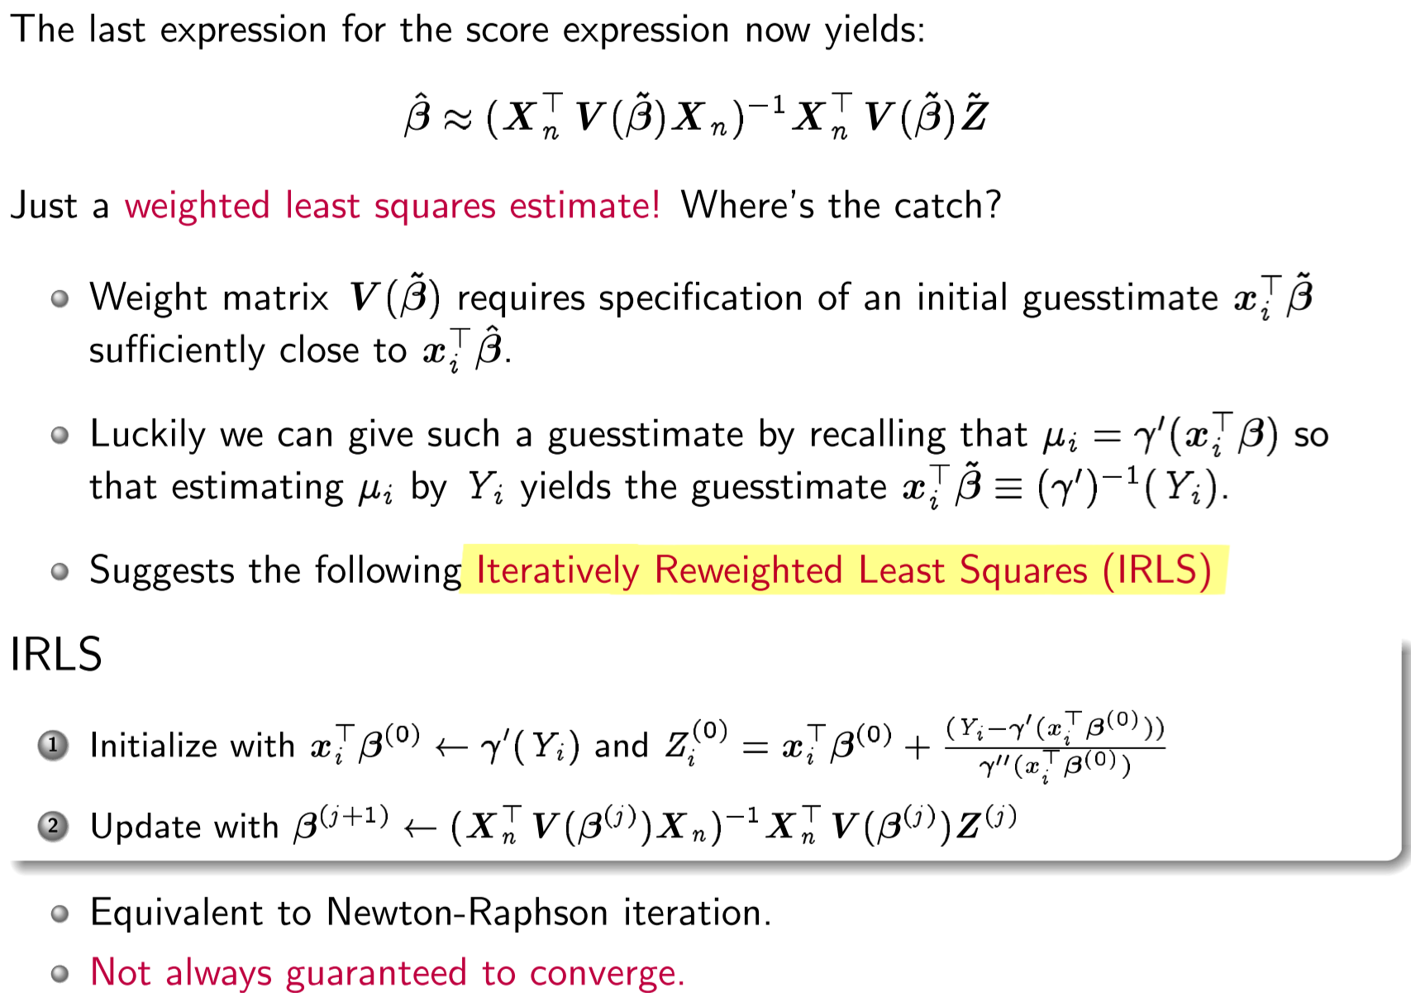

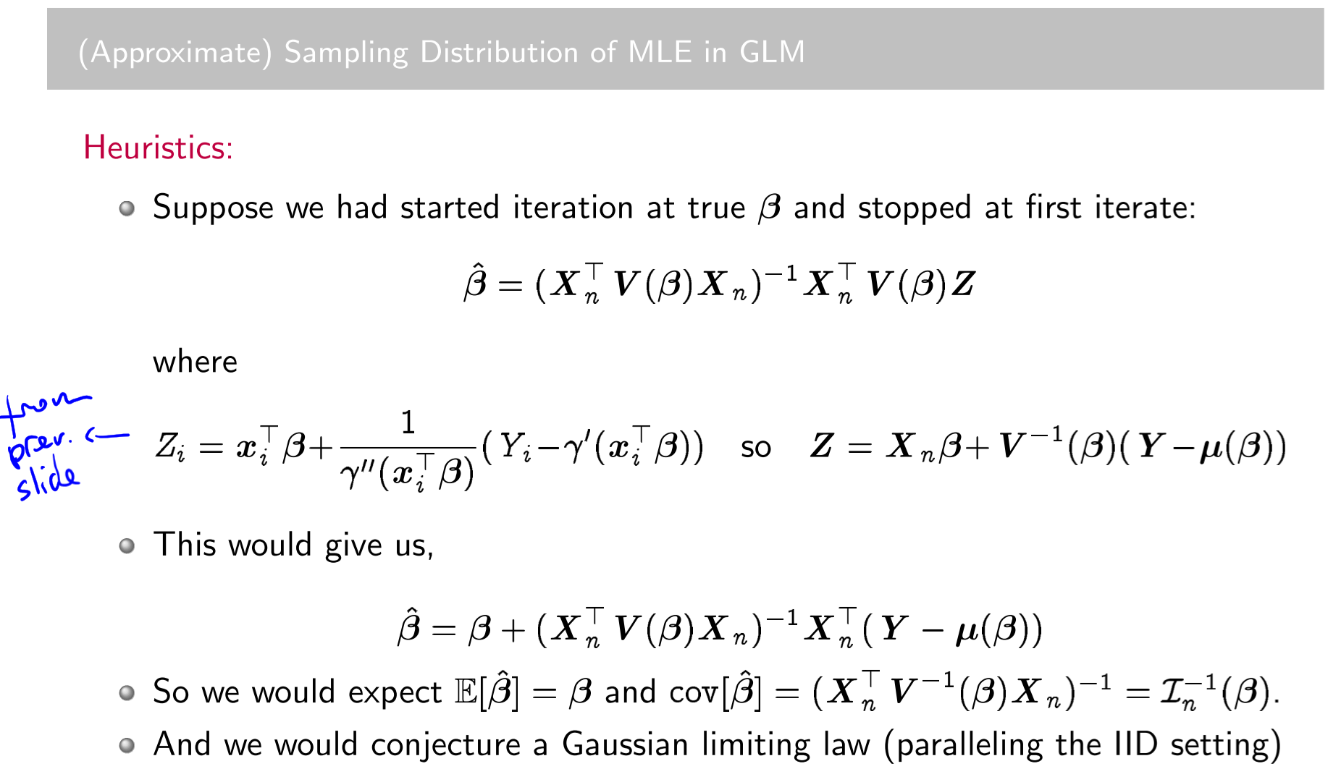

**Lecture 18 – Generalized Linear Models**

Important: asymptotical normality of MLE in GLM

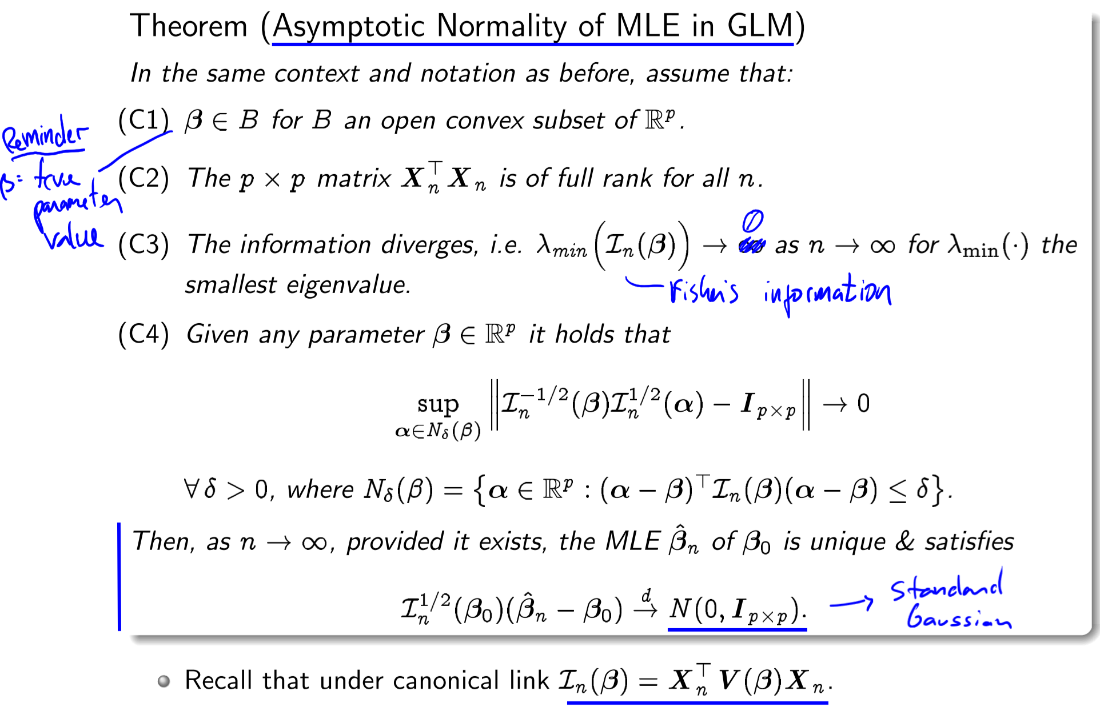

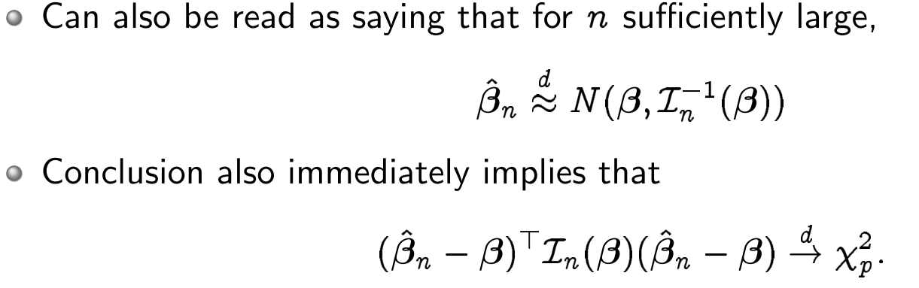

Box-Cox transformation

Instead of using GLM on non-gaussian distributions, we use Box-Cox to make dist. look Gaussian

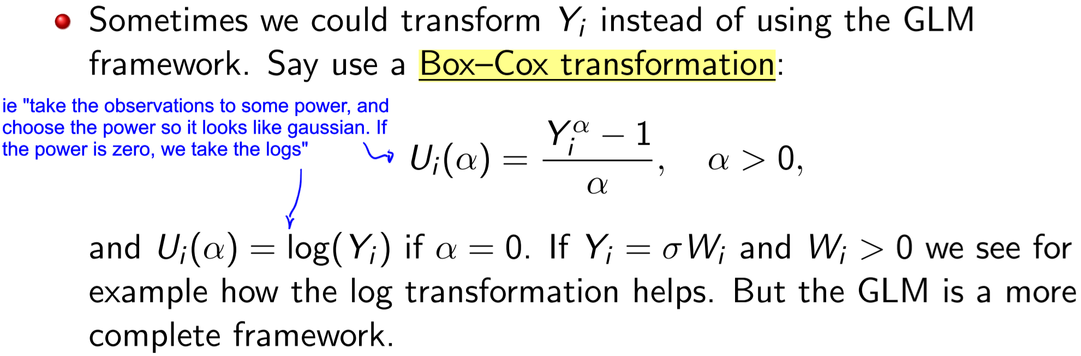

Examples on slides 7 and 8 (ignored).

**Lecture 18 – Measures of fit**

**Saturated model, saturated likelihood**

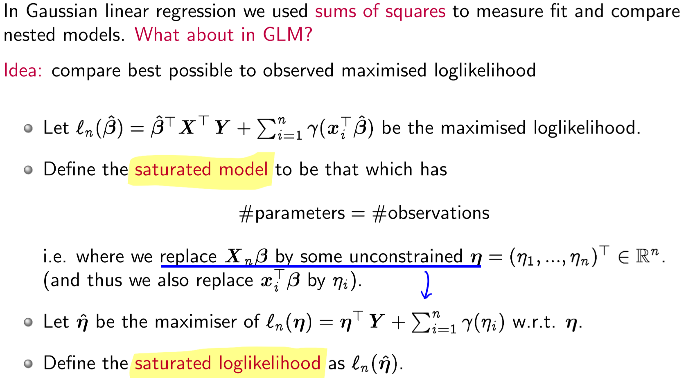

**Deviance, Scaled Deviance**

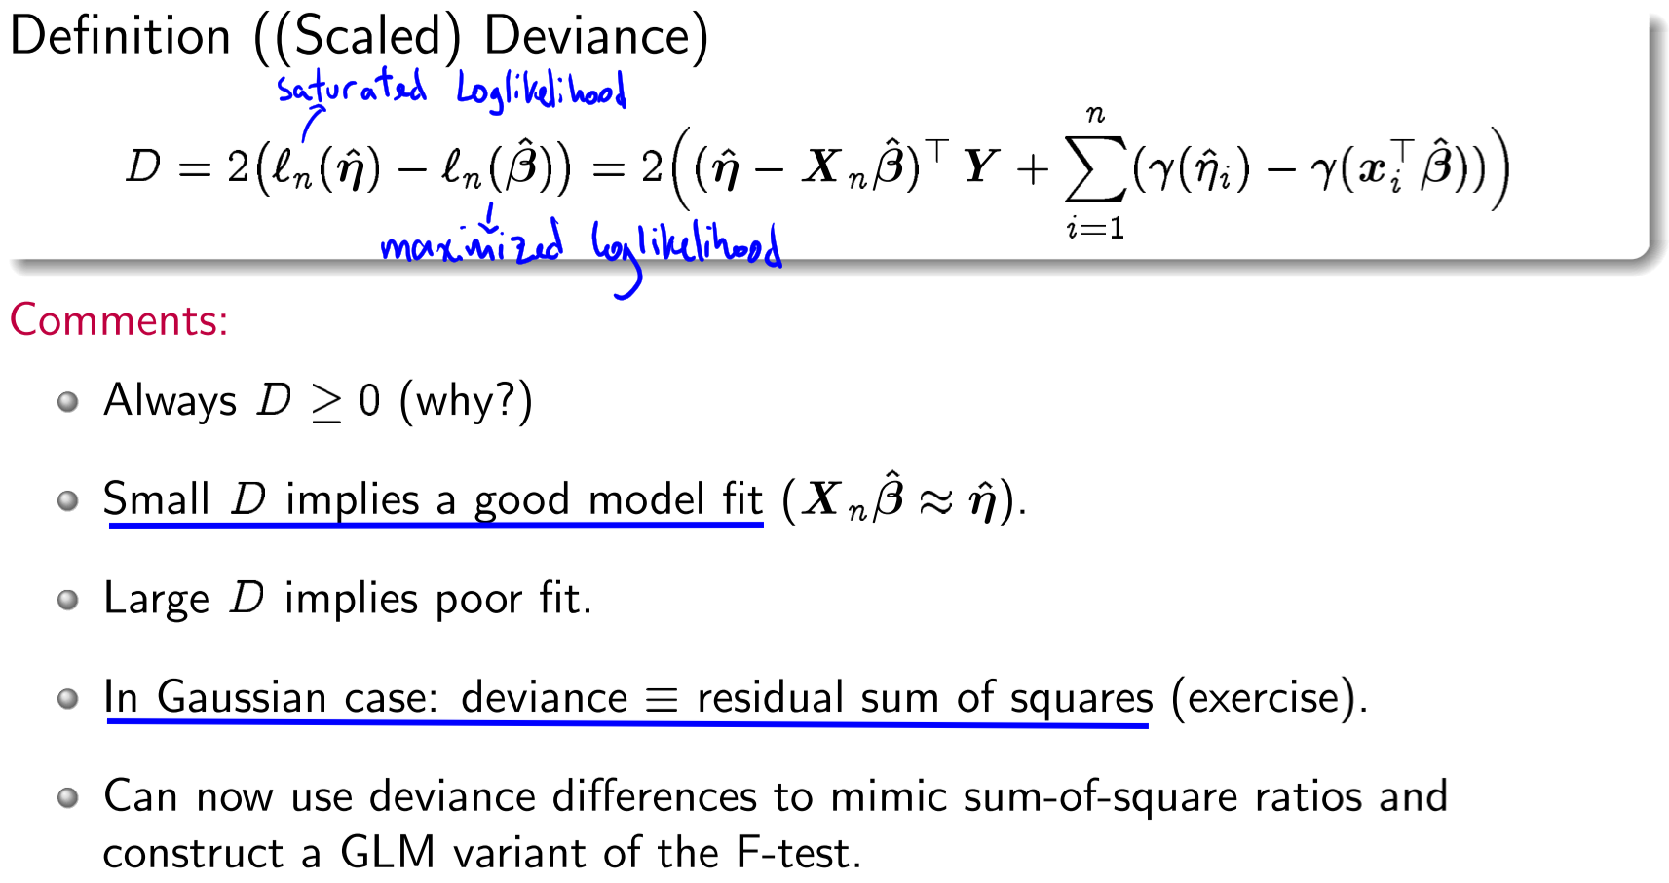

Example

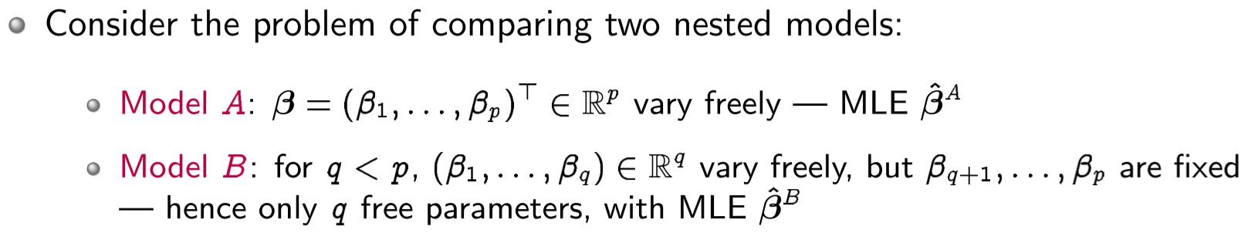 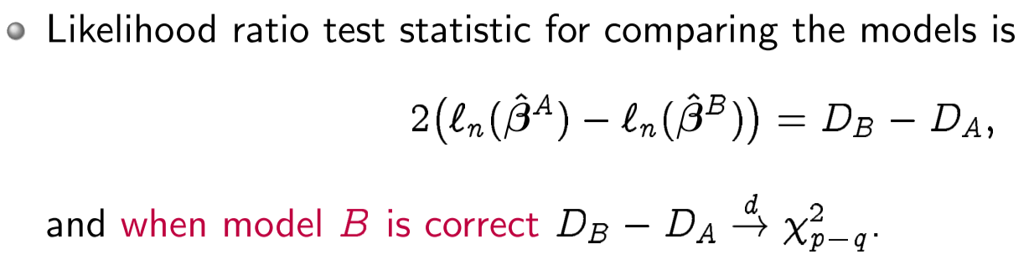

**Lecture 18 – Residuals**

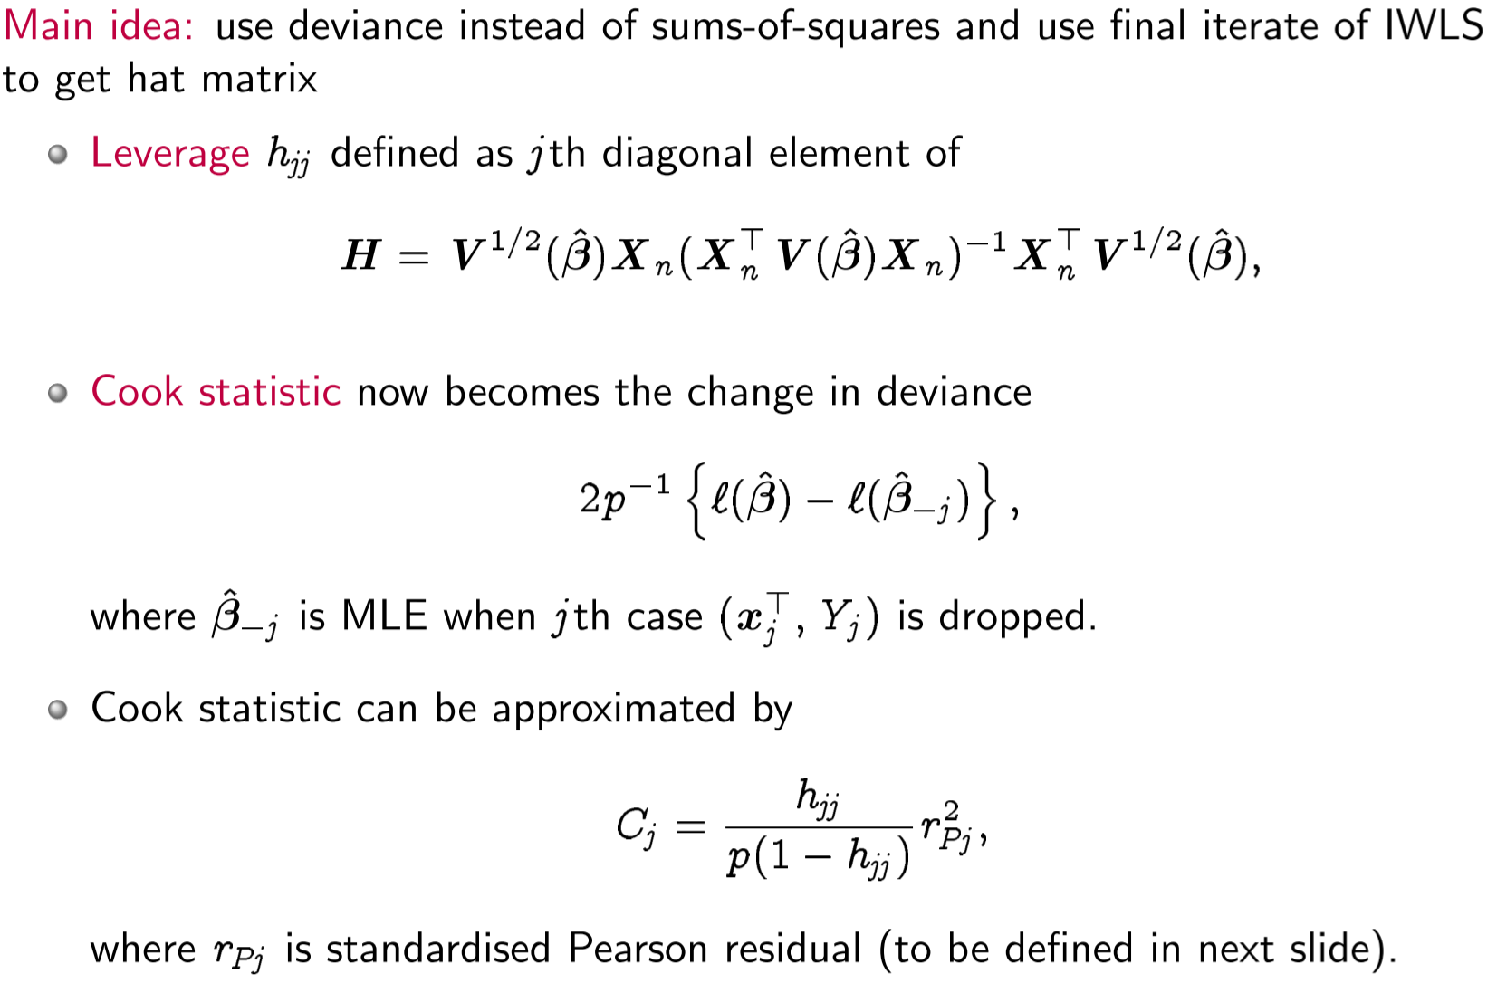

**Deviance residual, Pearson residual,**

We can use either deviance or pearson residual

* Professor prefers pearson because it gives a result in the space of Yi

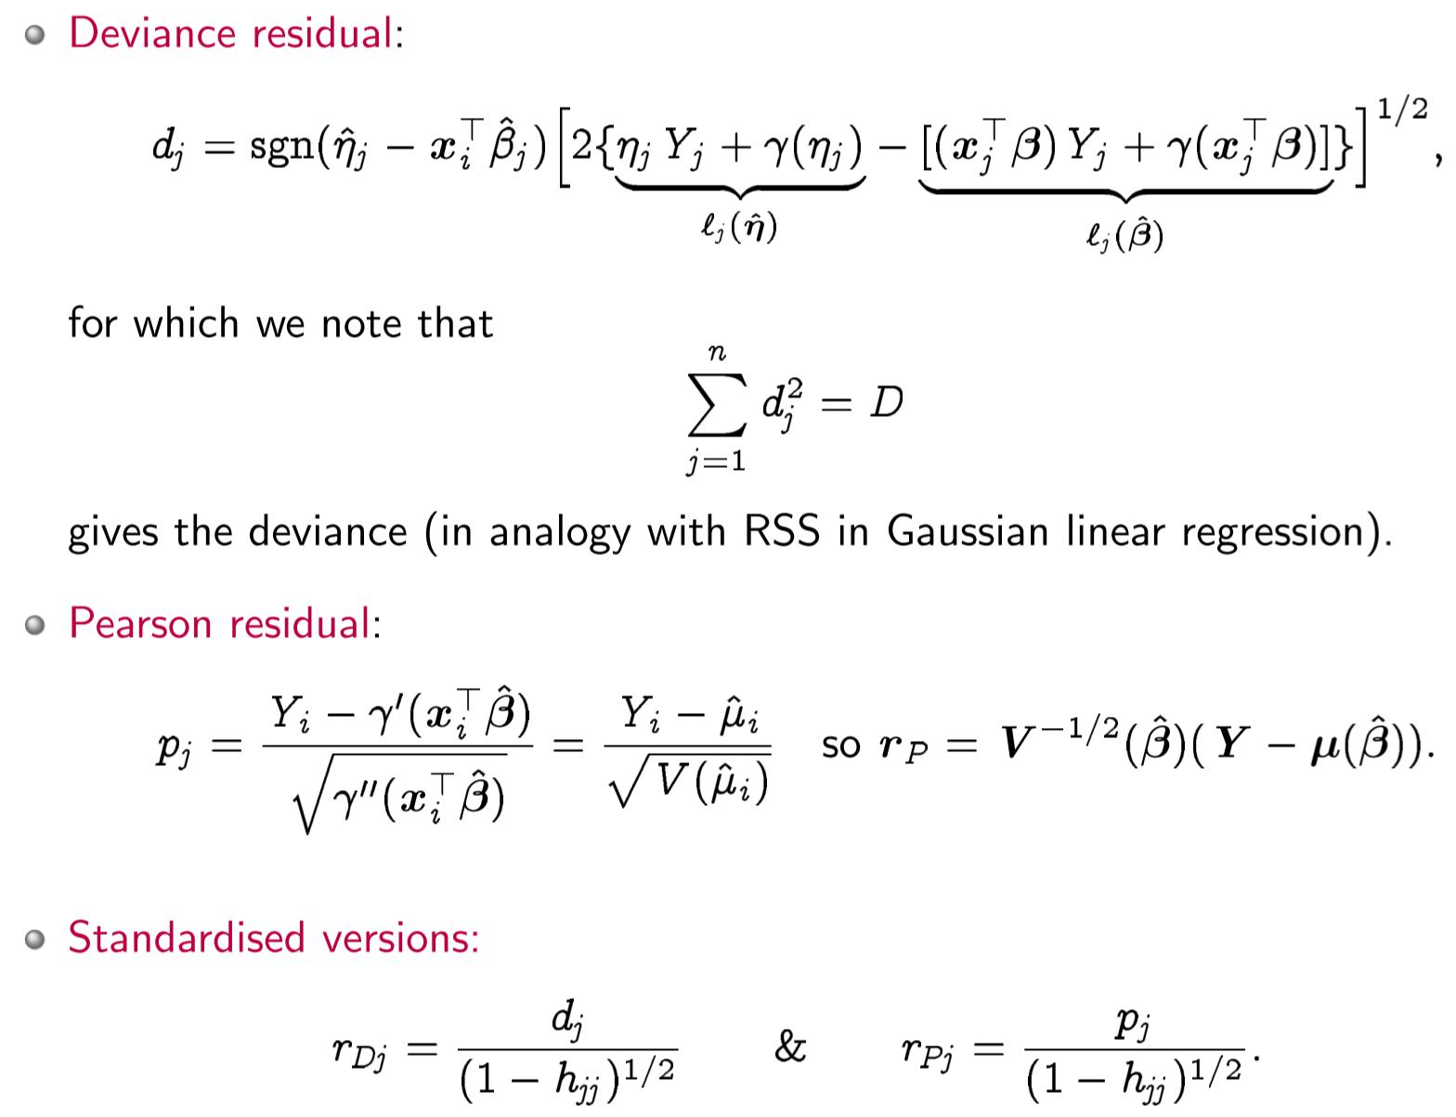

**Lecture 18 – Examples**

**Logistic Regression for Binary Data, Loglinear regression for count data**

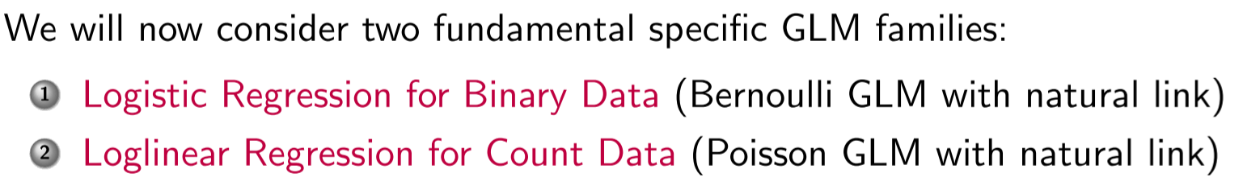

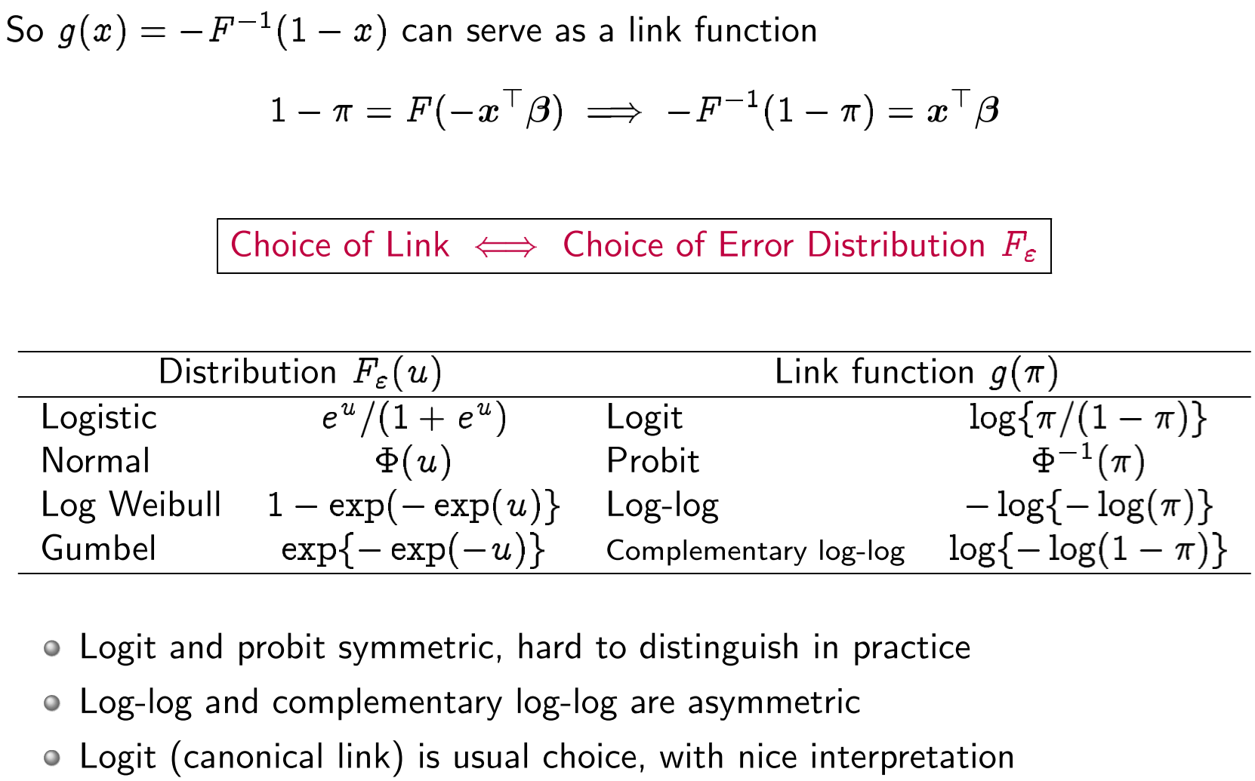

**Covariate classes**

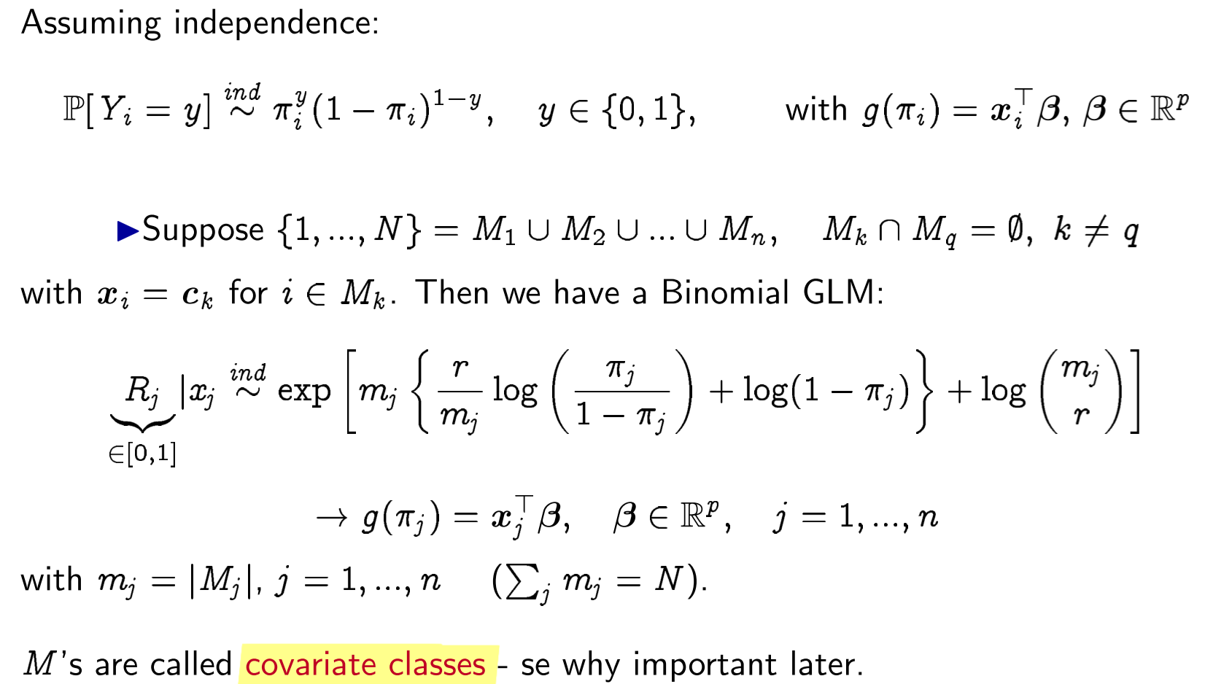

**Lecture 19 – Residuals**

Logistic/binary regression (slide 5) omitted.

Sparseness affects interpretability of deviance. A solution: grouping data! (i.e. merge into covariate classes),

**Jittered residuals**

Brillinger suggest the use of “jittered quantile residuals” for binary responses (a.k.a quantile residuals)

**Lecture 19 – Separation**

**Logistic Regression** MLE (for bernoulli data?) does not exist when data are perfectly separable:

Stack exchange: 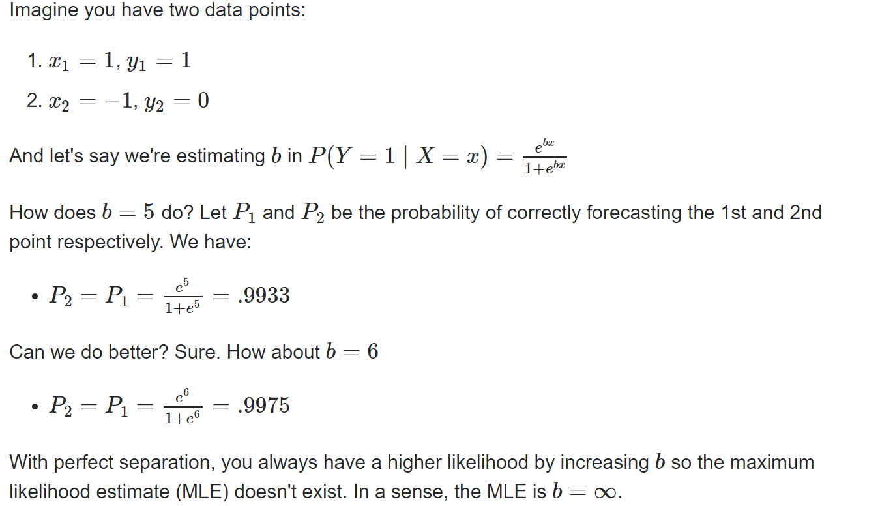

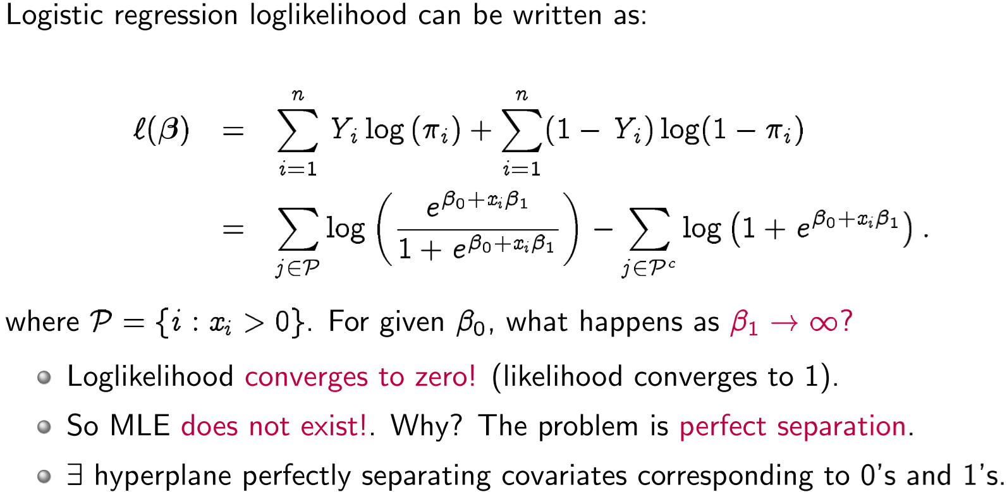

Complete separation

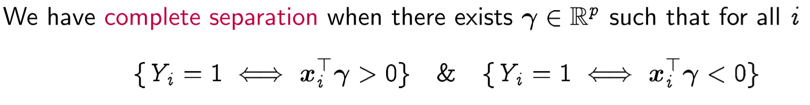

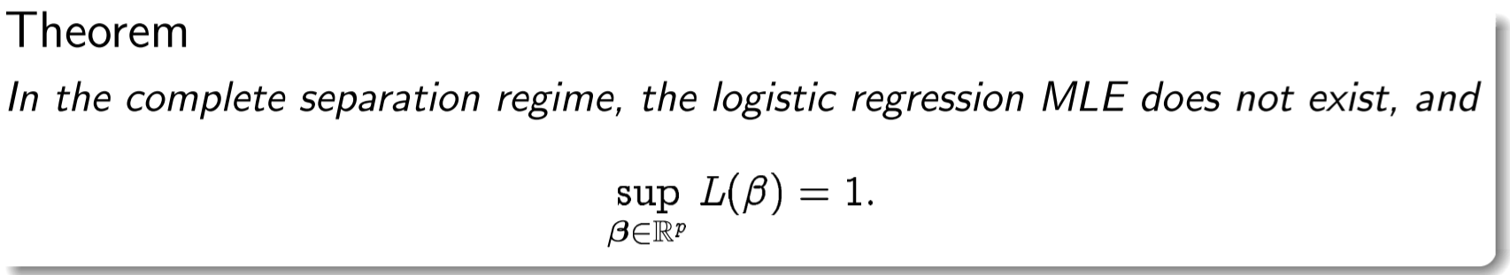

Regularized Logistic Regression

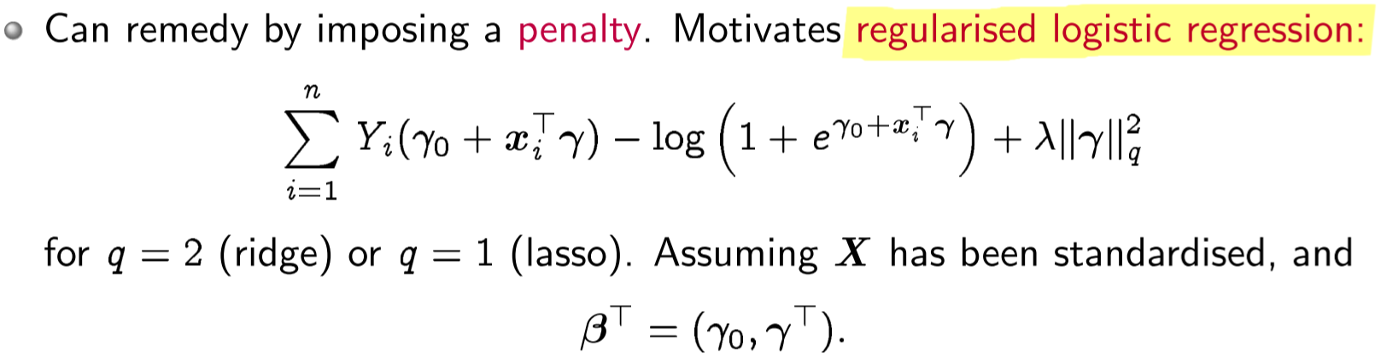

Can we at least hope that MLE exists in the overlapping regime?

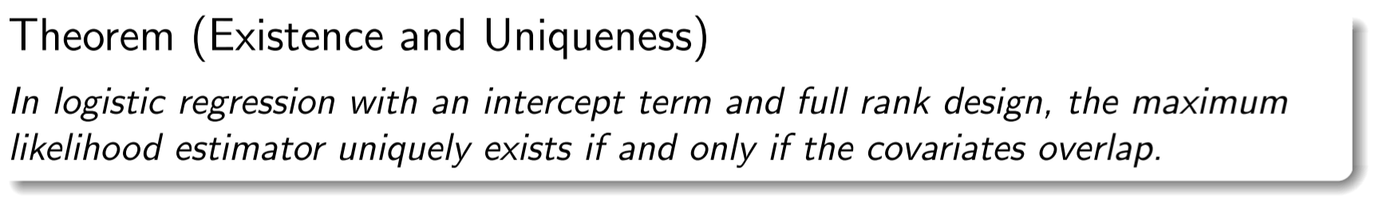

Countably infinite datasets, Lemma Poisson and Multinomial

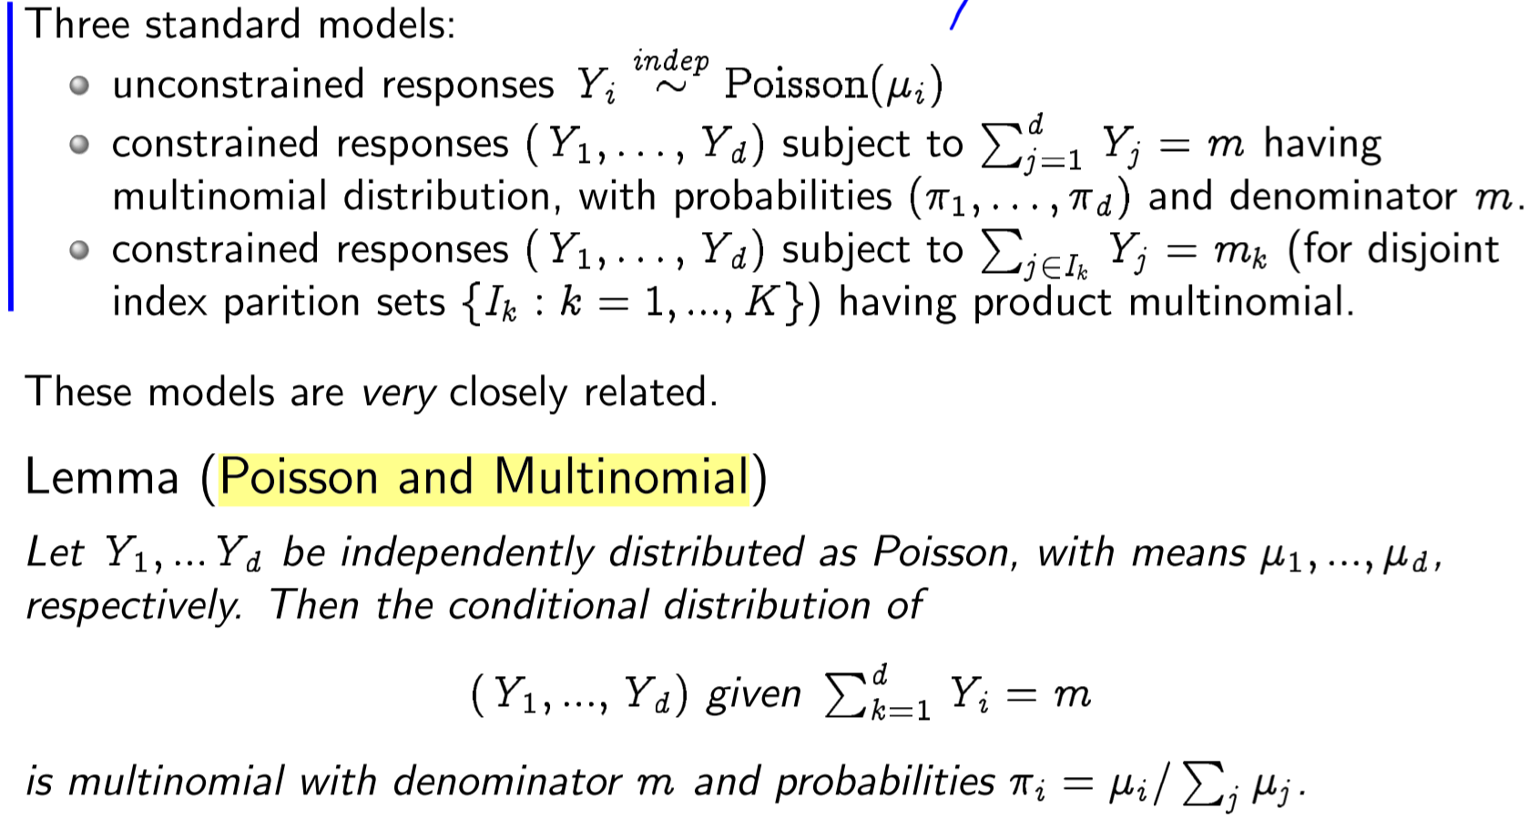

**Loglinear** regression for poisson GLM , slide 19

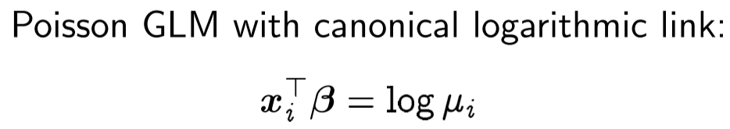

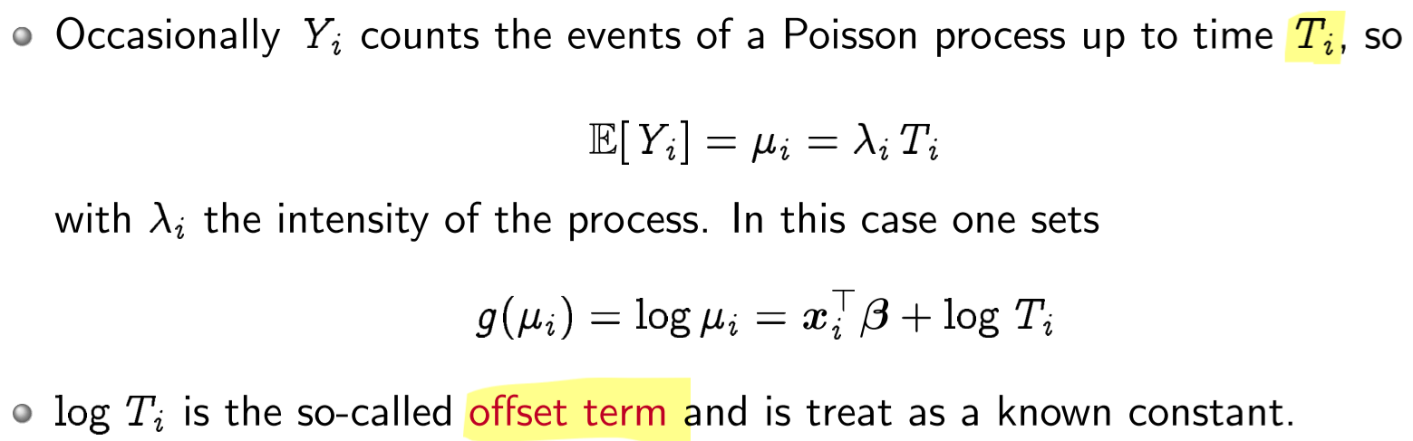

…

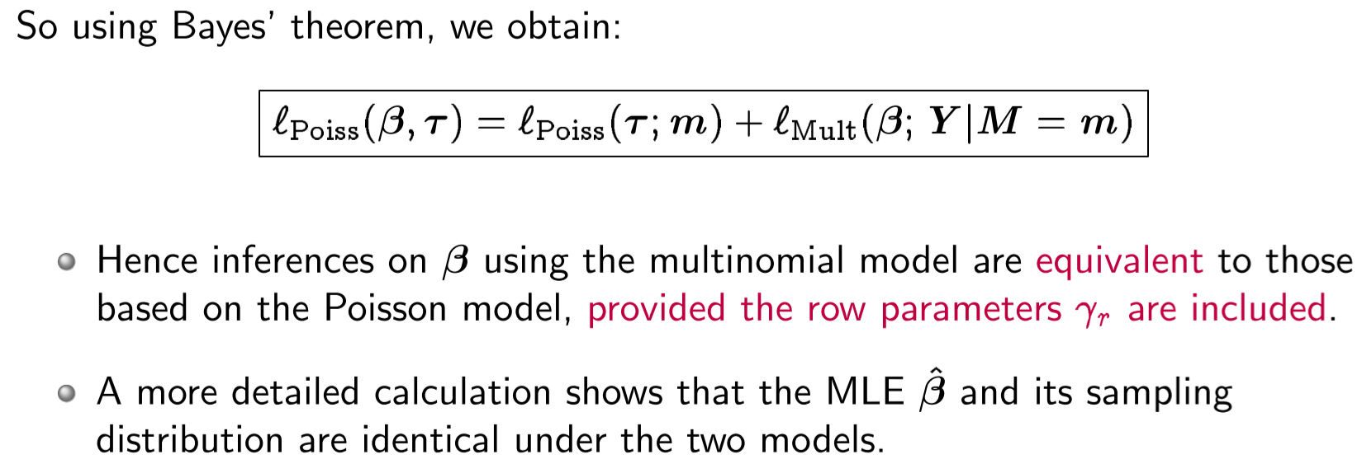

Perfect Separation can also affect multinomial regression: If any one class is separated from all the rest by a covariate hyperplane, then by reduction to the binary case we can see that the MLE for that class will fail to exist. A covariate is an independent variable.

**Lecture 19 – Nonparametric relationships**

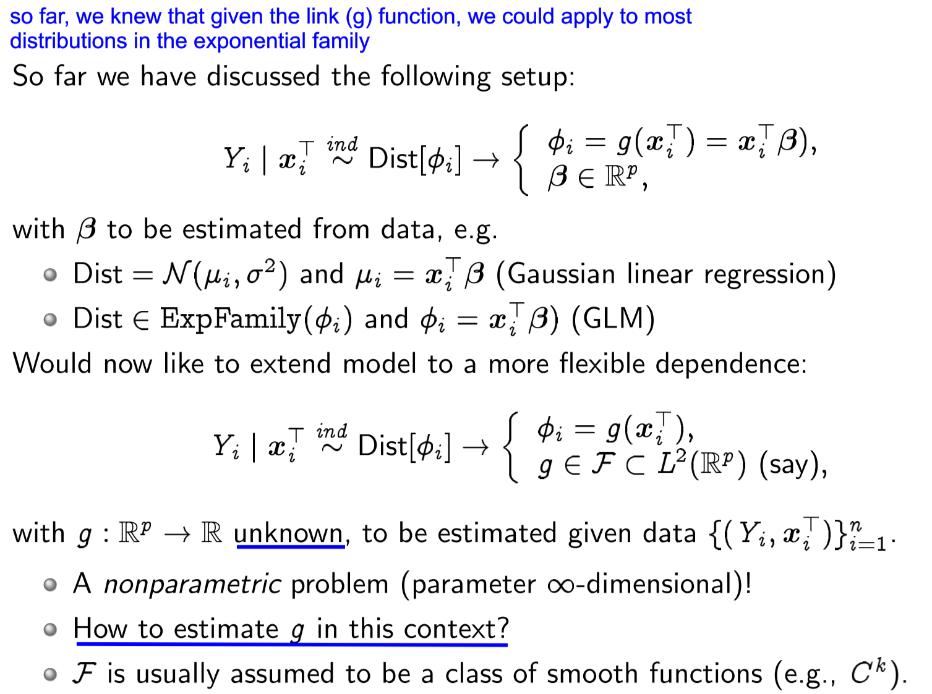

As before, we take samples and “create” or “smooth” input using kernels:

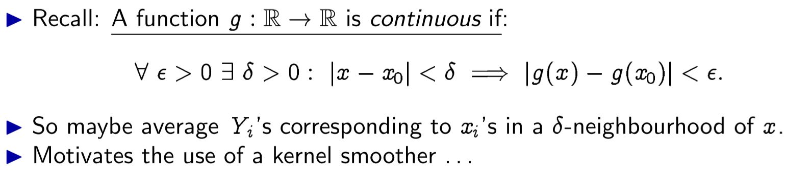

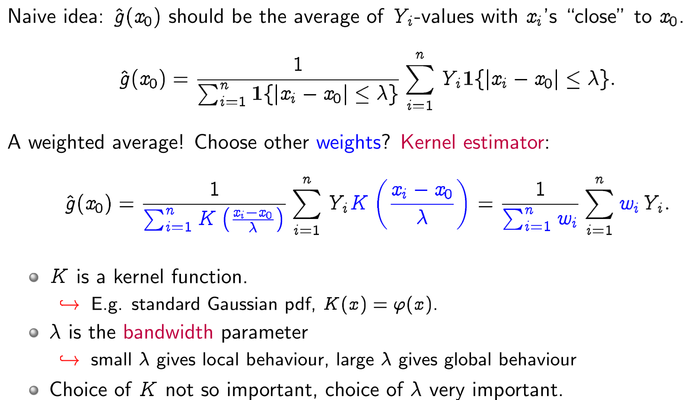

**Lecture 20**

We use piecewise cubic splines to represent the non-parametric function

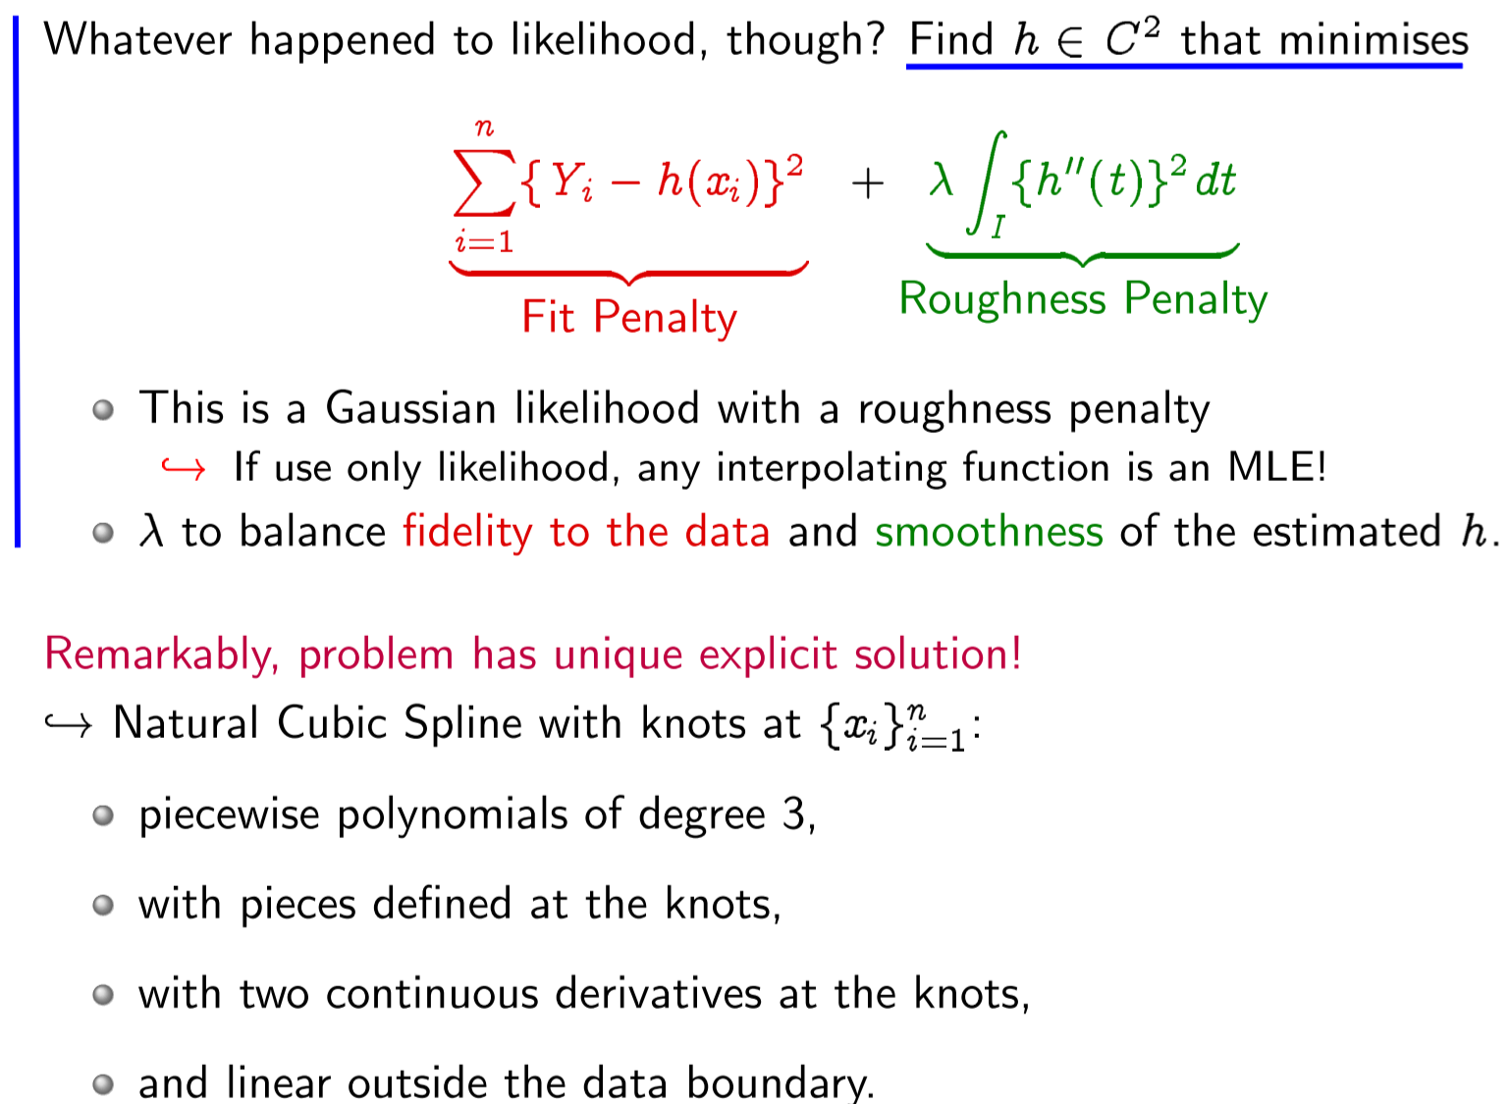

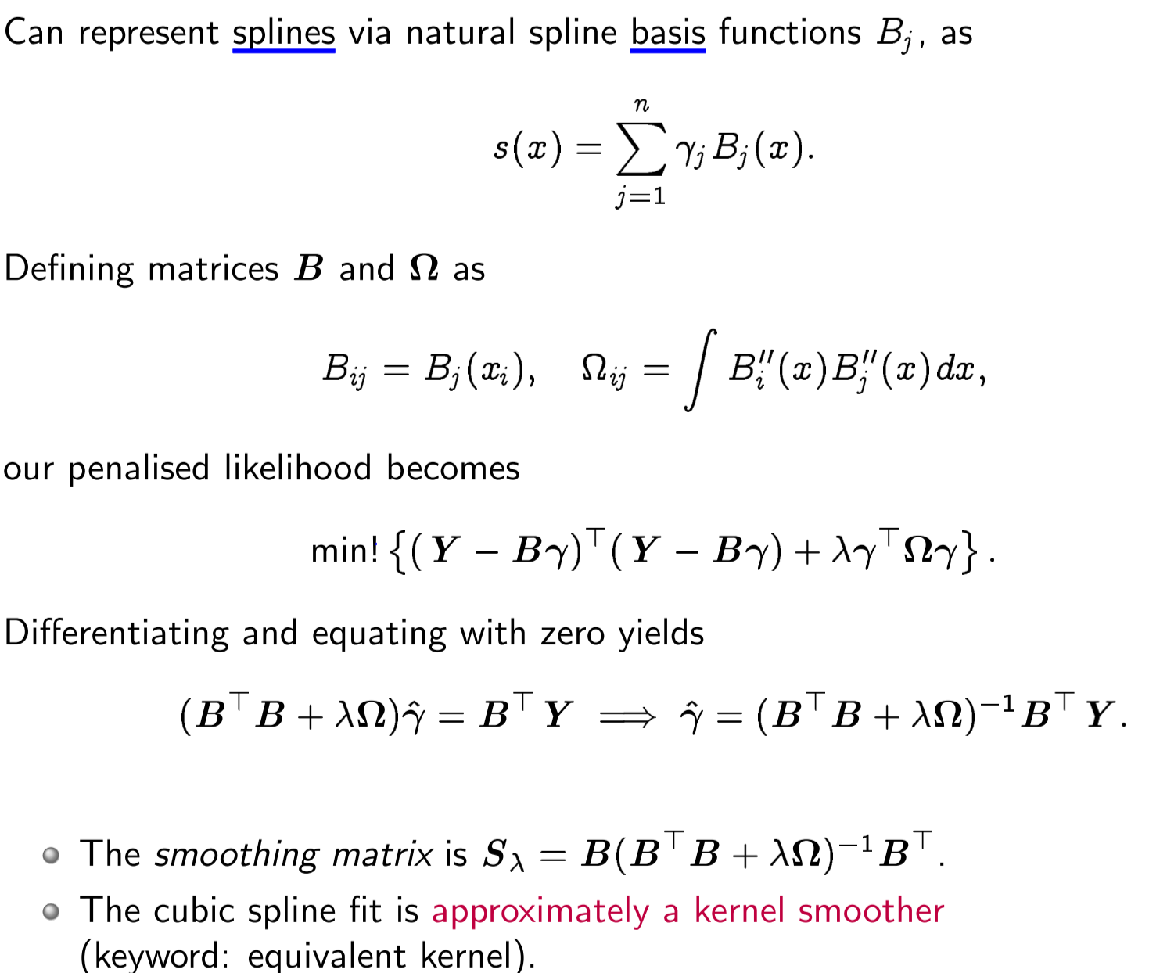

Degrees of freedom

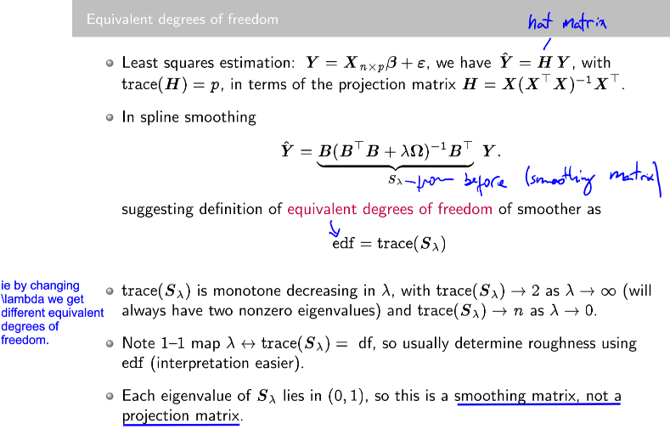

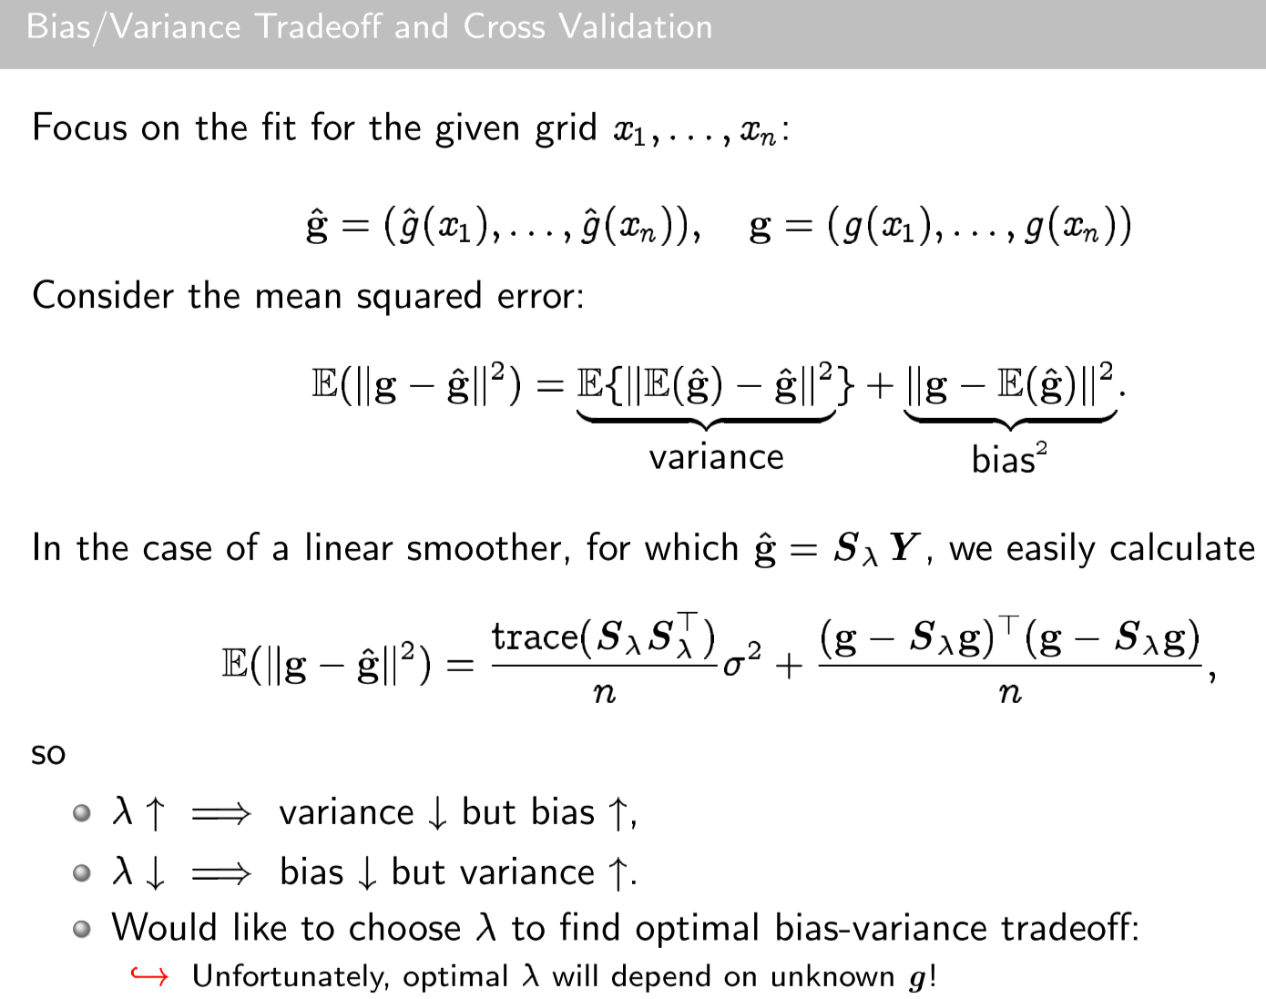

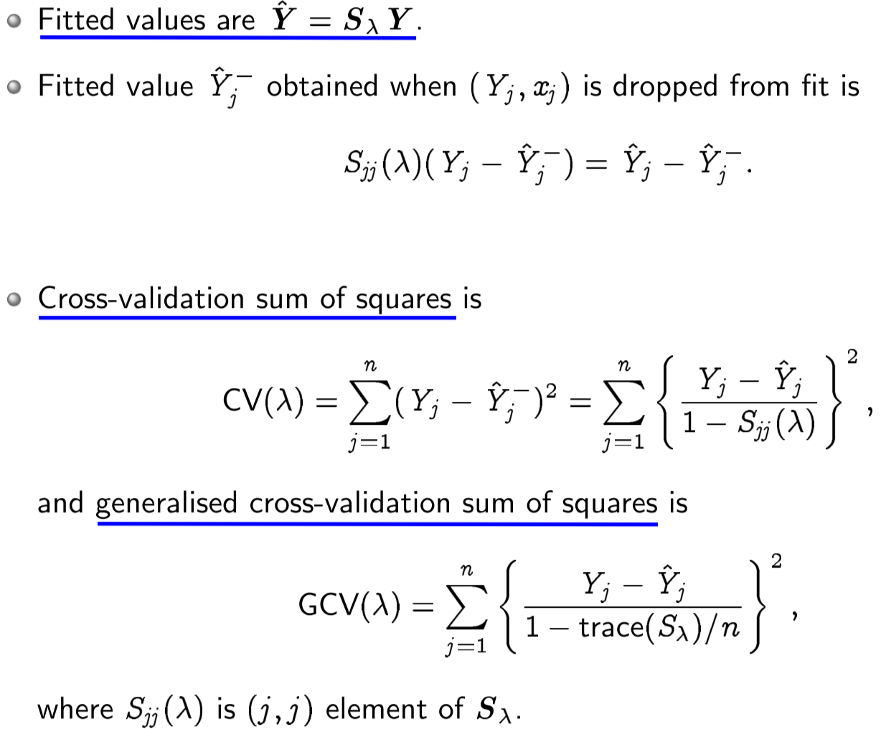

**Orthogonal functions (bias)**

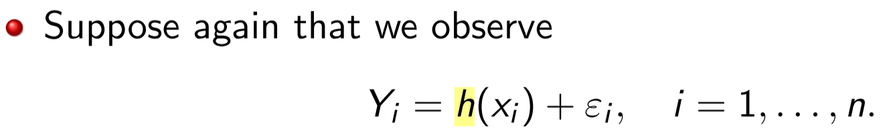

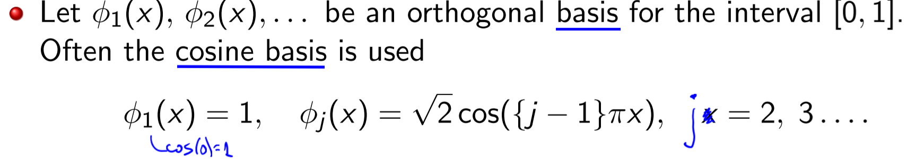

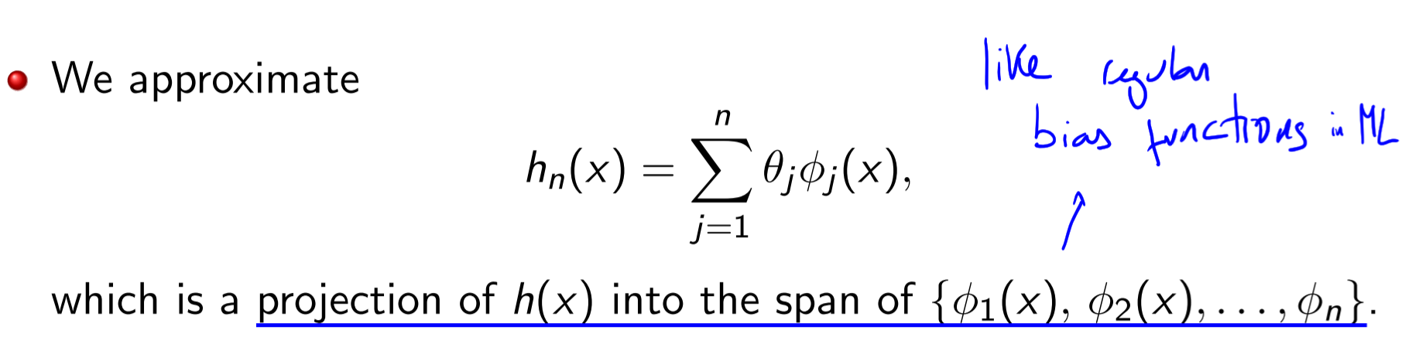

Modulator

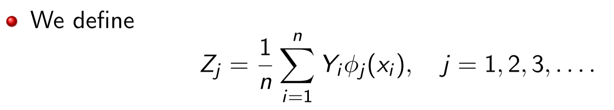

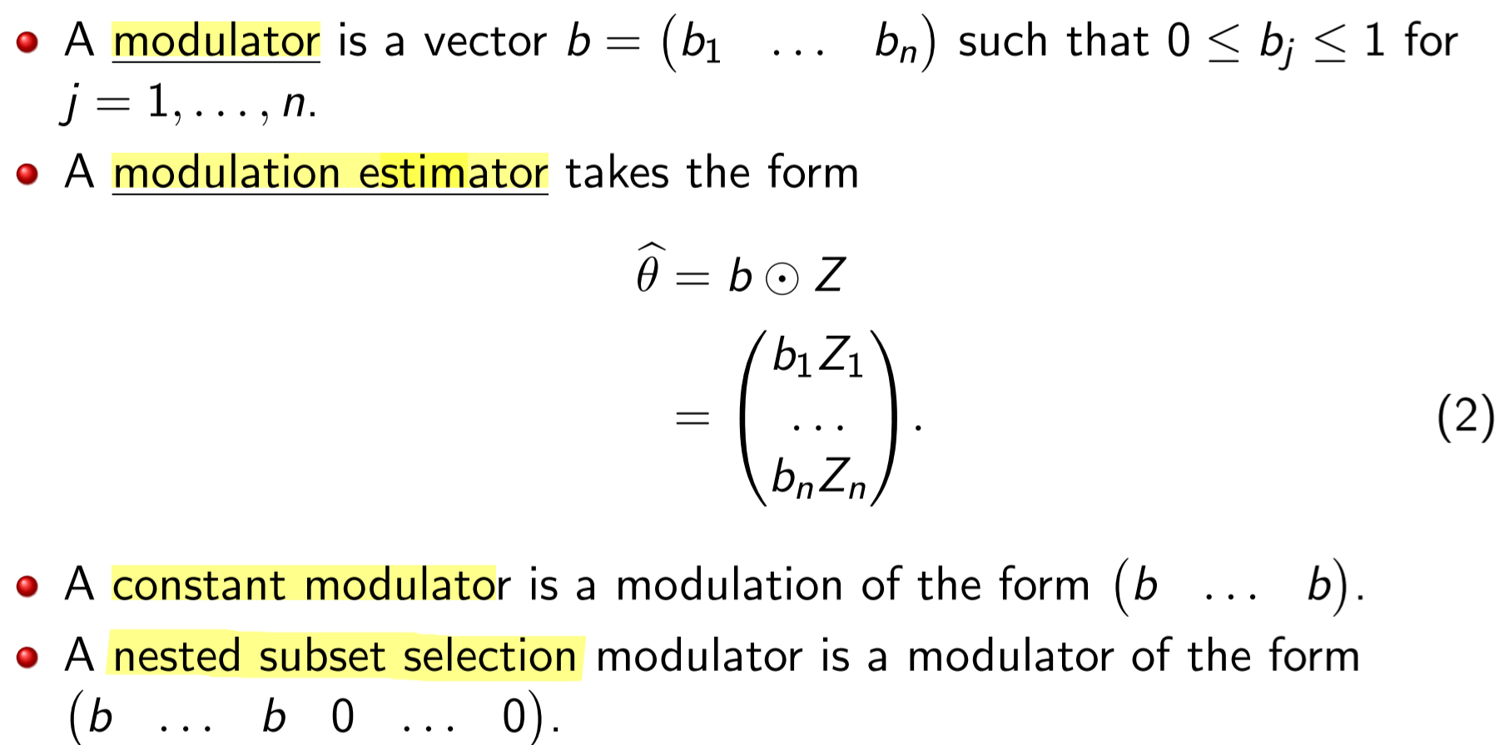

Now we use the modulator b to rewrite our problem that was “find the function h”

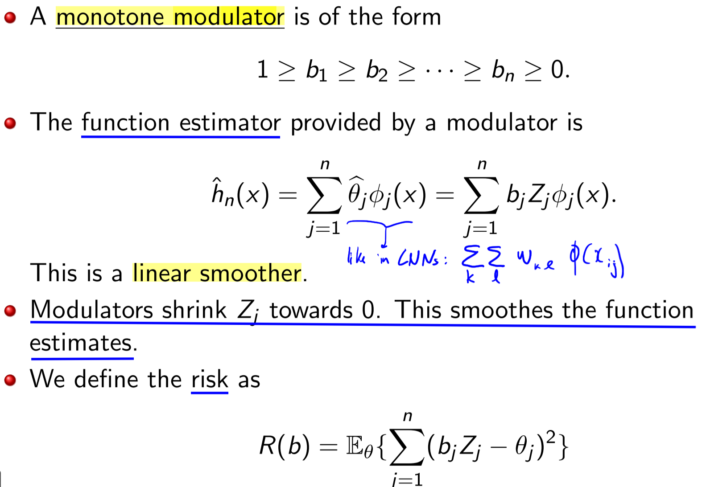

On the new formulation we have b (a modulator) which is unknown.

* We know the other terms: Y_i are observations and \phi is the cosine bias (?)

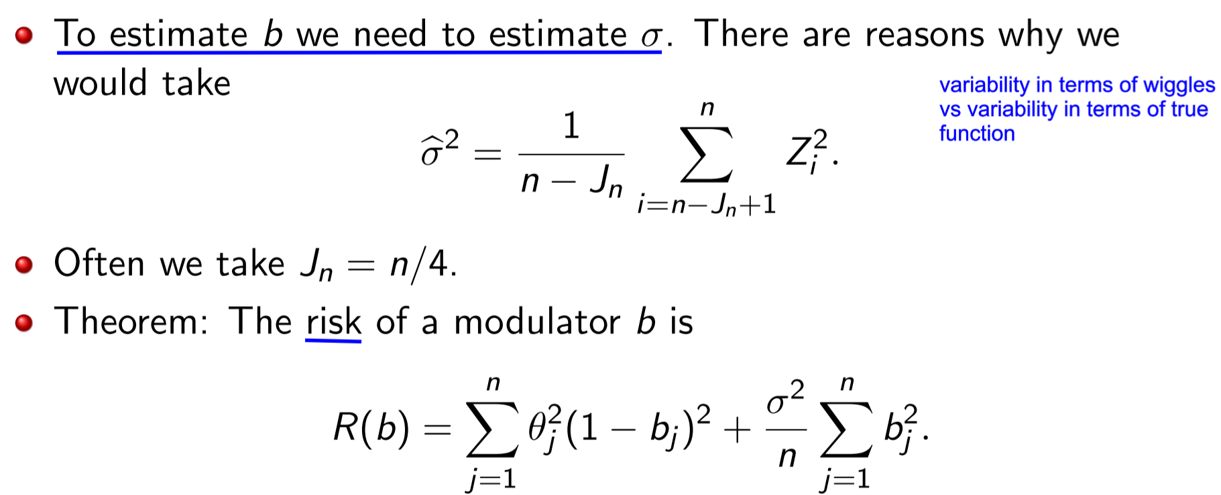

…. Etc ignored the rest on slides 19-??

If noise is not gaussian, slides 29-30!

**Lecture 21 – GLM examples**

Example of Bernoulli

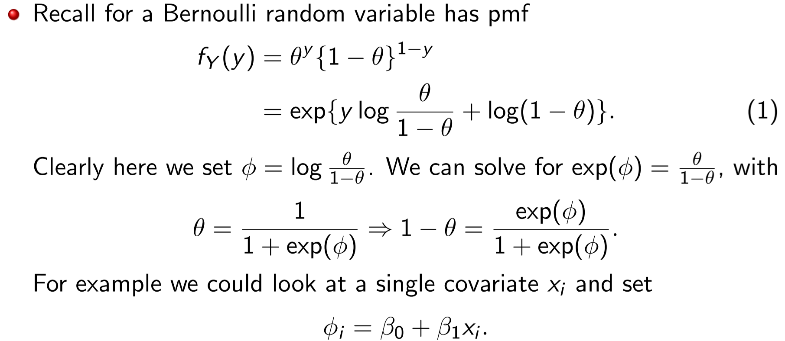

Reminder that the deviance is:

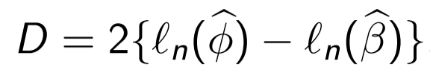

Poisson example

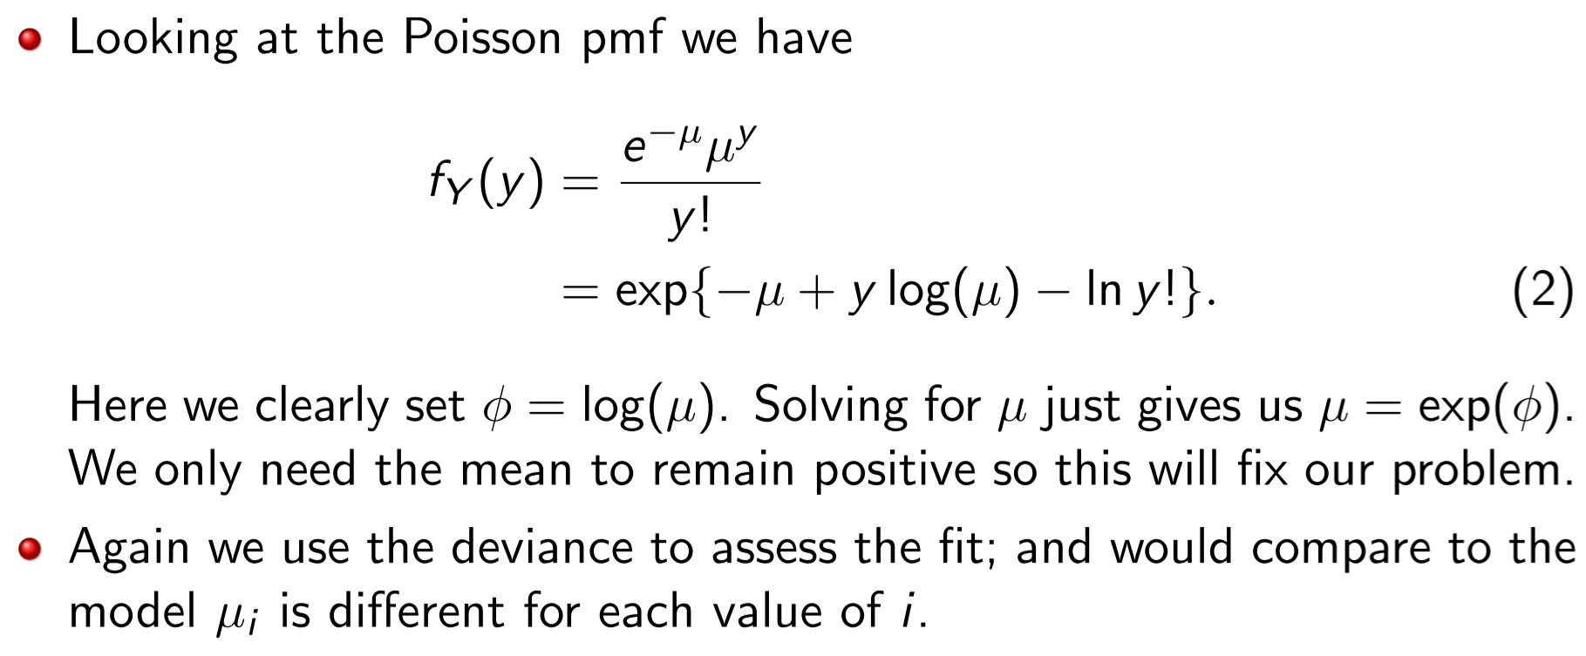

**Hastie and Park, elastic net**

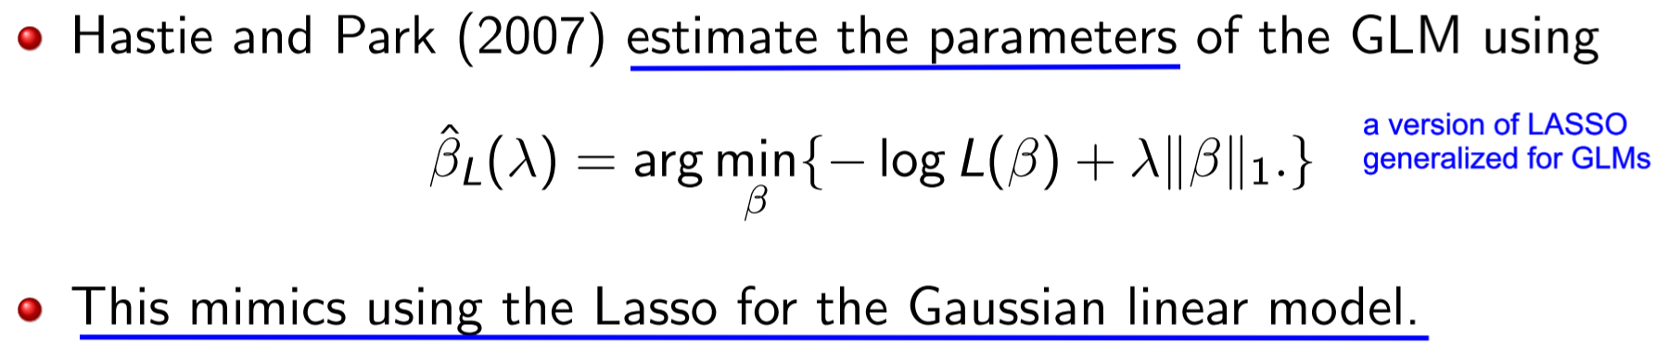

Unfortunately unlike the LASSO it is not a convex optimisation problem.

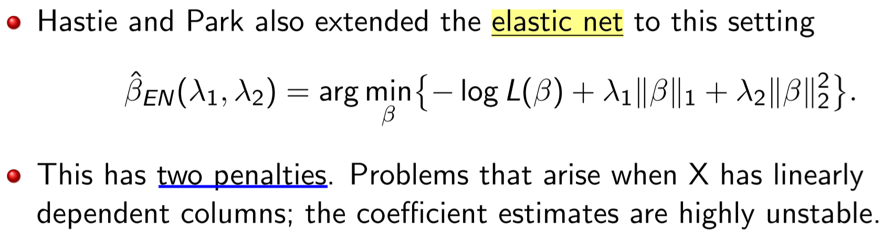

The additional penalization of the elastic net, is not either yielding a convex problem

**GLM Nonparametric relationships with x_i, penalised likelihood**

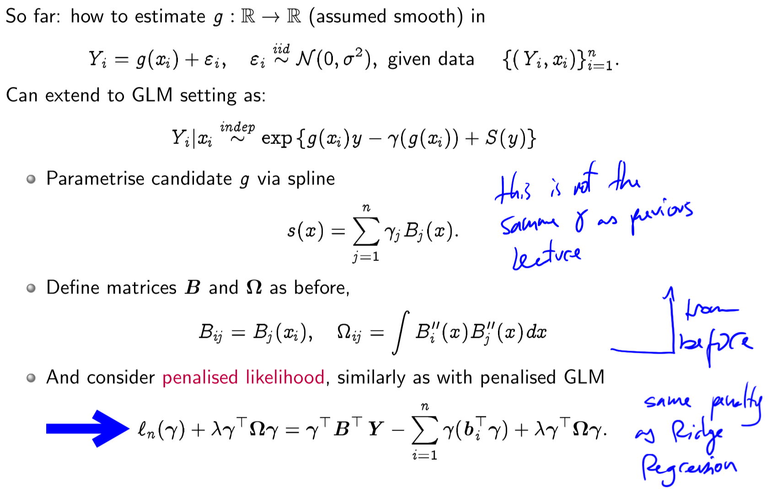

Hierarchy, or timeline of what we learnt:

* We started out as linear model Y = \beta x + \epsilon, with a gaussian and a parametric model
* What if the data is not Gaussian?
* We moved to GLM, where we assumed a non-Gaussian distribution of Y
* We assume Y is not \beta x, but instead an unknown function g
  + We did that with Lasso, Ridge regression, and regularised…
* Now if we don’t want a Gaussian for Y, and want a general form non-parametric form for g
  + We use g as a combination with spline. So it’s NON parametric and NON gaussian
* Then we moved to unknown function relationships with non-gaussian data

How do we generalize even further?

“If we have too many variables and are living in some space, we need to worry that we’re not creating some artificial low dimensional space that we’re hoping around in”:

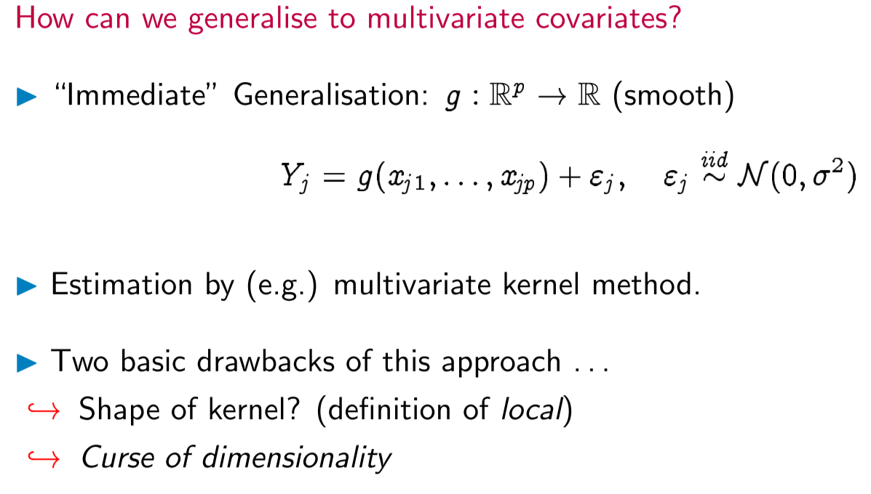

These have homostoscatic (?) variables.

Here we could use the kernel method to find function g. two drawbacks (slide 11)

* What will the kernel look like? E.g. use spherical (but we ignore difference between variables)
* Becomes harder and harder to estimate due to higher number of relationships between covariates, because the phenomenon we study grows in complexity with the dimensionality
  + **Curse of dimensionality** (slide 14): “neighbourhoods with a fixed number ofpoints become less local as the dimensions increase”

**Additive models:** proposed to get around curse of dimensionality: it captures variation in one variable, but allows for difference functions for each variable. And **Generalised Additive Models** if we have random variables which are no longer Gaussian:

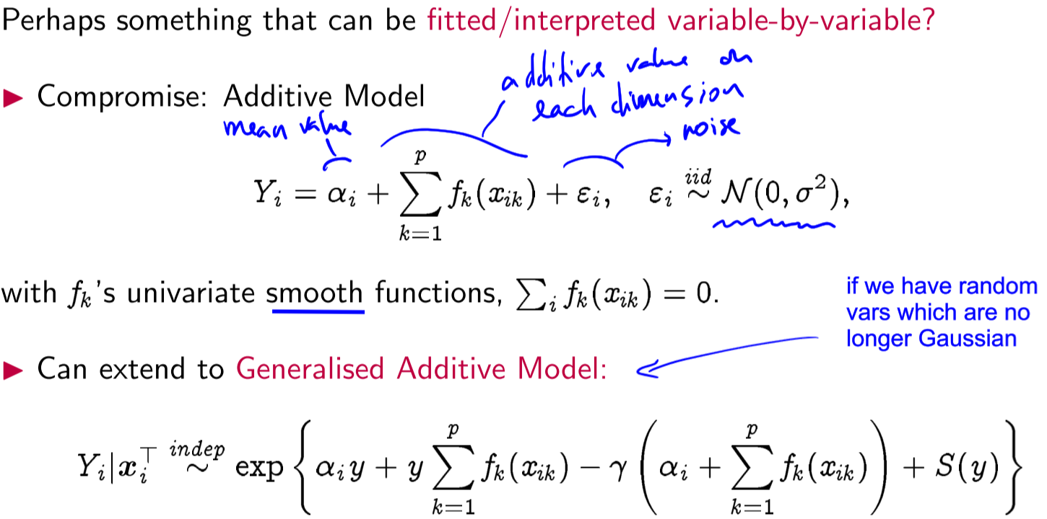

f_x needs to be fit, we use **backfitting algorithm**

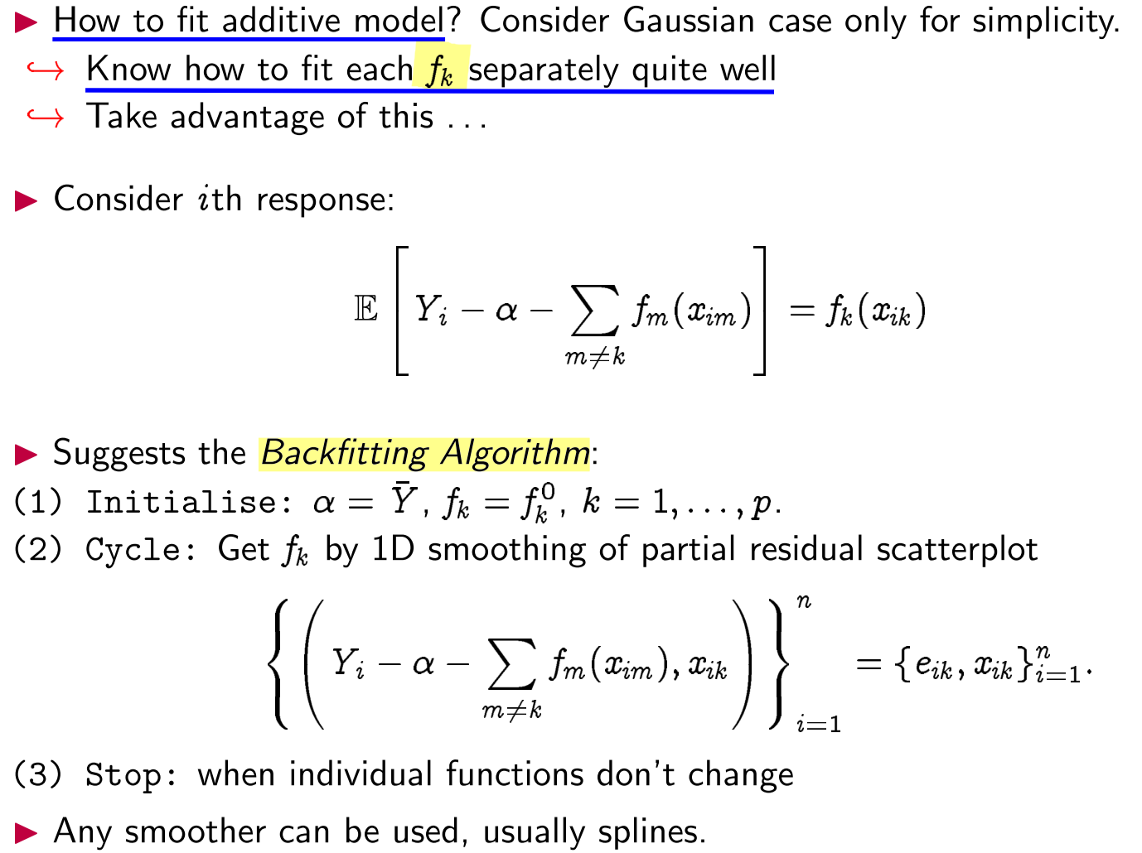

Or something inspired on tomograph (slide 12).

To fit model to the data, slide 18.

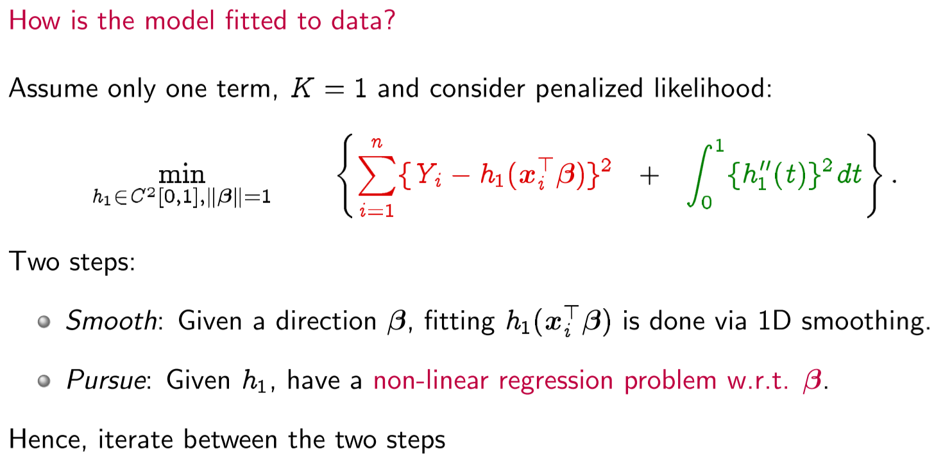

Since beta is estimated in a non-linear, we don’t need to estimate different values for h_k, we can fix one. Leads to a **single-layer neural network**

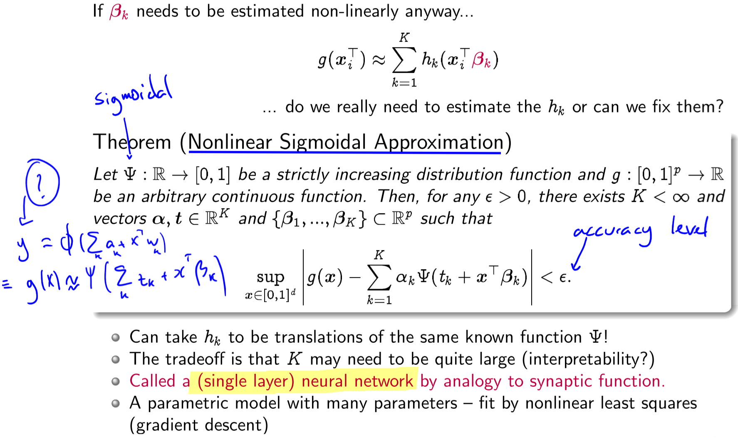

Since we’ve gone non-linear, why not attempt to learn which transformations to include from the data?

* Instead of including our original covariates ( columns of X)... ... use derived covariates ( can be larger than ). (My note: these “derived covariates” are the weights of a **DNN, Deep** **Neural** **Network**)

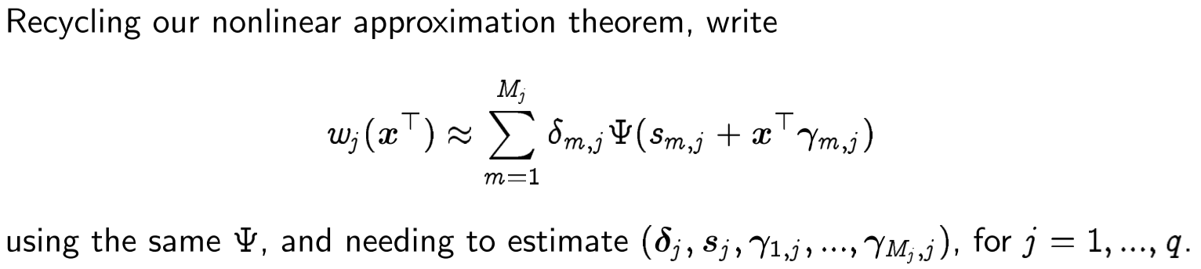

* + Highly non-linear and non-convex

**Lecture 22 – Causal Inference – NOT EXAMINABLE!**

If we say “X causes Y”; mathematically this means changing the value of x changes the distribution of Y. When X causes Y then X and Y will be associated (one type of association is correlation), but the converse is generally not true.

**Consistency Relationship** when the output symbols e.g. C_0 and C_1 are introduced to denote potential outcomes. i.e. Y = C_x

Note that many things are unobserved in this model. When X = 1 then we do not observe C0 for those cases; also when X = 0 we do not observe C1. We call those outcomes counterfactual.

**Average causal effect, causal relative risk, association:**

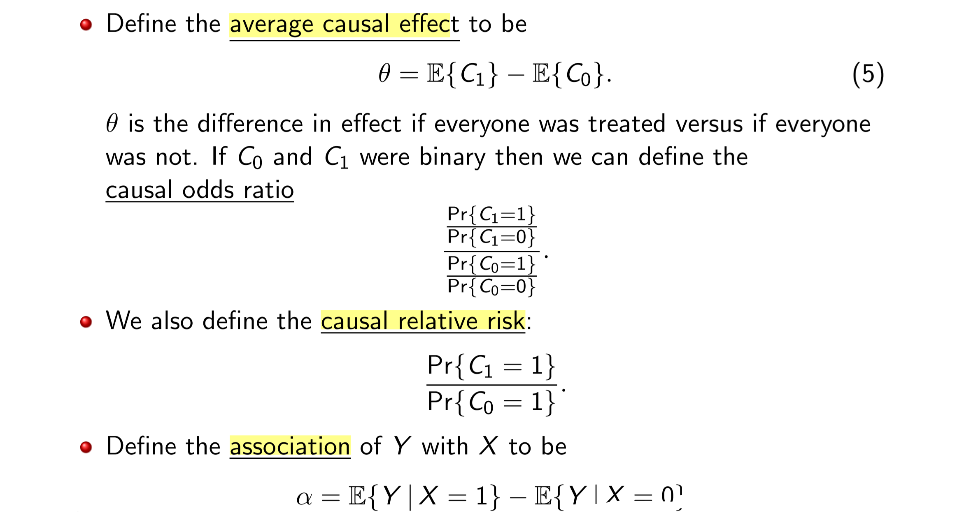

Association is not causation (slide 26), ie θ different than \alpha

* Ie causal effect is difference than association

**Lecture 22 – Causal Inference – NOT EXAMINABLE!**

Association is not causation. But if eg treatment would be randomly assigned to experimental units C0 and C1, then \theta = \alpha. Thus:



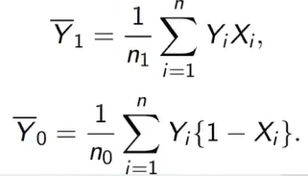

Because they’ve been randomly assigned, then X is independent of (C0, C1)

Thus, association = causation:

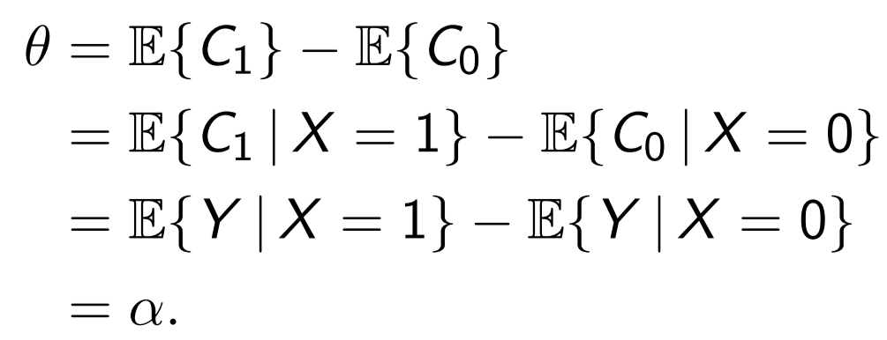

**Causal effect, conditional causal effect**

Can we at least hope that MLE exists in the overlapping regime?

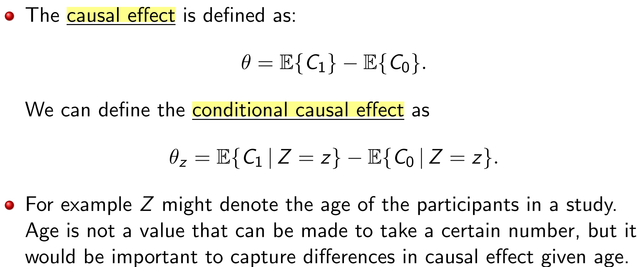

Now suppose X /∈ {0, 1} but instead X ∈ X. We then have a **counterfactual function C(z)** rather than the **counterfactual vector** (C0, C1).

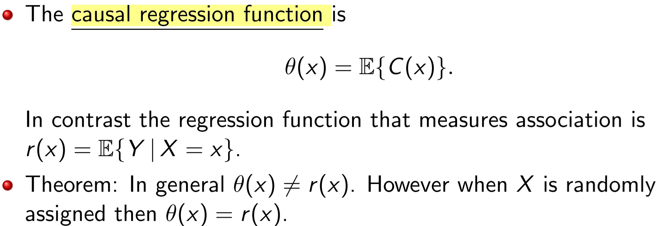

A study in which the treatment (or exposure) is not randomly assigned, is called an observational study.

**Cofounding variables, unmeasured confounding:**

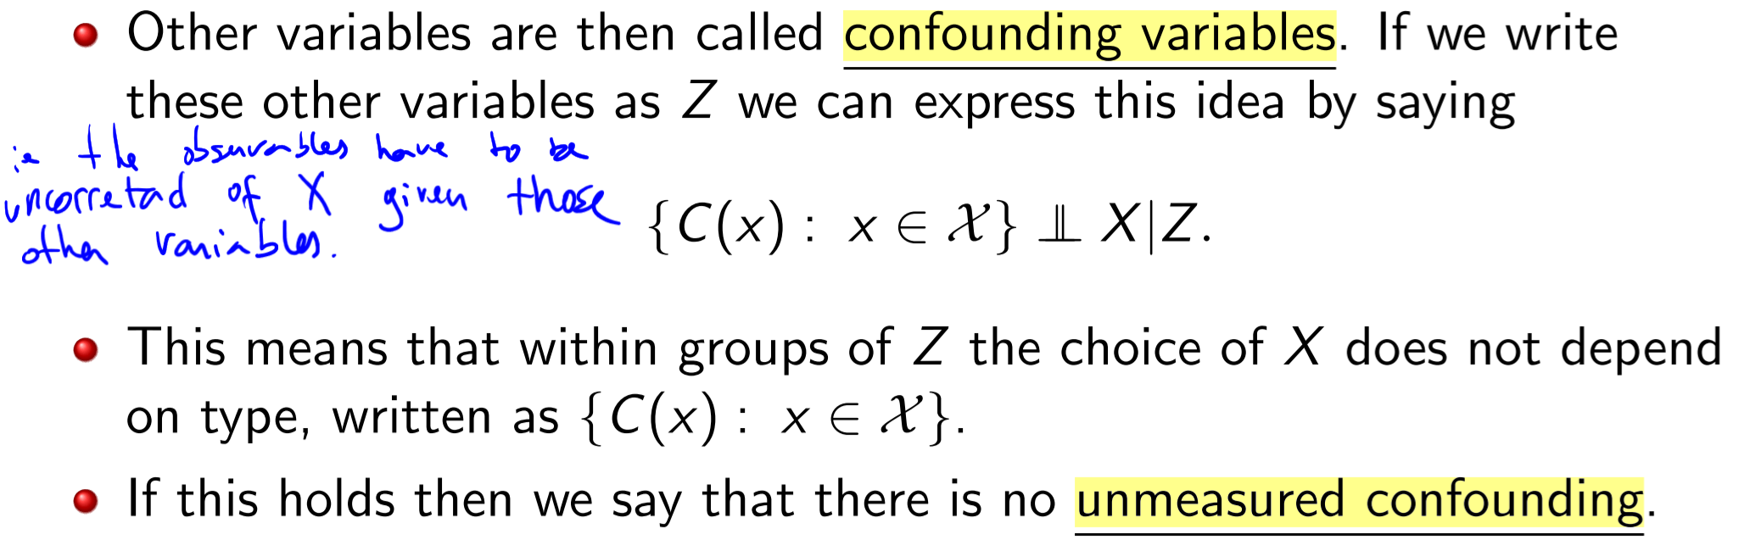

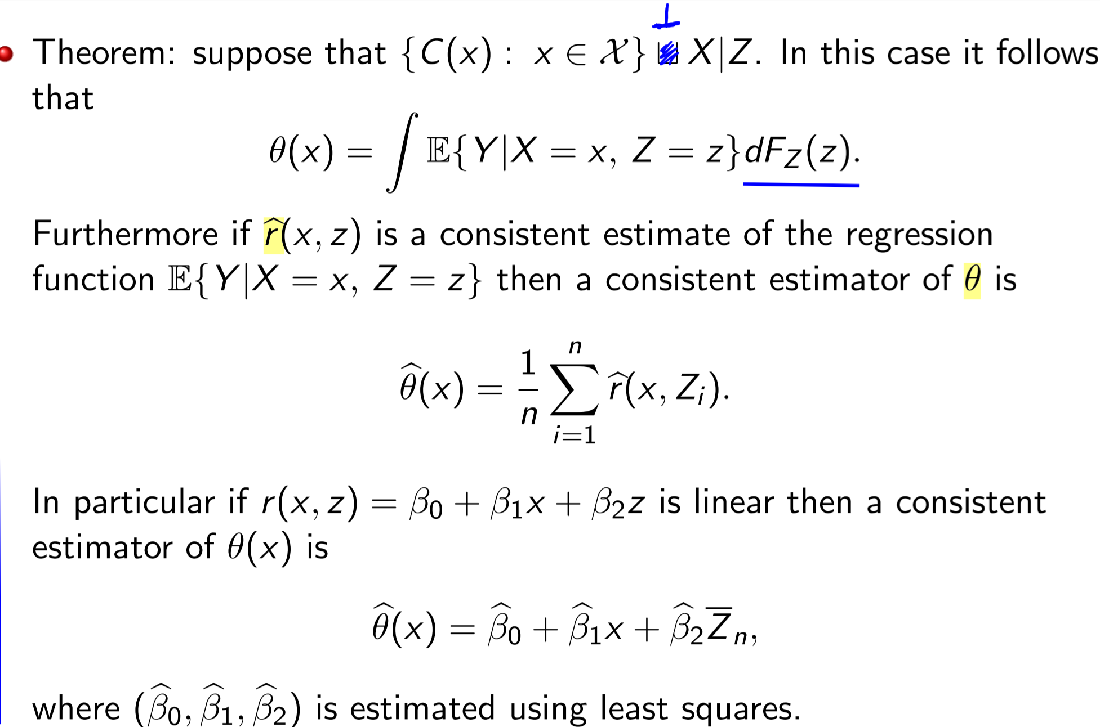

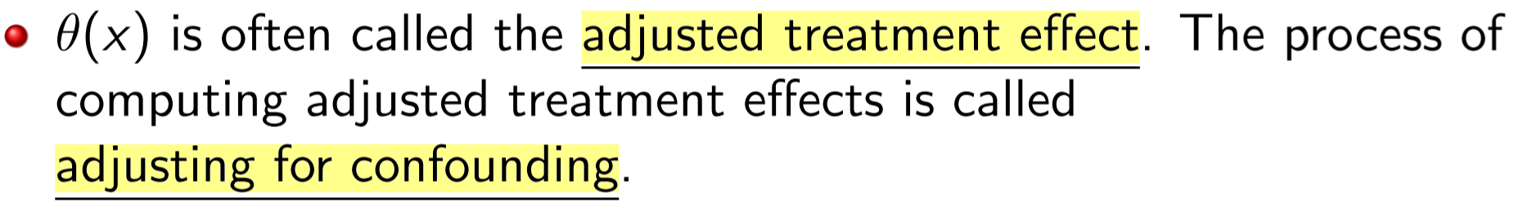

**Simpson’s Paradox** (on binary data) for tricky english interpretation (omitted)

**Lecture 23 – Directed Graphs**

Let X, Y and Z be random variables, X and Y are conditionally independent given Z (recall lecture 2) written X⊥Y|Z if:

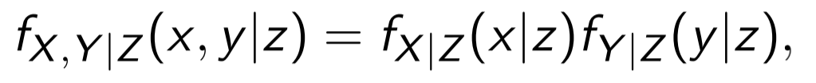

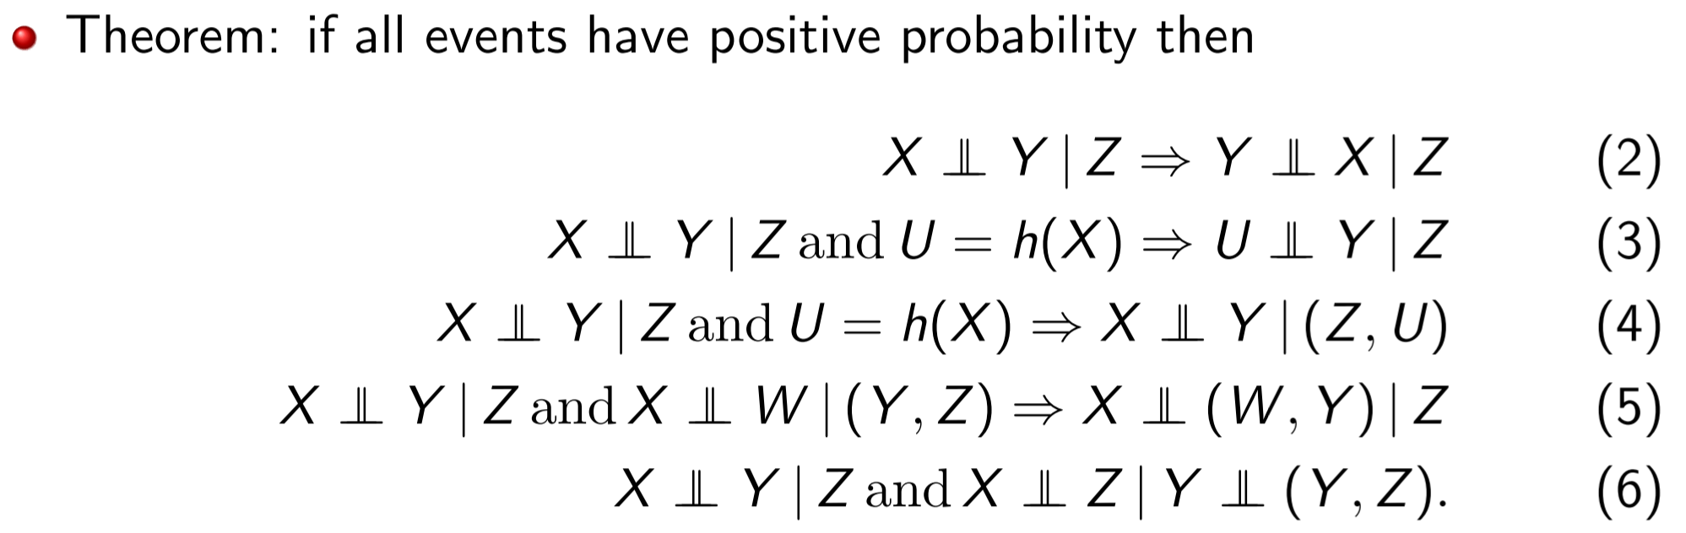

A directed graph G consists of a set of vertices V with an edge set E of ordered vertices.

If (X, Y) ∈ E then there is an arrow pointing from X to Y

The set of all **parents** of X is written as π(X)

If an arrow connects two variables X and Y (in either direction) then we say that X and Y are **adjacent**.

We say that X is an **ancestor** of Y if there is a directed path from X to Y. We also say that Y is a **descendent** of X.

When variables that are pointed into the collider are not adjacent to each other then we say it is an unshielded collider:

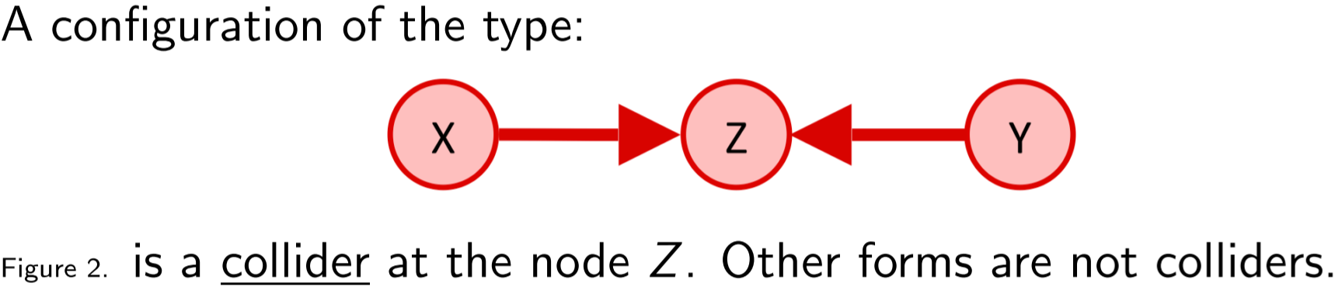

Let X be a binary treatment variable, Y a binary outcome and Z a third binary variable.

acyclic graph has no cycles

**Direct Acyclic Graph**

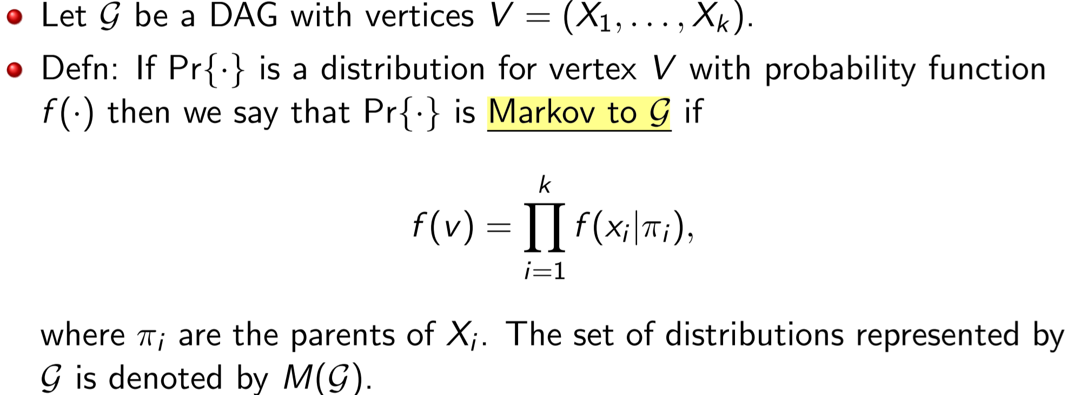

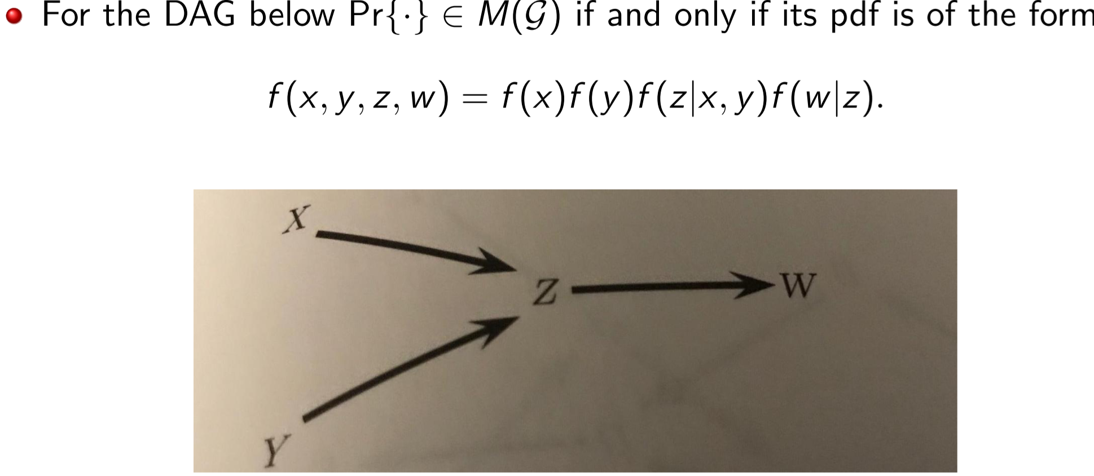

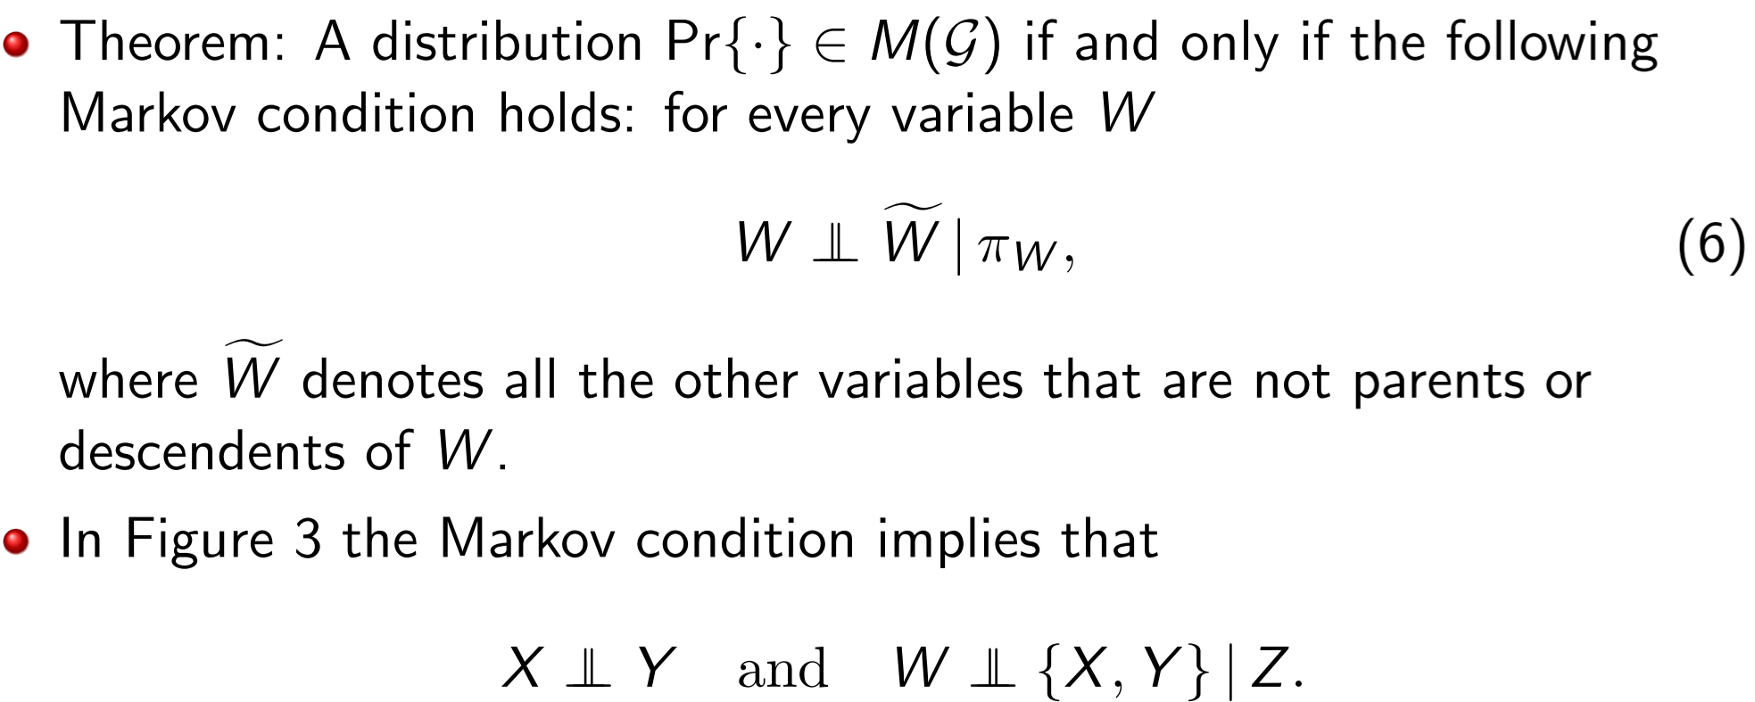

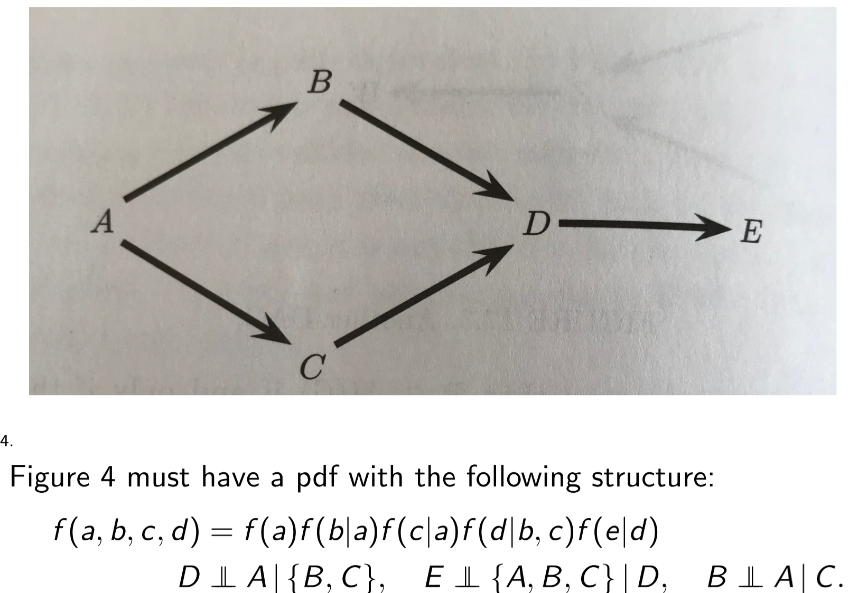

**Rules of D-separation**

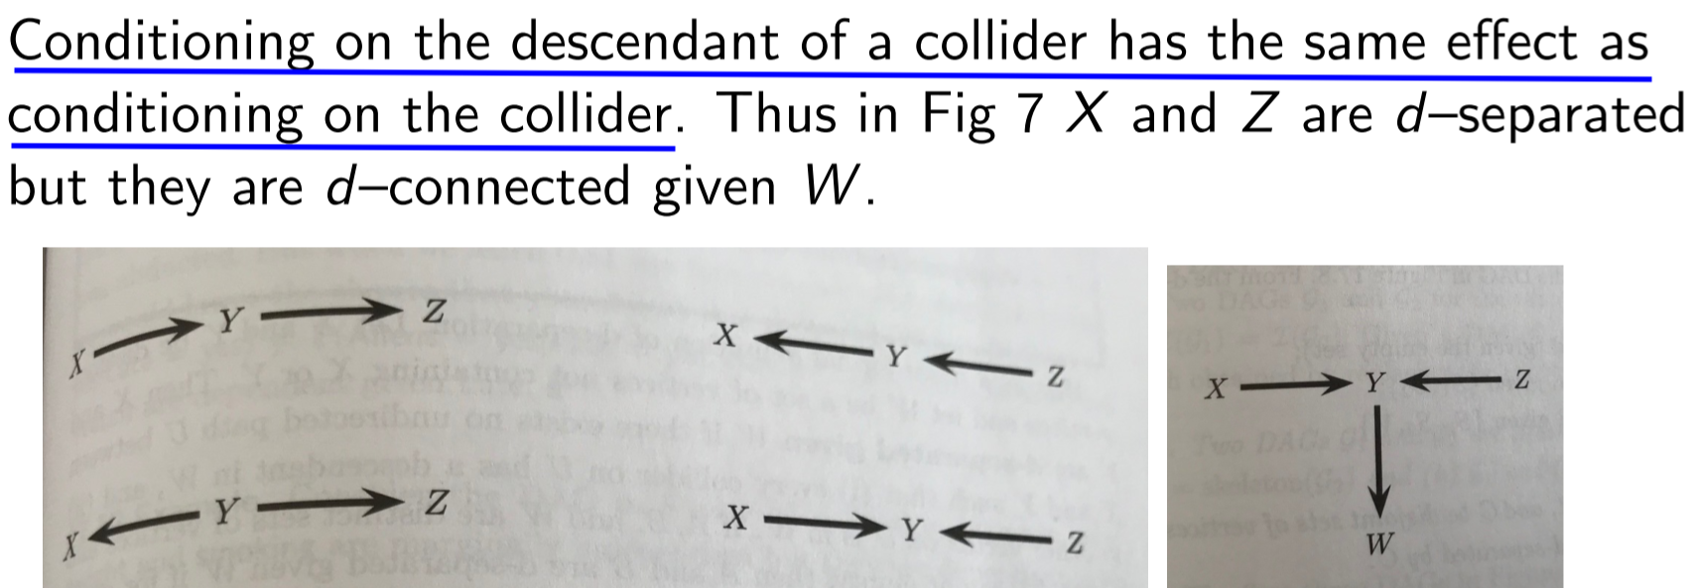

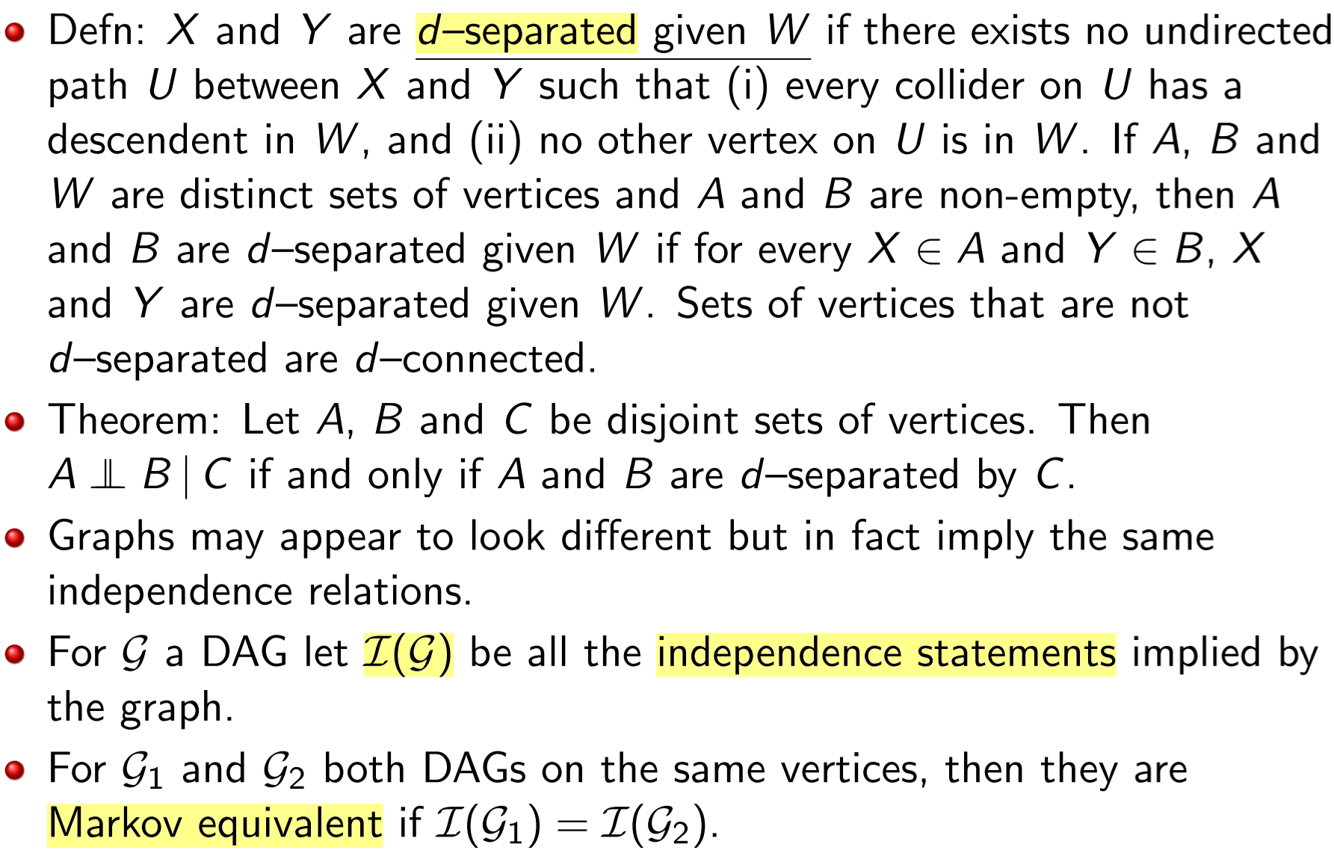

Note: independent statements are all statements that factorize the graph:

- eg p(a,b,c) = p(a|b) * p(b) * p(c)

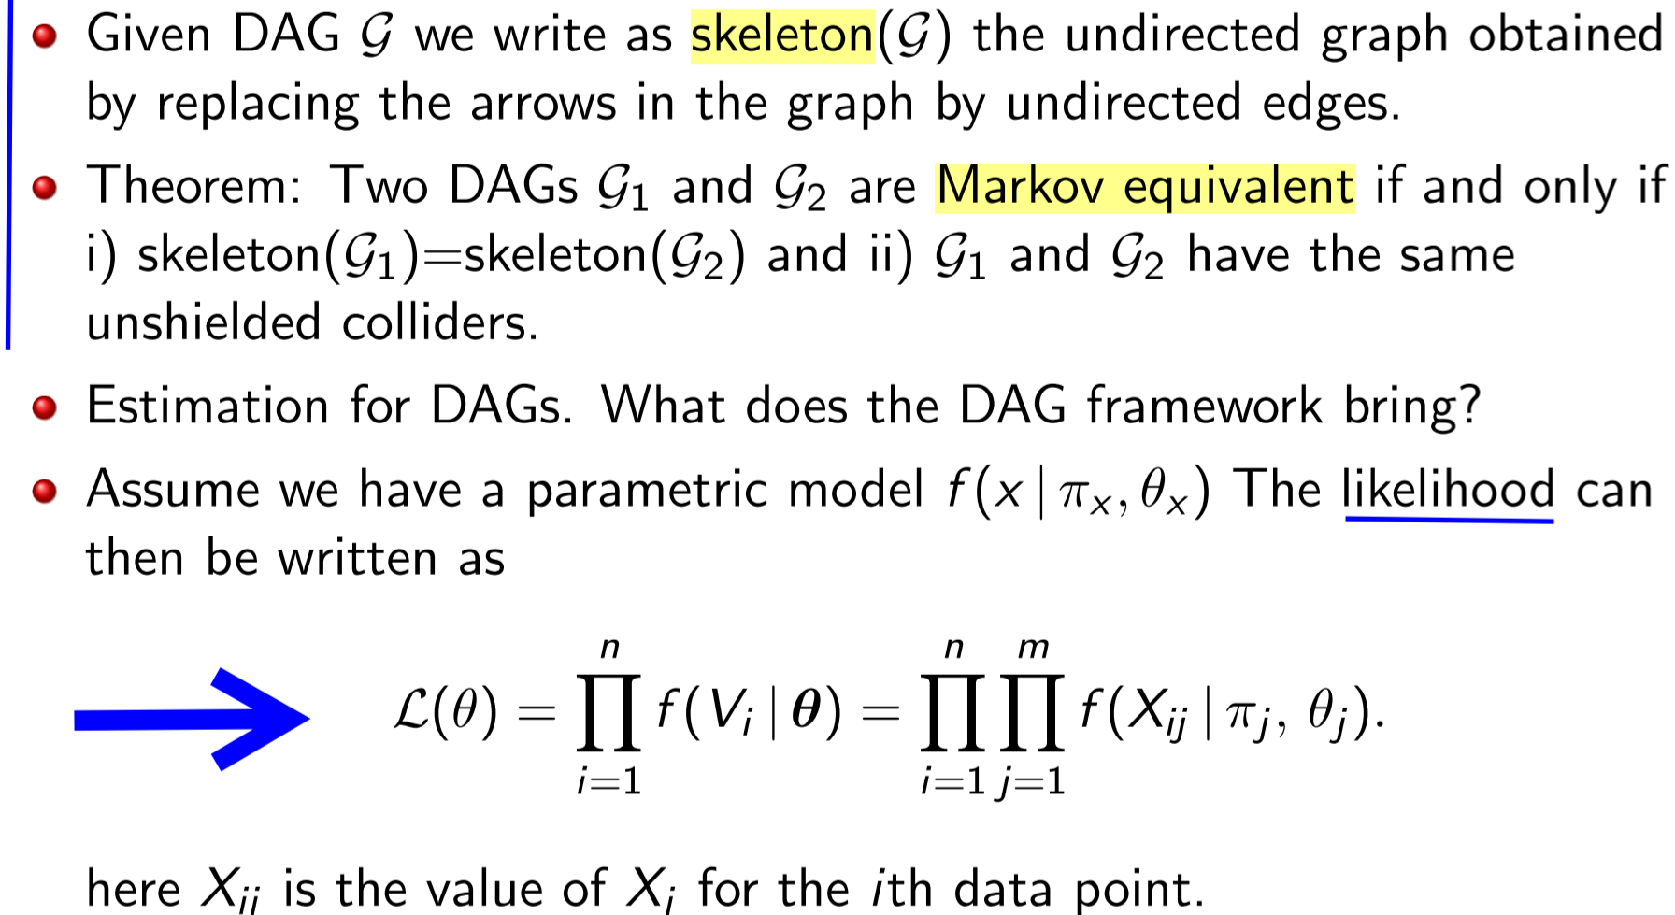

**Lecture 23 – AI and Fairness**

**Well-calibrated, score**

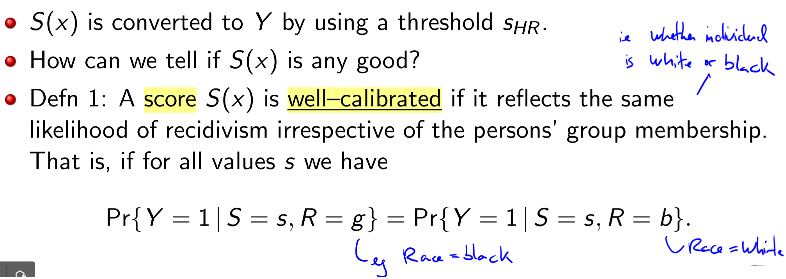

**Predictive parity**

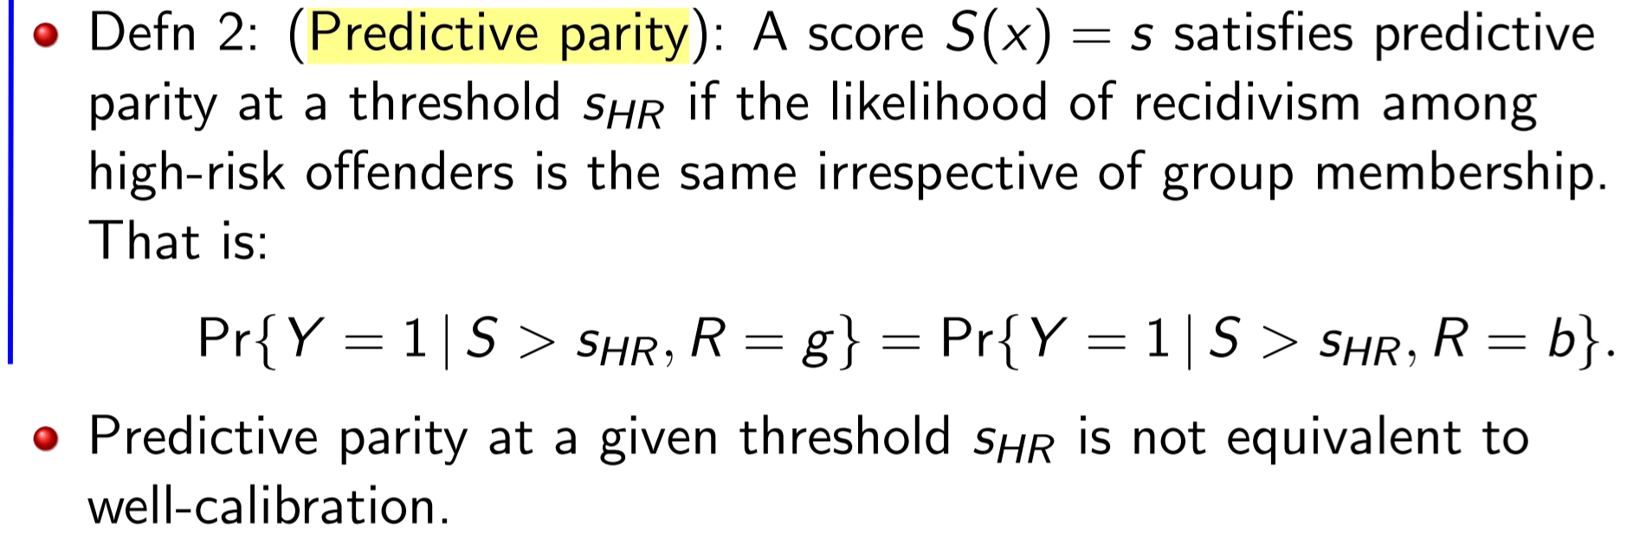

**Well-calibrated, score**

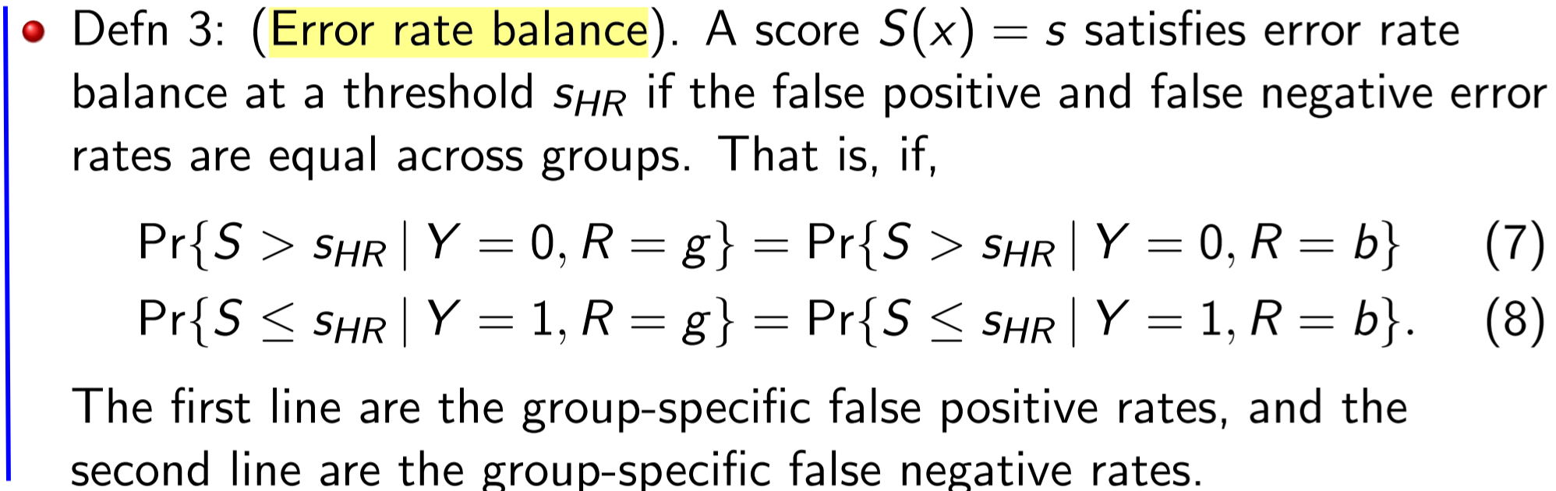

**Statistical Parity, group fairness**

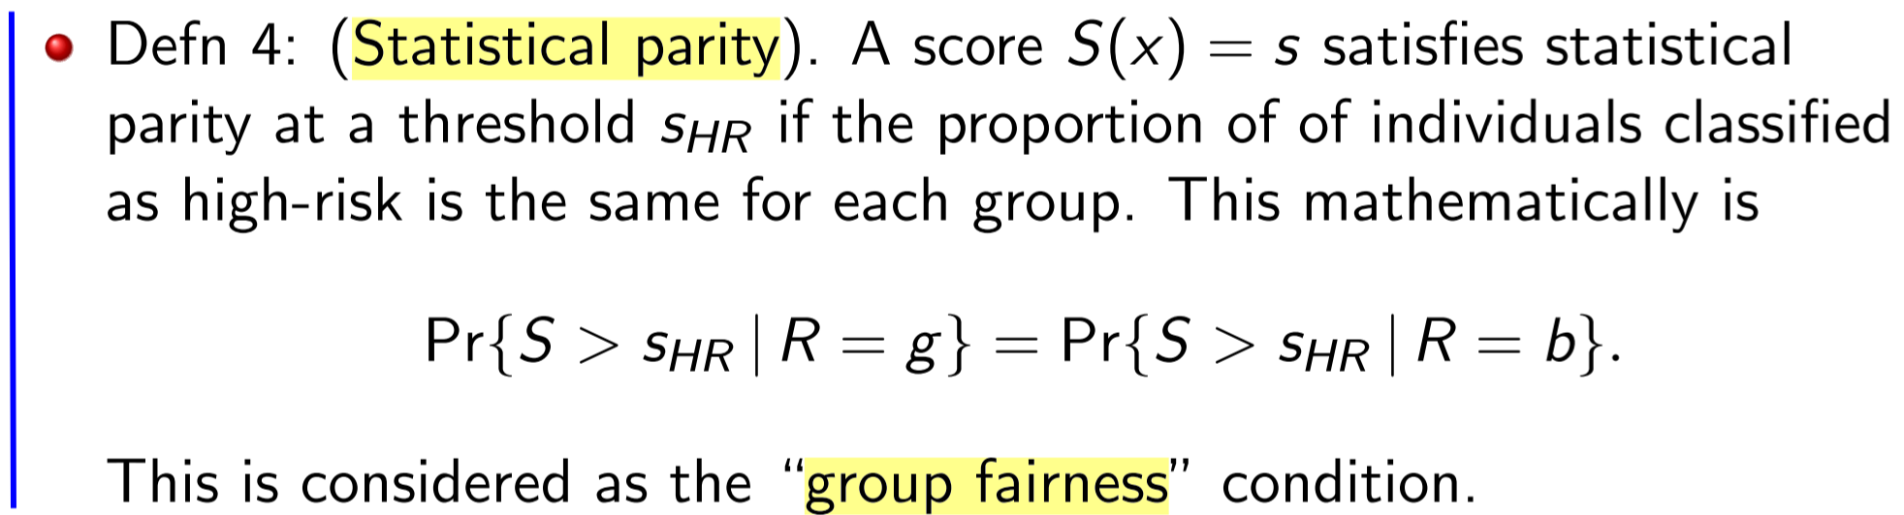

**Lecture 25 – Examples**

**Hypothesis testing in Linear Model**

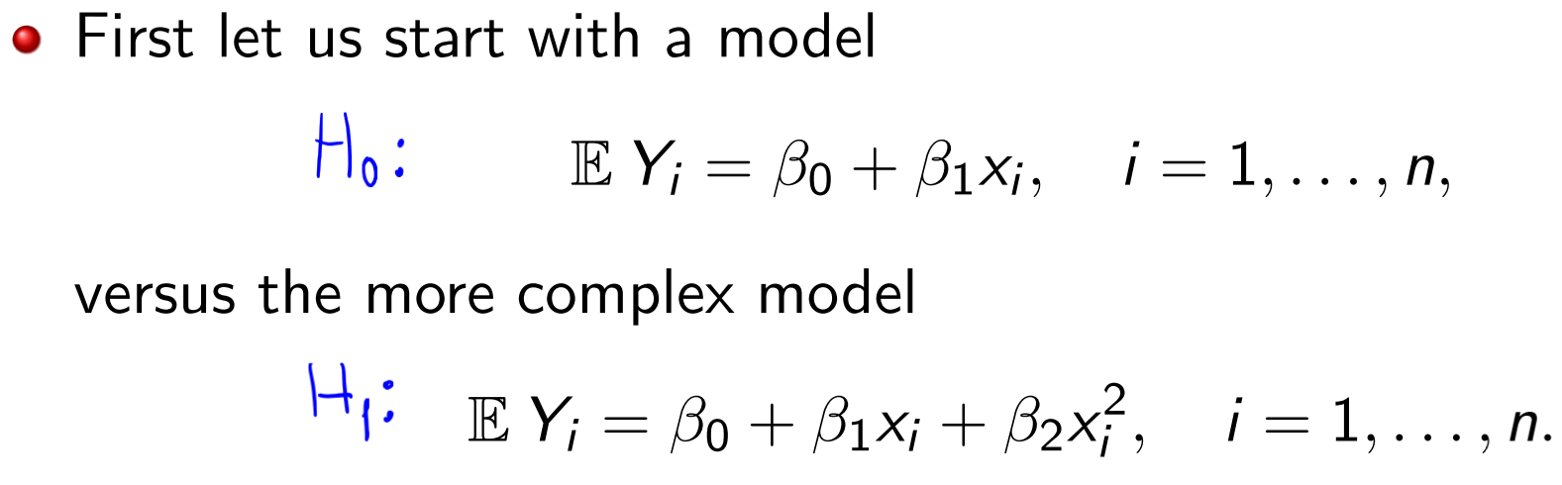

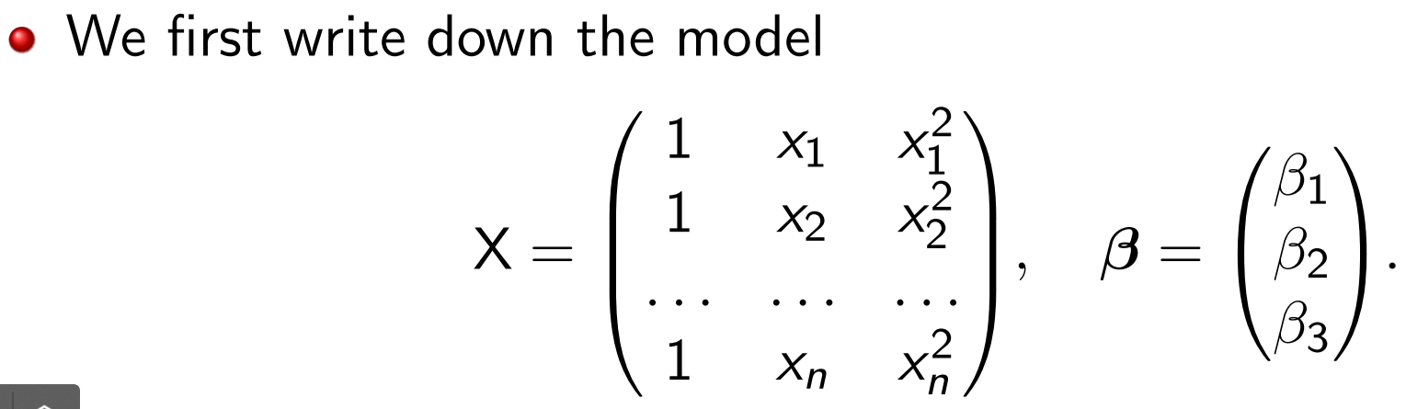



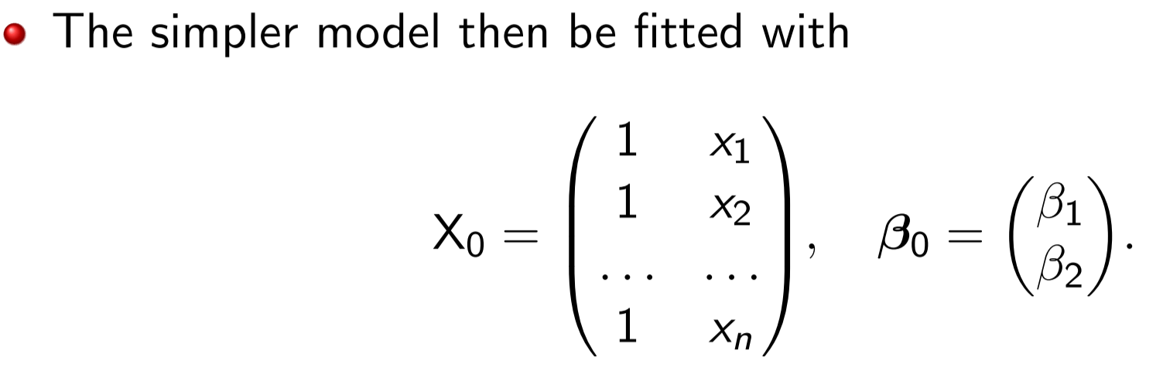

**Is this a linear model?**

